The Superior Court of Justice:
Mapping the Way Forward
2010-2012 Report
ISSN 1918-9850 (Online)

Superior Court of Justice Judges and Masters by Region, at March 31, 2012

Michael F. Brown, Regional Senior Justice, Central East Region
Central East Region
Local Administrative Judges
Margaret P. Eberhard, Barrie
Drew S. Gunsolus, Cobourg, Lindsay and Peterborough
Edwin B. Minden, Newmarket
Allan R. Rowsell, Durham
Thomas M. Wood, Bracebridge
Judges of the Region

R. Cary Boswell
J. Christopher Corkery
Guy P. DiTomaso
Mark L. Edwards
Jane E. Ferguson
Michelle K. Fuerst
Cory A. Gilmore
Bruce A. Glass
Fred Graham
Mary Jane Hatton
Susan E. Healey
Peter H. Howden
Jayne E. Hughes
Alan P. Ingram
Ronald P. Kaufman
Myrna L. Lack
Peter D. Lauwers
Barry G.A. MacDougall
J. Robert MacKinnon
Peter Z. Magda
John R. McCarthy
John P.L. McDermot
Heather A. McGee
John R. McIsaac
Michael K. McKelvey
Gregory M. Mulligan
Anne M. Mullins
Clifford S. Nelson
Hugh K. O’Connell
Lydia M. Olah
Elizabeth A. Quinlan
Sherrill M. Rogers
David W.E. Salmers
Margaret A.C. Scott
J. Bryan Shaughnessy
Alexander Sosna
Alfred J. Stong
D. Roger Timms
Ramona A. Wildman

C. Stephen Glithero, Regional Senior Justice, Central South Region
Central South Region
Local Administrative Judges
Harrison S. Arrell, Brantford
Patrick J. Flynn, Kitchener
Donald J. Gordon, Cayuga
Joseph R. Henderson, Welland
Cheryl Lafrenière, Hamilton
(Family Court)
Jane A. Milanetti, Hamilton
(Civil and Criminal)
James R.H. Turnbull, Simcoe
Linda M. Walters, St. Catharines
Judges of the Region

David A. Broad
Caroline E. Brown
Grant A. Campbell
Kim A. Carpenter-Gunn
John J. Cavarzan
Deborah L. Chappel
David S. Crane
Peter B. Hambly
James C. Kent
Richard A. Lococo
Thomas R. Lofchik
Wendy L. MacPherson
Theresa Maddalena
Barry H. Matheson
Randolph J.D. Mazza
Mary Jo McLaren
Dale Parayeski
Alex Pazaratz
Joseph W. Quinn
James A. Ramsay
Robert B. Reid
Robert D. Reilly
J. Wilma Scott
James W. Sloan
David M. Steinberg
Donald J. Taliano
Gerald E. Taylor
C. Anne Tucker
Alan C.R. Whitten

Francine E. Van Melle, Regional Senior Justice, Central West Region
Central West Region
Local Administrative Judges
Clayton Conlan, Owen Sound and Walkerton
Douglas K. Gray, Milton
Casimir N. Herold, Guelph
Katherine M. van Rensburg, Brampton
Judges of the Region

Deena F. Baltman
John R. Belleghem
Thomas A. Bielby
Kendra D. Coats
David L. Corbett
Peter A. Daley
Fletcher Dawson
Meredith Jackson Donohue
Thomas M. Dunn
Bruce Durno
Dale F. Fitzpatrick
Joseph Michael Fragomeni
S. Casey Hill
C. William Hourigan
Kenneth A. Langdon
Gordon D. Lemon
A. Donald K. MacKenzie
Gisele M. Miller
Nancy M. Mossip
John C. Murray
Terrance P. O’Connor
David G. Price
Leonard Ricchetti
Silja S. Seppi
Lorna-Lee Snowie
John R. Sproat
Robert M. Thompson
Michael H. Tulloch
Bonnie J. Wein

Charles T. Hackland, Regional Senior Justice, East Region
East Region
Local Administrative Judges
Robert N. Beaudoin, Ottawa (Civil)
Douglas M. Belch, Kingston and Napanee (Criminal and Civil)
Richard G. Byers, Picton
Michel Z. Charbonneau, L’Original
Johanne Lafrance-Cardinal, Cornwall
V. Jennifer Mackinnon (Family Court)
James E. McNamara, Pembroke
Michael J. Quigley, Brockville and Perth
Lynn D. Ratushny, Ottawa (Criminal)
Robert F.B. Scott, Belleville
Anne C. Trousdale, Kingston and Napanee (Family Court)
Judges of the Region

Brian W. Abrams
Catherine D. Aitken
Peter B. Annis
Jennifer A. Blishen
Martin S. James
John M. Johnston
Paul B. Kane
Stanley J. Kershman
Paul F. Lalonde
Rick T. Leroy
Maria T. Linhares de Sousa
Helen K. MacLeod-Beliveau
Robert L. Maranger
Colin D.A. McKinnon
Hugh R. McLean
John A. McMunagle
Monique Métivier
Timothy Minnema
Julianne A. Parfett
Kenneth E. Pedlar
Robert Pelletier
Heidi S. Levenson Polowin
Denis J. Power
Timothy D. Ray
Cheryl Robertson
Giovanna Toscano Roccamo
Albert J. Roy
Douglas J.A. Rutherford
Alan D. Sheffield
Robert J. Smith
Wolfram U. Tausendfreund
Gary W. Tranmer
Bonnie R. Warkentin
Masters
Calum U.C. MacLeod
Pierre E. Roger

Louise L. Gauthier, Regional Senior Justice, Northeast Region
Northeast Region
Local Administrative Judges
Robert G.S. Del Frate, Gore Bay and Manitoulin
Louise L. Gauthier, Sudbury
Cindy A.M. MacDonald, Cochrane
Ian S. McMillan, Sault Ste.Marie
David J. Nadeau, North Bay
J. Stephen O’Neill, Parry Sound
Robert A. Riopelle, Timmins
James A.S. Wilcox, Haileybury
Judges of the Region
Robert P. Boissonneault
R. Dan Cornell
M. Gregory Ellies
Edward E. Gareau
Robbie D. Gordon
Patricia C. Hennessy
Norman M. Karam
Edward J. Koke
John S. Poupore
Paul U. Rivard
George T.S. Valin
W. Larry Whalen

Helen M. Pierce, Regional Senior Justice, Northwest Region
Northwest Region
Local Administrative Judges
Helen M. Pierce, Thunder Bay
Erwin W. Stach, Kenora and Fort Frances
Judges of the Region
F. Bruce Fitzpatrick
John S. Fregeau
John F. McCartney
Terrence A. Platana
Douglas C. Shaw
G. Patrick Smith
John dePencier Wright

Edward W. Ducharme, Regional Senior Justice, Southwest Region
Southwest Region
Local Administrative Judges
John A. Desotti, Sarnia
Roland J. Haines, Stratford
Thomas A. Heeney, St. Thomas and Woodstock
John C. Kennedy, Goderich
Helen A. Rady, London
(Civil and Criminal)
Lynda C. Templeton, London (Family Court)
Bruce G. Thomas, Chatham and Windsor
Judges of the Region

Christopher M. Bondy
Alan W. Bryant
Scott K. Campbell
Thomas J.P. Carey
Joseph M.W. Donohue
Richard C. Gates
Andrew J. Goodman
Kelly A. Gorman
A. Duncan Grace
Paul J. Henderson
Peter B. Hockin
Lynne C. Leitch
Mary E. Marshman
Dougald R. McDermid
John F. McGarry
Victor Mitrow
Johanne N. Morissette
Mary Jo Nolan
Terrence L.J. Patterson
Renee M. Pomerance
Joseph G. Quinn
Steven Rogin
Henry A. Vogelsang
Masters
Lou Ann M. Pope

Edward F. Then, Regional Senior Justice, Toronto Region
Toronto Region
Team Leaders
Todd L. Archibald, Long Trials Civil
George Czutrin, Family
Alison L. Harvison Young, Small Claims Court
Wailan Low, Civil
John B. McMahon, Criminal
Geoffrey B. Morawetz, Commercial List
Ian V.B. Nordheimer, Criminal Long Trials and Homicides
Paul M. Perell, Class Actions
Katherine E. Swinton, Divisional Court
Kevin V.W. Whitaker, Estates
Benjamin T. Glustein, Masters Administration
Judges of the Region

Beth A. Allen
David R. Aston
Nancy L. Backhouse
Edward P. Belobaba
Mary Lou Benotto
Carole J. Brown
David M. Brown
Colin L. Campbell
Kenneth L. Campbell
Sandra Chapnik
Robert A. Clark
Michael Code
Barbara A. Conway
Katherine B. Corrick
Bonnie L. Croll
Peter A. Cumming
Michael R. Dambrot
Todd Ducharme
Tamarin M. Dunnet
Eugene G. Ewaschuk
Maureen D. Forestell
E. Eva Frank
Arthur M. Gans
Nola E. Garton
Susanne R. Goodman
Susan E. Greer
Glenn A. Hainey
Thea P. Herman
Susan G. Himel
Carolyn Horkins
Peter G. Jarvis
John R.R. Jennings
Jane E. Kelly
Frances P. Kiteley
Gloria R. Klowak
Emile R. Kruzick
Joan L. Lax
Thomas R. Lederer
Sidney N. Lederman
Ellen M. MacDonald
John A.B. MacDonald
Ian A. MacDonnell
Frank N. Marrocco
P. Theodore Matlow
J. David McCombs
Thomas J. McEwen
Faye E. McWatt
Ruth E. Mesbur
Anne M. Molloy
J. Patrick Moore
Frank J.C. Newbould
Alfred J.C. O’Marra
Brian P. O’Marra
Victor Paisley
Gladys I. Pardu
Laurence A. Pattillo
Michael A. Penny
Sarah E. Pepall
Craig Perkins
Andra M. Pollak
Michael G. Quigley
Lois B. Roberts
Harriet E. Sachs
Mary Anne Sanderson
Gertrude F. Speigel
James M. Spence
Christopher M. Speyer
Nancy J. Spies
Suzanne M. Stevenson
Elizabeth M. Stewart
David G. Stinson
George R. Strathy
Julie A. Thorburn
W. Brian Trafford
Gary T. Trotter
John C. Wilkins
Darla A. Wilson
Janet M. Wilson
Herman Wilton-Siegel
Masters
Linda S. Abrams
Carol Albert
Ronna Brott
Ronald Dash
Andrew T. Graham
Joan Haberman
Thomas Hawkins
May J. Jean
Barbara McAfee
Robert A. Muir
*Richard B. Peterson
Julian Polika
*David H. Sandler
Donald E. Short
(*Traditional Masters)

Regions and Court Locations of the Superior Court of Justice of Ontario
01 Northwest - Fort Frances, Kenora, Thunder Bay
02 Northeast - Cochrane, Gore Bay, Haileybury, North Bay, Parry Sound, Sault Ste Marie, Sudbury, Timmins
03 East Region- Belleville, Brockville, Cornwall, Kingston, L'Orignal, Napanee, Ottawa, Pembroke, Perth, Picton
04 Central East - Barrie, Bracebridge, Cobourg, Durham, Lindsay, Newmarket, Peterborough
05 Central West - Brampton, Guelph, Milton, Orangeville, Owen Sound, Walkerton
06 Toronto - Toronto
07 Southwest - Chatham, Goderich, London, St. Thomas, Sarnia, Stratford, Windsor, Woodstock
08 Central South - Brantford, Cayuga, Hamilton, Kitchener, St. Catharines, Simcoe, Welland.
The Superior Court of Justice: Mapping the Way Forward
2010-2012 REPORT
Table of Contents
The Superior Court of Justice: Mapping the Way Forward 2010-2012 Report 1
Superior Court of Justice Judges and Masters by Region 3
Message from the Chief Justice 18
Message from the Associate Chief Justice 21
Jurisdiction of the Superior Court of Justice 23
Criminal Jurisdiction 23
Civil Jurisdiction 23
Small Claims Court Jurisdiction 24
Divisional Court Jurisdiction 25
Family Jurisdiction 26
Role of the Senior Family Judge under the Courts of Justice Act 29
The Judicial Executive of the Superior Court of Justice 30
Judicial Committees and Advisory Groups 31
Advisory Group on Access to Court Information 31
Clerkship Committee 31
Education Committee 32
Facilities Committee 32
Information Technology Committee 33
Jury Review Committee 33
Library Committee 33
Security Committee 34
Senior Family Judge's Consultation Committee 34
Workload and Wellness Committee 35
Key Achievements and Initiatives of the Superior Court 37
Family 37
The Province-Wide Expansion of Front-End Family Justice Services 37
Expansion of the Dispute Resolution Officer Pilot Project 38
The Crown Wardship Pilot Project 39
The Often-Cited Family Law Case List Initiative 39
Civil 40
Enhancing Efficiency in Civil Proceedings 40
Criminal 40
The Criminal Proceedings Rules 40
Enhancing Criminal Pre-Trials 41
Criminal Delay Reduction Strategy and Summary Conviction Initiative 41
Responding to Courtroom Shortages in Brampton, Barrie and Newmarket 41
Technology Initiatives 42
Collaboration with the Ministry of the Attorney General on Technology Initiatives 42
Defining the Court’s Vision for CIMS 42
Supporting the Ministry’s Province-Wide Implementation of Digital Recording Devices 43
The Impact of Social Media on the Justice System 44
The Judicial Information Technology Organization (JITO) 44
Judicial Support for the Ontario Justice Education Network (OJEN) 47
Court Accessibility 48
Addition to the Law Clerk Complement 48
Contingency Planning for the G20 Summit 49
Roles and Responsibilities in the Office of the Chief Justice 50
Executive Legal Officer 51
Executive Administrative Officer 52
Legal Counsel in the Office of the Chief Justice 52
Regional Offices 53
Legal Research Facility 53
Statistics by Region 54
Central East Region 54
Central South Region 55
Central West Region 56
East Region 57
Northeast Region 58
Northwest Region 59
Southwest Region 60
Toronto Region 61
Comparison between New Civil Proceedings: 62
Superior Court and Small Claims Court Branch 62
Retired Judges 63
In Memoriam 65
Looking Forward 66
Endnotes and Photo Descriptors 67

As we look at the road ahead and map the way forward, I know that the members of the Superior Court will continue in their unfailing dedication to serve the public.
Chief Justice Heather J. Smith

Message from the Chief Justice
It is my great pleasure to present the third Report of the Superior Court of Justice, covering the Court’s activities for the 2010 and 2011 fiscal years (April 1, 2010 to March 31, 2012). This Report celebrates and highlights the Court’s significant achievements over the last two years, feats made possible by our steadfast commitment to excellence and innovation. Despite severe fiscal restraint, we have achieved major and transformative improvements to our Court, resulting in tangible and measurable benefits to the people of Ontario. This Report summarizes our major achievements and highlights important initiatives that continue to move the Court forward in delivering justice to all Ontarians.
The Superior Court continues to modernize and innovate in all areas of its jurisdiction. In March 2012, this Court became the first and only in Canada to amend its Criminal Proceedings Rules to comply with Criminal Code changes legislated by Bill C-2. In civil matters, the Court continues to provide certainty, timeliness, and cost savings through the implementation of and support for new civil rules, which came into force in 2010. The family justice system has also seen dramatic change in the last two years, with the most significant enhancements in front-end family justice services since the inception of the family court concept—resources that will empower Ontario families and make family law proceedings more efficient and affordable at every Superior Court location. In each of these three areas of law, the Superior Court remains dedicated to providing meaningful, effective, and timely access to justice.
As we look at the road ahead and map the way forward, I know that the members of the Superior Court will continue in their unfailing dedication to serve the public. I am tremendously proud of the judges and judicial officers of this Court and the work they perform. Over 10,000 Superior Court decisions are delivered annually. The quality of this Court’s judgments continues to meet the highest standards. The judges and judicial officers of our Court are remarkable in the commitment, integrity, and wisdom that they bring to their courtrooms. I am confident that I speak for every member of the Court when I say that I take great pride in being part of one of the most respected and admired justice systems in the world.
As always, I am truly grateful to the extraordinary Executive of the Court—Associate Chief Justice Cunningham, the eight Regional Senior Judges, and the Senior Family Judge—for the wise counsel they impart to me and to their fellow judges, and for their tremendous contributions to the administration of this Court. I also express my sincere thanks to all of the judges and judicial officers for their outstanding work in this Court over the past two years.
However, the successes of this Court don’t belong to the judges alone. Our achievements are also the product of the determined efforts of dedicated and professional Court Services staff and staff in the Office of the Chief Justice. The work of the Court could not be performed without their able assistance and I thank them for their excellent contributions to our achievements, both past and to come.
The Superior Court is very proud to mark the accomplishments covered in this Report. Armed with the knowledge of the strides we’ve made in these last two years, we will boldly and confidently chart our course into the future. I am overwhelmingly optimistic about the future progress of this Court.
Yours truly,
Heather J. Smith, Chief Justice.

The Hon. Madam Justice Heather J. Smith,
Chief Justice
As this will be my last message as Associate Chief Justice, I wanted to thank all of our judges for their wonderful support over the last nearly ten years. It has been a privilege to have served as your Associate Chief Justice.
Yours truly,
Associate Chief Justice J. Douglas Cunningham.

Message from the Associate Chief Justice
I am very pleased to join in presenting this Report of the Superior Court of Justice. This Report offers a remarkable reflection on the commitment of all of our judges to supporting an accessible, efficient, and effective justice system.
As Associate Chief Justice, I am committed to the management of aspects of the Court’s large and growing workload, notably the Divisional Court and the Small Claims Court. I am also a member of the Regional Senior Judges Council, which functions as the Court’s Executive Committee, and I am Chair of the Deputy Judges Council. As well, I serve on the Executive Committee of the Canadian Judicial Council and Chair the Administration of Justice Committee. In addition to these administrative responsibilities, I seek to maintain as full a sitting schedule as possible.
A significant portion of my time is spent conducting mediations and presiding in the Divisional Court. Unique to Ontario, the Divisional Court is one of the busiest appellate courts in Canada. It is also the Court of first instance for all judicial review applications in Ontario. Judges who preside will possess a wealth of administrative law expertise for the hundreds of judicial review applications the Divisional Court hears each year.
Recently, our Court has paid special attention to the operation of the Small Claims Court. On January 1, 2010, its monetary jurisdiction increased from $10,000 to $25,000 as part of overall reforms to the civil justice system. Since then, there have only been modest increases in the number of Small Claims Court cases commenced, but other factors appear to have had an impact on the Court’s ability to offer a prompt trial date at certain centres. Our Court continues to investigate and implement all available scheduling solutions so that the Small Claims Court maintains its reputation as a timely, efficient, and affordable dispute resolution forum.
Finally, I would like to commend the deputy judges, who so diligently and effectively preside over the Small Claims Court. Together, they deal with the majority of civil proceedings brought in this province, and do so fairly and expeditiously. Recently, the Deputy Judges Council made several modest recommendations to improve the education and position of deputy judges. Those recommendations have been delivered to the Attorney General, and I am hopeful that they will soon be implemented, not only for the benefit of deputy judges, but also the people in Ontario, whom we all serve.
As this will be my last message as Associate Chief Justice, I wanted to thank all of our judges for their wonderful support over the last nearly ten years. It has been a privilege to have served as your Associate Chief Justice.
Yours truly,
J. Douglas Cunningham, Associate Chief Justice.

The Hon. Mr. Justice Douglas Cunningham,
Associate Chief Justice

Jurisdiction of the Superior Court of Justice
The Superior Court of Justice in Ontario has inherent jurisdiction, arising from Ontario’s common law traditions, over criminal, civil, and family cases. The Court has all the jurisdiction, power, and authority historically exercised by courts of common law and equity in England and Ontario. The Superior Court’s inherent jurisdiction gives it authority to hear any matter that is not specifically assigned to another level of court. The Court also has authority over matters granted to it by federal and provincial statutes. A complement of 242 federally appointed full-time judges and 75 supernumerary judges serve the roughly 13 million people of Ontario.

Criminal Jurisdiction
The Superior Court of Justice is a superior court of criminal jurisdiction. The Court has the power to try any indictable offence under the Criminal Code of Canada. However, the Superior Court generally only tries the most serious criminal offences. These include murder, manslaughter, drug trafficking, and other offences against the security of the state, or an attempt or conspiracy to commit one of these offences. An individual accused of any of these offences is tried by a judge of the Superior Court, and may or may not face a jury.
The Superior Court also has appellate authority over summary conviction cases heard in the Ontario Court of Justice. The Superior Court’s new Criminal Proceedings Rules came into effect on March 1, 2012, and require all parties to comply with new timelines to ensure the timely resolution of summary conviction appeals.
The Superior Court has a Criminal Rules Committee, chaired by Justice Bruce Durno, with ad hoc members selected by Justice Durno in collaboration with the Chief Justice.
The total number of criminal proceedings commenced in the Superior Court of Justice was 3,938 during the year ending March 31, 2011, and 3,921 during the year ending March 31, 2012.
Statistics setting out the number of new criminal proceedings commenced in each Superior Court region over the last two fiscal years are set out at the end of this Report, beginning on page 69.

Civil Jurisdiction
The Superior Court of Justice hears all civil proceedings in Ontario including commercial matters, personal injury, bankruptcy and insolvency cases, and litigation involving wills and estates. The Superior Court also has some appellate jurisdiction under various statutes. Civil proceedings in the Superior Court are generally governed by the Rules of Civil Procedure.
The Rules of Civil Procedure are made by the Civil Rules Committee, subject to the approval of the Attorney General. The Civil Rules Committee has 29 members and is chaired by Associate Chief Justice Dennis O’Connor of the Ontario Court of Appeal. Of the 16 judicial members, eight members are judges appointed by the Chief Justice of the Superior Court of Justice. To ensure the perspectives of several regions are considered when civil rule amendments are tabled, Regional Senior Judges from six regions are members of the Civil Rules Committee.
On January 1, 2010, amendments to the Rules of Civil Procedure and the Courts of Justice Act came into effect that incorporated most recommendations in the report on the Civil Justice Reform Project. 1 Key reforms included an increase to the monetary jurisdiction of the Small Claims Court from $10,000 to $25,000 and an increase in the monetary jurisdiction of the Simplified Procedure, governed by Rule 76 of the Rules of Civil Procedure, from $50,000 to $100,000.
The Civil Justice Reform Project recommendations sought to improve access to justice by making the civil justice system more accessible and affordable for all Ontarians. Since the 2010 amendments, the Office of the Chief Justice and the Ministry of the Attorney General for Ontario have monitored developments to assess the effectiveness of these reforms.
81,946 civil proceedings were commenced in the Superior Court of Justice between April 1, 2010 and March 31, 2011. The following year, between April 1, 2011 and March 31, 2012, that total fell slightly to 81,465.
(These numbers do not include the approximately 20,000 uncontested estates cases commenced in Ontario each year or any Small Claims Court or Divisional Court cases, which are described in the following sections.)
Statistics setting out the number of new civil proceedings commenced in each Superior Court region over the last two fiscal years are set out at the end of this Report, beginning on page 69.

Small Claims Court Jurisdiction
The Small Claims Court branch of the Superior Court of Justice is an extraordinarily busy court in Ontario, handling nearly half of all civil claims in the province. In 2011, over 45% of all civil cases heard in Ontario were commenced in the Small Claims Court.
A total of 67,912 new small claims proceedings were commenced between April 1, 2010 and March 31, 2011, and 66,394 between April 1, 2011 and March 31, 2012.
The Small Claims Court provides an efficient and cost-effective forum for Ontarians to bring or defend civil claims seeking up to $25,000 in monetary or property damages. The Rules of the Small Claims Court provide for streamlined procedures so that cases can be determined at a lower cost and in less time for litigants than cases commenced in the Superior Court.
The monetary jurisdiction of the Small Claims Court increased from $10,000 to $25,000 on January 1, 2010. Two years later, the Court has begun to see the effects of this increase in monetary jurisdiction. There has been a natural change in the caseload of the Court. In addition, more complex cases are being heard which can take more time at trial. At some centres, concerns have arisen over the time to the next available trial date. This concern has been investigated by the Office of the Chief Justice, and in consultation with Administrative Judges of the Small Claims Court, it has largely been addressed. The Court continues to monitor the timeliness of trial dates to ensure the continued effectiveness of the Small Claims Court and its longstanding success in providing an affordable, efficient, and timely dispute resolution forum for the people of Ontario.
Typically, deputy judges preside over proceedings in the Small Claims Court. Deputy judges are senior lawyers appointed for a three-year term by the Regional Senior Judge, with the approval of the Attorney General. Provincially appointed judges may also hear Small Claims Court proceedings. As of March 31, 2012, the roster of the Small Claims Court included 385 deputy judges and 2 per diem provincially appointed judges.
The Courts of Justice Act establishes a Deputy Judges Council for the Small Claims Court. The Deputy Judges Council, chaired by Associate Chief Justice Douglas Cunningham, serves the following functions:
- to review and approve standards of conduct for deputy judges as established by the Chief Justice,
- to review and approve a plan for the continuing education of deputy judges as established by the Chief Justice, and
- to make recommendations on matters affecting deputy judges.
In each region, the Regional Senior Judge delegates the responsibility of overseeing the Small Claims Court to an Administrative Superior Court Judge. The Committee of Administrative Judges of the Small Claims Court is chaired by Regional Senior Justice Charles T. Hackland and comprises judicial representatives from each of the eight regions. In 2010 and 2011, the Administrative Judges met bi-annually, as in the past, to discuss matters of mutual concern related to the Small Claims Court.
While the number of new Superior Court civil proceedings in the province exceeded the number of new Small Claims Court proceedings in 2011/12, four regions had more Small Claims Court proceedings than Superior Court civil proceedings (Central East, East, Northeast and Northwest). Statistics comparing new civil proceedings commenced in the Superior Court and the Small Claims Court branch are set out at the end of this Report, beginning on page 77.

Divisional Court Jurisdiction
The Divisional Court is an appellate branch of the Superior Court. It functions as the primary forum for judicial review of government action in Ontario and hears statutory appeals from decisions of provincial administrative tribunals. In addition, the Divisional Court has some family and civil appellate jurisdiction. A proceeding is usually heard and decided by a panel of three judges but may be heard by a single judge in some circumstances.
The Divisional Court is scheduled to hear matters at various times of the year in each of the regions of Ontario, except in Toronto, where the Divisional Court sits regularly throughout the year.
During 2010 and 2011, Justice Katherine E. Swinton was the administrative team lead for the Divisional Court in Toronto. Justice Swinton worked in tandem with Associate Chief Justice Douglas Cunningham to coordinate sittings in Toronto and across the province. Together with the assistance of the dedicated Divisional Court staff, this appellate branch operated as a model of effectiveness and efficiency.
The Divisional Court is one of the busiest appellate courts in Canada, with 1,296 new proceedings commenced in the fiscal year ending March 31, 2011, and 1,235 in the fiscal year ending March 31, 2012.

Family Jurisdiction
Since family law involves both federal and provincial statutes, jurisdiction over family proceedings in Ontario is divided between the Superior Court of Justice and the Ontario Court of Justice in most court locations. Both courts preside over child and spousal support and child custody and access. However, under federal law, the Superior Court has sole jurisdiction in all cases involving divorce and the division of property while, under provincial law, child protection and adoption cases must be commenced in the Ontario Court of Justice.
In 17 of the 50 Superior Court locations, this split jurisdiction has been unified by the Courts of Justice Act which created the Family Court as a branch of the Superior Court. At any Family Court site, all family matters are heard, including divorce, division of property, support, custody and access, child protection, and adoption. Family Court was originally known as the Unified Family Court and began as a pilot project in Hamilton in 1977. The pilot project eventually became a permanent feature of the Superior Court in 1984. In 1995, Family Courts were established in Barrie (Central East Region), London (Southwest Region), and Kingston and Napanee (East Region). In 1999, the project expanded to include 12 more sites—Bracebridge, Cobourg, Durham Region, Lindsay, Newmarket, and Peterborough (Central East Region), Brockville, Cornwall, L’Orignal, Ottawa, and Perth (East Region), and St. Catharines (Central South Region).
Throughout the evolution of this system and the expansion of Family Courts in various sites throughout the province, the philosophy and approach in family law proceedings has also changed drastically. In the past, the “ugly affidavit wars” were a constant feature in family law litigation. However, as of July 1, 2004, all family law proceedings commenced in either the Superior Court of Justice or the Ontario Court of Justice have been governed by the same Family Law Rules. All proceedings apply the same procedures, forms, and steps in accordance with the Rules. Since a common set of Family Law Rules were implemented across Ontario, we have seen the system evolve towards one which emphasizes case management and encourages settlement, ultimately leading to a less adversarial approach to family law.
The Courts of Justice Act provides for a Family Rules Committee, which has the mandate to make rules for the Ontario courts in relation to the practice and procedure of family proceedings, subject to the approval of the Attorney General. Members of the Committee are appointed by and include representatives from the Superior Court of Justice, the Ontario Court of Justice, the Ministry of the Attorney General, as well as various family justice partners and stakeholders such as the Law Society of Upper Canada, Children’s Aid Societies, the Office of the Children’s Lawyer, and leading members of the family bar. The Chairperson for the Family Rules Committee is appointed by the Chief Justice of Ontario.
Between April 1, 2010 and March 31, 2011, a total of 56,939 new family proceedings were commenced in the Superior Court of Justice: 30,252 in Family Court branch locations and 26,687 in non-Family Court branch locations.
The figures were similar the next year, from April 1, 2011 to March 31, 2012, when a total of 57,021 new family proceedings were commenced: 30,461 in Family Court sites and 26,560 in non-Family Court sites.
Statistics setting out the number of new family proceedings commenced in each Superior Court region over the last two fiscal years are set out at the end of this Report, beginning on page 69.

Role of the Senior Family Judge under the Courts of Justice Act
By 1999, with the expansion of the Family Court branch, it was clear that the new vision for family law required a different kind of executive support for family proceedings. A new position was created at the Regional Senior Judges Council table for the Senior Family Judge to advise the Chief Justice and each Regional Senior Judge on family matters in each region, as well as on key issues pertaining to the Family Court branch.
Section 14(5) of the Courts of Justice Act establishes the position and duties of the Senior Judge of the Family Court. Under this provision, the Senior Family Judge is authorized to advise the Chief Justice on important issues pertaining to the Family Court branch. These issues include the education of judges who sit in Family Court, the practices and procedures in Family Court (including mediation), the expansion of the Family Court to other locations in Ontario, and the expenditure of funds budgeted for the Family Court. In addition, the Senior Family Judge meets from time to time with the Community Liaison and Resources Committees in each of the Family Court branch locations throughout the province. Under the Act, the Chief Justice may assign responsibility to the Senior Family Judge for any other duties that relate to the Family Court.
Madam Justice Mary Jane Hatton completed her term as Senior Judge of the Family Court in the summer of 2010 and returned to sit at the Oshawa Courthouse in Central East Region. Mr. Justice R. John Harper, who was based in London in Southwest Region, was appointed Senior Family Judge in fall 2010, and is ably discharging that role.

The Hon. Mr. Justice R. John Harper,
Senior Family Judge

The Judicial Executive of the Superior Court of Justice
The Judicial Executive of the Superior Court of Justice includes the Chief Justice, the Associate Chief Justice, eight Regional Senior Judges, and the Senior Judge of the Family Court. These 11 judges make up the executive of the Court—the Regional Senior Judges Council. The respective roles and responsibilities of each member of the Court’s Judicial Executive were outlined in detail in the Superior Court of Justice (Ontario) 2007-2008 Annual Report. 2

Under the Courts of Justice Act3, the Chief Justice may hold meetings with the Associate Chief Justice, the eight Regional Senior Judges, and the Senior Family Judge to consider matters concerning sittings of the Superior Court, the assignment of judicial duties, the rules of court, and the administration of justice generally. The Regional Senior Judges Council provides meaningful advice to the Chief Justice on high-level policy and governance issues affecting the judicial administration of the Court, as well as issues relevant to the Courts of Justice Act, the rules of court and the administration of justice. Between April 1, 2010 and March 31, 2012, the Regional Senior Judges Council met 12 times to consider such issues.

The Chief Justice sets the policies of the Superior Court on the advice of the Regional Senior Judges Council. In providing that advice, each Regional Senior Judge brings the perspective of his or her respective region considered in the context of what is in the best interests of the whole Court. Regional Senior Judges are unique in this respect, having the expertise of administering the Court within his or her region, and an excellent understanding of local issues and trends. They are exceptional administrators whose primary objective as part of the Court’s Judicial Executive is to promote and improve the administration of justice across Ontario. Their sage advice and wise counsel is of immense assistance to the Chief Justice.
The Regional Senior Judges Council has tackled some important issues in the last two fiscal years, including new scheduling protocols from the recommendations of the Court’s Workload and Wellness Committee, judicial coordination of new front-end family justice services, and support for the statement of the Court’s “vision” and priorities for the Court Information Management System (CIMS) being designed by the Ministry of the Attorney General.

Judicial Committees and Advisory Groups
The Chief Justice, in collaboration with the Regional Senior Judges Council, has established a series of committees to assist in managing the affairs of the Court. The committees are comprised of at least one judicial representative who has been, or currently is, a member of the Regional Senior Judges Council. Some of the committees report directly to the Chief Justice, some report to Council, and others liaise more informally with the senior administrative judges of the Court. The committees address issues within their respective mandates and provide advice to the Chief Justice and the Regional Senior Judges Council, who in turn develop and adopt formal policy on behalf of the Court.
A brief description, organized alphabetically, of each of the Court’s committees and their activities over the past two years follows.

Advisory Group on Access to Court Information
In December 2010, the Chief Justice established the Advisory Group on Access to Court Information. The mandate of the Group is to examine and make recommendations to the Chief Justice on all issues concerning “access” to court information. Such issues include access to digital audio recordings and access to court exhibits. Access to digital audio recordings has formed the Group’s initial priority focus, as digital recording becomes the standard method of taking the court record. The Ministry of the Attorney General is targeting full implementation of digital recording devices in courtrooms across Ontario in fall 2012.
Under the chairmanship of Justice Bruce Durno, the 2010 and 2011 group members Justice J. Christopher Corkery, Justice Robert L. Maranger, Justice Renee M. Pomerance, Justice John S. Poupore, Justice Leonard Ricchetti, Justice Nancy J. Spies, Justice James R.H. Turnbull, and Justice Bonnie Warkentin worked diligently to address access issues and concerns.

Clerkship Committee
The Clerkship Committee is charged with maintaining the integrity of the Superior Court’s prestigious clerkship program. The Committee ensures that the Court recruits judicial law clerks from among the best and the brightest law students each year, while providing clerks with an educational program of the highest quality.
The mandate of the Clerkship Committee is to provide advice to the Chief Justice on issues relating to the clerkship and summer law student programs. Issues include, but are not limited to, recruitment, the assignment of judicial mentors (articling principals) to law clerks, educational programming, outreach to Canadian law schools, and meeting the articling requirements under the Law Society of Upper Canada’s licensing process for lawyers.
Committee membership is by appointment by the Chief Justice and consisted of two co-Chairs, Justice Christopher Speyer and Justice George R. Strathy, and two standing members, Regional Senior Justice Edward W. Ducharme and Justice Heidi S. Levenson Polowin. Justice Thea P. Herman served on the Committee as Chair Emeritus.

Education Committee
The Chief Justice’s Education Committee is tasked with organizing judicial education programs for all members of the Court. These programs encompass substantive law, the skills of judging, and social context awareness. As mandated by the Chief Justice, the Committee collaborates with the National Judicial Institute to organize two educational conferences each year, held in the spring and fall. Committee members frequently participate on panels and arrange for stimulating and distinguished guest speakers for the education programs. Presenters have included prominent judges, lawyers, and legal academics from across the country.
In 2010 and 2011, educational seminars were presented on such diverse topics as the impact of new social media on court proceedings, effective judicial responses to cases involving child alienation, internet crimes against children, and civility and professionalism in the courtroom.
Chief Justice Heather Smith chairs the Committee of six additional members, three of whom are appointed on the recommendation of the Ontario Superior Court Judges’ Association. Former Senior Family Justice Mary Jane Hatton served as a member of the Education Committee until summer 2010. Thereafter, Senior Family Justice R. John Harper joined the committee. During the 2010 and 2011 fiscal years, the other members of the Education Committee were Justice Michelle Fuerst, Justice Paul M. Perell, Justice G. Patrick Smith, Justice Elizabeth M. Stewart, and Justice Michael H. Tulloch.

Facilities Committee
Reporting to the Chief Justice, the Facilities Committee has a mandate to consider, review, and provide strategic advice on courthouse facilities issues. Working with the Regional Senior Judge of any affected region, the Committee provides comments and helpful advice to the Chief Justice and to the members of the Regional Senior Judges Council on projects for new courthouses and renovations to existing courthouses.
All committee members bring their own expertise from handling major facilities projects in their respective regions. Justice J. Bryan Shaughnessy, as the former Regional Senior Judge in Central East Region, was instrumental in the design and development of the Durham Consolidated Courthouse, which became operational in March 2010. Justice Lynne Leitch, as the former Regional Senior Judge in Southwest Region, was closely involved in the renovation projects at the London Courthouse and the soon to be completed St. Thomas Consolidated Courthouse. And, Justice Ian V.B. Nordheimer, as the Regional Senior Judge’s designate in Toronto Region, has managed several facilities issues in the Superior Court’s busiest region.

Information Technology Committee
The Superior Court of Justice Information Technology (IT) Committee reports and makes recommendations to the Chief Justice on IT plans, policies, and proposals that affect the Superior Court. In June 2010, on the advice of the Regional Senior Judges Council, the Chief Justice amended the Committee’s mandate to reflect the priority of advising the Chief Justice on the Ministry of the Attorney General’s CIMS initiative.
Thereafter, the IT Committee began crafting a statement of the Court’s vision and priorities for CIMS, to assist the Ministry of the Attorney General, as requested, in designing CIMS. In February 2011, the IT Committee’s Vision Statement was adopted by the Chief Justice, on the advice of the Regional Senior Judges Council. That thoughtful and comprehensive statement not only establishes the Court’s vision and priorities for CIMS, but more generally, supports the development of a modern, accessible, and timely justice system. This important statement continues to serve as a guide for the Ministry as it moves forward in developing CIMS.
Beyond CIMS, the IT Committee has been developing recommendations for the Chief Justice on such current issues as the impact of social media on the courts and the use of electronic and wireless devices in the courtroom.
Justice Bruce Durno chairs the committee, whose membership during the 2010 and 2011 fiscal years included Justice Robert N. Beaudoin, Justice Thomas A. Heeney, Justice Frances P. Kiteley, Justice Gisele M. Miller, Justice Michael G. Quigley, Justice Allan R. Rowsell, Justice G. Patrick Smith, Justice James R.H. Turnbull, Justice Bonnie Warkentin, and Justice W. Larry Whalen. The Judicial Information Technology Office (JITO) performs a secretariat role for the Committee. A description of the role of the Judicial Information Technology Office is detailed later in this report.

Jury Review Committee
The Chief Justice established the Court’s Jury Review Committee in 2011 to examine concerns related to juries in Ontario. Under the terms of reference endorsed by the Regional Senior Judges Council and approved by the Chief Justice, the Committee develops recommendations for Council’s consideration on a broad range of jury-related issues. During 2011, Regional Senior Justice Michael F. Brown chaired the Committee and worked closely with its members, Justice Erwin W. Stach, Justice Michael R. Dambrot, Justice Robert G.S. Del Frate, and Justice Michelle Fuerst. This Committee also worked collaboratively with the Jury Review Sub-Committee established by the Ministry of the Attorney General.

Library Committee
The Chief Justice’s Library Committee consults with and advises the Manager of Judicial Library Services on the legal research and information needs of the Superior Court of Justice. The Library Committee has begun the tremendous shift from print to digital resources, reducing redundancy between print and digital collections. Going forward, print resources will be focussed only on judges’ core tools. This shift is balanced with ongoing technical support for judges, with training on the use of digital resources. In addition to publically available content, the Court continues to develop the Judges’ Toolkit with online resources specific to Ontario.
Committee membership is structured so as to meet the diverse needs of judges of the Court, with representation for, but not limited to, bilingual judges, judges in larger centers, and judges in northern Ontario. With Regional Senior Justice Louise L. Gauthier as Chair, the Committee included Justice Lynn D. Ratushny, Justice Michelle Fuerst, and Justice Sidney N. Lederman during the 2010 fiscal year, and Justice Bruce A. Glass, Justice Robert A. Riopelle, and Justice Peter B. Hambly during the 2011 fiscal year. The manager of the Judges’ Library, Louise Hamel, serves as an ex officio member.

Security Committee
The Security Committee continues to play an important role in addressing the security concerns of the judges of the Superior Court of Justice. The Committee has realized several notable accomplishments in the past two years. The Committee made significant updates to the threat response protocol for judges, in addition to expanding two programs that improve judges’ security outside the courthouse to all regions in the province. The Committee also formed a special panel devoted to security issues at the fall 2010 judicial educational conference. Finally, committee members participated in the development of court security policy and standards for Ontario courthouses in collaboration with the Ministry of the Attorney General, the Ministry of Municipal Affairs and Housing, and the Ministry of Community Safety and Correctional Services.
Chaired by Regional Senior Justice Edward F. Then, the Committee reports to the Chief Justice and provides helpful advice to the Regional Senior Judges Council on security issues and initiatives. Its members included Regional Senior Justice C. Stephen Glithero, Regional Senior Justice Charles T. Hackland, and Justice John B. McMahon.

Senior Family Judge's Consultation Committee
The Senior Family Judge’s Consultation Committee was originally established in 2008 as part of the Superior Court's Family Law Strategic Plan. The Committee was designed to assist the Senior Family Judge in implementing the Court’s family law initiatives. The Senior Family Judge determines, in his discretion, whether any of the issues within the mandate of the Senior Family Judge will be referred to the Committee for consultation or discussion; however, the advice of the Committee is not binding. The Senior Family Judge may ask members of the Committee to consult with their judicial colleagues in each region on issues relating to the best practices and procedures for family proceedings and the province-wide expansion of front-end family justice services. Committee members also provide feedback and input on various family law initiatives.
Since its inception, the Committee has provided critical support to the Senior Family Judge. The Committee has assisted in the development and implementation of numerous family law strategies and initiatives, has prepared reports for the Senior Family Judge on the diversity of challenges and possible solutions facing their respective regions, and has assisted in the province-wide expansion of front-end family justice services.
Committee membership was determined by the Senior Family Judge in consultation with the Chief Justice and each Regional Senior Judge, and includes one judicial representative from each region. Membership is also structured to provide balanced representation from both Family Court branch and non-Family Court branch sites.
Senior Family Justice R. John Harper chairs the Committee. In 2010 and 2011, membership included Justice Jennifer A. Blishen, Justice Kendra D. Coats, Justice George Czutrin, Justice Mary Jo Nolan, Justice J. Wilma Scott, Justice Robert A. Riopelle, Justice Douglas C. Shaw, and Justice Ramona A. Wildman. On January 1, 2012, Committee membership changed and four new members were welcomed to the Committee, Justice Deborah L. Chappel, Justice John S. Fregeau, Justice Drew S. Gunsolus, and Justice James A.S. Wilcox. In addition, the appointments of four existing members – Justices Blishen, Coats, Nolan, and Czutrin – were extended to ensure continuity of knowledge and practice.

Workload and Wellness Committee
Established by the Chief Justice in 2007, the Workload and Wellness Committee examines concerns related to the workload and wellness of judges and provides recommendations to the Chief Justice and the Regional Senior Judges Council. When formed, the Committee identified and established five priority issues for consideration: communications, family law proceedings, judicial complement, scheduling, and government relations.
The Committee worked diligently through each of its stated priorities and has provided valuable advice on these very important issues. The Committee’s work has included comprehensive reports on key issues, including the Report on Judicial Scheduling and the Report on Government Relations. In May 2010, on the advice of the Regional Senior Judges Council, the Chief Justice adopted, with few amendments, the recommendations of the Workload and Wellness Committee on each of the five identified issues of concern. During the spring 2010 Judicial Education Conference, the Chief Justice conveyed her appreciation to Committee members for their excellent work on behalf of the Court.
One of the recommendations from the Report on Government Relations provided that the Chief Justice would, on an annual basis, report to the judges of the Court on the status of activities under each heading in the Memorandum of Understanding between the Chief Justice and the Attorney General. 4 The Chief Justice provided her first annual report orally during the fall 2010 Judicial Educational Conference. The Chief Justice has continued to provide this report to the judges of the Court, during either the spring or fall Judicial Education Conferences.
The Court continues to monitor its progress in meeting the adopted recommendations through the Office of the Chief Justice and from information obtained from members of the Regional Senior Judges Council or Court committees.
The Workload and Wellness Committee was first chaired by Associate Chief Justice Douglas Cunningham. He steered the Committee through the development of its mandate and through the first two priority issues. Later, with a renewed membership, the Committee came under the leadership of Regional Senior Justice C. Stephen Glithero, who led the Committee through its last three priorities – judicial complement, scheduling, and government relations. The Committee is comprised of three Regional Senior Judges and two representatives from the Ontario Superior Court Judges Association. Although the Committee has fulfilled its original mandate, the Chief Justice has requested that Committee members remain available to provide advice and recommendations to the Regional Senior Judges Council on an ad hoc basis from time to time.

Key Achievements and Initiatives of the Superior Court

Family

The Province-Wide Expansion of Front-End Family Justice Services
The last two years have seen the most dramatic transformation of the family justice system in Ontario since the Family Law Rules were applied across the province nearly a decade ago. The family law system has evolved towards a model focussed on case management and early resolution. The course of that evolution dealt with many challenges resulting from inequitable allocation of resources, lack of available services, and inconsistent application of programs and procedures from courthouse to courthouse. However, recent expansion and enhancement of family law services throughout the province have radically improved the Superior Court’s delivery of justice in family law.
Judges, lawyers, and community service providers strongly agree that front-end information and services are critical to making family proceedings more efficient and effective. The necessary family law information and services must be provided to litigants at the earliest stage of the process; only then can families and children across Ontario have meaningful access to justice.
During the last two years, in a time of significant economic hardship, the Ministry of the Attorney General, in collaboration with the courts, justice partners, and stakeholders, achieved the most significant developments and enhancements in family justice services since the inception of the Family Court concept. New services and improved existing programs that provide additional information, assistance, and advice to families across Ontario were developed, resourced, and implemented in record time. The Ministry’s dedication and commitment, in addition to the tireless efforts of the judiciary, and the selfless volunteerism of many members of the family law bar made possible these successful and overwhelmingly positive changes to family justice services. These advancements, implemented in fall 2011, include:
- Standardized, comprehensive, and free Mandatory Information Program sessions in all court locations across the province;
- Free on-site and sliding-scale off-site Mediation Services at all court locations in Ontario; and
- Family Law Information Centre (FLIC) resources, including an Information Referral Coordinator (IRC) at all court locations.
The MIPs provide litigants with essential information about the family justice system, the options available to resolve their disputes, and the effects of separation on children and adults. This program empowers litigants—represented or unrepresented—to make informed choices about their future and to discover what resources are available to assist with the philosophy of putting children first and of resolving matters early before further, unnecessary litigation.
Live, interactive, in-person participation in the MIPs have been and will continue to be the Court’s standard. Even so, the Court continues to work with the Ministry of the Attorney General to develop options for connecting to live presentations in more remote court locations.
Information and Referral Coordinators (or IRCs) are another front-end resource now available at all Superior Courts across the province. IRCs provide an early assessment of litigant needs, expedite access to legal and non-legal community resources, and identify high-risk or urgent cases that may require immediate legal advice and judicial intervention.
The Court’s unwavering support for the delivery of front-end services for family litigants wherever they live in Ontario has been its most significant and inspired accomplishment of the last year. The front-end services initiative could not be a better example of the practical, tangible, and deliverable ideas that have changed the way the Court operates, ensuring that matters are more judge-ready. This initiative was instituted by the Ministry and promoted with the strong leadership of Senior Family Justice Harper, who visited local court sites across the province to assist the Regional Senior Judges and the respective local judges in each region in promoting the services to the local bar.
These enhanced and expanded services have already made a significant impact. Since their inception, over 20,000 individuals have benefited from the Mandatory Information Programs across Ontario. In 2011-2012, client satisfaction rates for these programs reached a remarkable 75%. Mediation settlements have reached an astounding 80% success rate since their expansion across the province.
These are truly ground-breaking achievements, particularly in a time of severe fiscal restraint. As the Court and litigants are only beginning to benefit from these improved services, the future for family proceedings looks very promising.

Expansion of the Dispute Resolution Officer Pilot Project
Dispute Resolution Officers (DROs) are senior family law lawyers, appointed by the local Regional Senior Judge pursuant to Rule 17(9) of the Family Law Rules, to conduct family case conferences. The DRO project provides litigants in family proceedings with an early evaluation of their case by a neutral third party. This often narrows the issues in dispute and facilitates settlement. The bulk of the work conducted by DROs deals with motions to change child and spousal support orders. These court proceedings continued to increase in volume over the last two years as the economy remained volatile.
In locations where the DRO program is offered, the first appearance on a request to change an order comes before a DRO, rather than a judge. The DRO meets with the parties to determine the issues, explore settlement options, and determine if the file is ready to go before a judge. DROs do not have the authority to make orders but are often able to help the parties agree to a settlement, which can then be confirmed by a judge; or, at minimum, DROs can assist in setting a schedule for disclosure and next steps in the proceeding.
The DRO program was originally implemented in Toronto Region in 1995. The lead judge for the Toronto DRO project is Justice George Czutrin. In the last two years, DROs have been appointed through pilot projects in five additional court locations: Brampton and Milton (Central West), and Newmarket, Barrie, and Durham (Central East). The successful implementation of the DRO pilot project is largely due to the unrelenting dedication and commitment from the local family law bar in these locations, the majority of whom continue to provide this service to the Court on a pro bono basis. In addition to the family bar members, the local Lead Judges for the DRO pilot projects (Justice Czutrin in Toronto, Justice Leonard Ricchetti in Brampton, Justice Kendra D. Coats in Milton, Justice Cory A. Gilmore in Newmarket, Justice Lydia M. Olah and Justice Fred Graham in Barrie, and Justice Mary Jane Hatton in Durham) have provided invaluable leadership and guidance.

The Crown Wardship Pilot Project
A court-wide Working Group comprised of judges from the Ontario Court of Justice, Superior Court of Justice, and the Court of Appeal was established in 2009 to develop strategies to address delays in Crown Wardship appeals. In the Toronto Region, the Working Group implemented a pro bono pilot project to facilitate these proceedings through the court system.
A common reason for delay in Crown Wardship appeals is the number of self-represented litigants who are unfamiliar with the process. In partnership with Pro Bono Law Ontario, The Advocates’ Society, and the local Toronto Children’s Aid Societies, the Working Group developed the Appeals Assistance Project – Crown Wardship Pilot Program to provide legal assistance to self-represented parties.
In addition to the pro bono aspect of this initiative, since 2009, Justice George Czutrin (Team Lead Judge for Family in the Toronto Region) began a case management and monitoring program for all Crown Wardship appeal cases heard in Toronto. Under this program, court staff keep track of the key timelines and events in the appeal process based on Rule 38 of the Family Law Rules and schedule appearances before the Team Lead Judge to keep cases moving on the required timeline.

The Often-Cited Family Law Case List Initiative
As we move forward in this electronic age, the Court has taken steps to move away from a paper-based system and to make use of new technology to streamline and simplify various court functions. While the Ministry of the Attorney General is continuing to develop new initiatives to modernize court operations, the Court and its judges have been taking similar steps in this direction in areas within the Court’s purview.
The Often-Cited Family Law Cases Practice Direction permits parties in family law cases to omit hard copies of certain often-cited cases from their books of authority and simply refer to relevant excerpts. Easy access to complete copies of these cases is provided on the Court’s website where each case in the list can be viewed by direct hyperlink to a full version of the case. As of April 2010, five of the eight Superior Court regions have implemented the practice direction.
The case list associated with this practice direction is generally updated twice a year, and is accessible to judges and the public via the Court’s website:
http://www.ontariocourts.ca/scj/en/notices/pd/family/listcases.htm

It is hoped that these types of innovations will continue to be implemented across the province.

Civil

Enhancing Efficiency in Civil Proceedings
Following the 2010 amendments to the Rules of Civil Procedure, the Superior Court of Justice sought ways to more effectively utilize the time and expertise of its judicial officials.
Launched in April 2010 as a pilot project, case management masters from Toronto began to hear all Rule 76 pre-trial conferences in Brampton, Milton, and Newmarket. The Court has relied on the expertise and dispute resolution skills of masters to help achieve settlement in Rule 76 cases, which gives judges in the Central East and Central West regions more time to hear all other civil motions and trials.
In early 2012, case management masters ably assumed the responsibilities of the Registrar in Bankruptcy in both Toronto and Ottawa—the two busiest bankruptcy centres in the province. Drawing upon the expertise of several case management masters experienced in areas of bankruptcy and commercial law, the Court has been able to commit dedicated full-time judicial officers to this growing area of Superior Court of Justice proceedings.

Criminal

The Criminal Proceedings Rules
The Superior Court’s new Criminal Proceedings Rules came into effect on March 1, 2012, marking the most significant amendments to the Rules and forms in 20 years. The new Rules consolidated a number of highly effective initiatives to streamline criminal proceedings in the Superior Court of Justice and contained several significant changes, which included:
- Modernization of the rules for summary conviction appeals. The new summary conviction appeal rules provide for more stringent timelines to ensure the timely progression of these appeals and set out a special protocol for appeals that involve the incompetence of trial counsel.
- A specific rule for all dangerous and long-term offender applications, which will now be subject to case supervision.
- New rules that provide for the appointment of either a case management judge or other judge to determine issues to be adjudicated in related trials.
The Superior Court is the first court in Canada to modernize its rules to support changes to the Criminal Code as a result of Bill C-2, the Fair and Efficient Criminal Trials Act. The Criminal Rules Committee moved swiftly to develop new rules of court that support the implementation of this legislation once it came into force in August 2011.
Justice Bruce Durno deserves enormous credit for spearheading the revisions to the Rules over the past several years. With the support of counsel in the Office of the Chief Justice, he consulted widely with judges, the Ministry of the Attorney General, Crown Attorneys, and the criminal bar on the changes to the Rules.

Enhancing Criminal Pre-Trials
The Court continued to hone the mandatory pre-trial conference process to enhance early resolution of issues. Now, in each Superior Court region, wherever possible, experienced judges may conduct criminal pre-trial conferences. In particularly high-volume sites, designated judges conduct pre-trial conferences exclusively, for up to six months. More complex criminal cases are either case supervised or case managed by experienced judges.
The Crown Attorneys and defence counsel in these centres have responded very positively to the consistent expectations of these Superior Court judges. The excellent result of this model has been more meaningful attendances at judicial pre-trials to narrow the issues and ensure the timely resolution of many cases that may otherwise have slowed criminal dockets.

Criminal Delay Reduction Strategy and Summary Conviction Initiative
In Toronto, in the spring of 2011, Regional Senior Justice Edward F. Then appointed a Committee of three judges, Justice Gladys I. Pardu, Justice John B. McMahon, and Justice Ian A. MacDonnell, to explore strategies to promote the expedition of criminal matters in the Toronto region. The Committee consulted widely and made a series of recommendations to Regional Senior Justice Then regarding every stage of a criminal proceeding. Regional Senior Justice Then implemented these recommendations during the second half of 2011 and the results have been extraordinary—no criminal trial scheduled in the first three months of 2012 was postponed. Thanks to the efforts of the Committee, criminal trials became more timely trials for accused persons and had fewer causes of delay.
In addition, Regional Senior Justice Then established a summary conviction appeal initiative to reduce the backlog of appeals in Toronto Region. As a result, summary conviction appeals are now heard one week each month by a team of four judges. This establishes a more regular schedule for timely hearings in conjunction with the new summary conviction appeal rules, which mirror the timelines for criminal appeals to the Court of Appeal for Ontario. As a result of the collaboration of the Crown, the defence bar and the judiciary, the backlog has been significantly reduced. Summary conviction appeals comprise approximately 15-20% of the volume of criminal proceedings in the Superior Court of Justice. If this model continues to work successfully in Toronto, the Court may consider exporting it to other regions across the province.

Responding to Courtroom Shortages in Brampton, Barrie and Newmarket
The Superior Court of Justice has experienced trial scheduling challenges due to the volume of criminal trials in Brampton, Barrie, and Newmarket. Each of these three centres has witnessed marked increases in population growth over the past decade. Each week, Regional Senior Justice Francine E. Van Melle (Central West region) and Regional Senior Justice Michael Brown (Central East region) work tirelessly with the local administrative judges and trial coordinators to ensure that scheduling of all available jury courtrooms is maximized. Projections for future criminal trials suggest that the problem may become more acute.
The Assistant Deputy Attorney General of Court Services Division, along with Ministry architects and staff, have been prompt to respond with proposed interim solutions that would make additional courtrooms available at these three sites. While these interim options are currently subject to various municipal and provincial approvals, the Ministry successfully demonstrated its ability to work in collaboration with the Office of the Chief Justice to develop options that effectively respond to these facilities challenges.

Technology Initiatives

Collaboration with the Ministry of the Attorney General on Technology Initiatives
The ever-changing technology landscape makes this both an exciting and challenging time for Ontario’s justice system. Over the last two years, the Superior Court has pursued every practical and feasible opportunity to enhance its technology and to support the Ministry of the Attorney General in developing a technology environment that will improve the efficiency of court operations and the quality of service to the public. Under the framework of the Memorandum of Understanding (MOU), the Chief Justice of the Superior Court has continued to collaborate with the Attorney General of Ontario to address areas of mutual concern, including information technology.
The Court has been a constant and stalwart supporter of the Ministry’s efforts to modernize court facilities. Technologically advanced courtrooms are being incorporated into the new courthouse facilities under construction all across Ontario. The Court has been working in collaboration with the Ministry to effect a modern vision for the technology-based courtroom.
In the last year, the Court also began work with the Ministry on a project to create daily court lists that the public can access online. These electronic lists will allow members of the public to find online the time and court location of any case, province-wide, that is listed for hearing the following day.
In addition to the initiatives above, the Court has concentrated its efforts on two major areas of focus in collaboration with the Ministry of the Attorney General: the Courts Information Management System (CIMS) and the Ministry’s province-wide implementation of digital recording devices. These two areas of focus are described below.

Defining the Court’s Vision for CIMS
Since 2010, the Court has continued to provide support for the Ministry of the Attorney General’s CIMS initiative and to collaborate with the Ministry to produce a modern system that will meet all of the Court’s IT requirements in the coming years. This important initiative will modernize technological support for court operations and provide the foundation for enhanced electronic court services for the public.
Following wide consultation in 2010, the Superior Court of Justice Information Technology Committee developed a ‘vision’ statement related to CIMS to assist the Ministry of the Attorney General in its design. The Court’s vision for CIMS is aimed at enhancing public access to the Court through electronic files and electronic filing. It also recommended the development of a more efficient system for judicial officials and court staff to access court files and information in a readily available, easily accessible and portable format. This recommendation is especially pertinent to judicial officials who often work in courthouses other than the location where the files for their assignments are kept. It will also allow judicial officials to more productively prepare for their cases and facilitate decision making. In addition, the ‘vision’ statement also recommended enhancements to modernize court administration and scheduling.
In February 2011, the Chief Justice adopted, on the advice of the Regional Senior Judges Council, the Committee’s initial recommendations from the ‘vision’ statement. The Court provided these recommendations to the Ministry’s CIMS design team to give the team a good understanding of the Superior Court’s vision for CIMS.
This important vision statement continues to serve as a guide for the Ministry of the Attorney General as it moves forward with the development of CIMS. The Court will provide further advice and input to the Ministry as the CIMS initiative evolves.

Supporting the Ministry’s Province-Wide Implementation of Digital Recording Devices
The Court has also remained supportive of the Ministry’s efforts to modernize in-court recording equipment through the province-wide implementation of digital recording devices. These devices provide clearer courtroom recordings and faster access for playback in court, in judges’ chambers, and for transcription by court reporters.
At the end of March 2012, digital recording devices had been installed in almost all Superior Court sites across Ontario. Full implementation is anticipated by fall 2012. During the period of implementation, the Chief Justice’s Advisory Group on Access to Court Information worked with the Ministry to effectively and appropriately inform judges about this modern technology. The Advisory Group has also been considering issues concerning access to digital recordings by judges, counsel, parties, the media, and the public.

The Impact of Social Media on the Justice System
The impact of social media and technology on the justice system has attracted considerable attention by courts across the country. This comes as no surprise, given the explosive growth in the use of text-based communication over the past several years. The significance of technology and access to information in the justice system grows with each passing day. Judges are faced with increasing media requests to use electronic and wireless devices to transmit text from courtrooms.
In January 2012, Chief Justice Beverley McLachlin spoke about the important relationship between the media and the courts—a relationship she described as “one of inescapable interdependence.”5 Members of the media play an essential role in building and maintaining public confidence in the judiciary and the administration of justice. However, the means by which journalists disseminate information to the public has changed. As noted by Chief Justice McLachlin, the traditional methods of reporting, through newspapers, radio, and television are now perceived as “old technology”. Social media now represents the primary source for news and current events for many people today.
Like every other court across the country, the Superior Court is grappling with the emerging issues of bloggers, Twitter, and other social media being used as the medium to report proceedings directly from the courtroom. The Court is focussed on developing a principled and consistent social media policy to guide judges. The assessment of these issues must account for, and strike a proper balance between, the requirements of the well-established open court principle and the necessity of safeguarding the integrity of court proceedings and the proper administration of justice. In early 2012, the Superior Court of Justice IT Committee began court-wide consultation on this issue. It is anticipated that the IT Committee will provide advice on a court policy to the Chief Justice and the Regional Senior Judges Council in fall 2012.

The Judicial Information Technology Organization (JITO)
The Judicial Information Technology Organization (JITO), as mandated by the MOU, is dedicated to ensuring the integrity and security of the information of the Superior Court. JITO provides security information and advice to the judiciary, maintains their applications, and provides technical support for the Court’s website. The Chief Justices’ Information Technology Steering Committee (CJITSC) directs JITO in respect of matters common to all three Ontario courts. These issues have generally concerned the security of judicial information. Justice Bruce Durno serves as the Superior Court representative on the CJITSC.
Through JITO, the Court has control over judicial information, which is segregated from ministry or government information in accordance with the Canadian Judicial Council’s Blueprint for the Security of Judicial Information.6 Beyond this, JITO has played a critical role in providing technical information, analysis, and advice to the Court on important technology initiatives, including CIMS and the province-wide implementation of digital recording devices in courtrooms. Further, recognizing the growing (and sometimes bewildering) array of new technologies, the Court requested and received from JITO a guide to useful technology tools for judges. JITO has also worked closely with the Court to identify technical and software requirements for the upcoming replacement of judges’ laptops in 2012-13. The new computers will have up-to-date operating systems, software, and features such as built-in web-cameras, so that judges can take advantage of technological changes to carry out their judicial responsibilities more efficiently.
In addition, the Superior Court began working with JITO and Judicial Library Services to redesign its website with the goal of improving its organization of information and visual appearance. These changes will make it easier for users, including self-represented litigants, members of the public, legal professionals, the media, and educators to find the information that is relevant to them.
An important and frequently accessed feature of the Court’s existing website is the section setting out practice directions. Practice directions are notices, guides, or other publications that govern the practice for proceedings, subject to the appropriate rules of procedure. In October 2011, the Court issued a practice direction that permits parties to rely on judicial decisions from electronic databases in their submissions to the Court. Recognizing the frequency with which judicial decisions are used and accessed through electronic databases, the practice direction is intended to improve access to justice, since electronic sources may be easier to find for lawyers and non-lawyers, and may be more economical to access than print resources. The Court will accept copies of judicial decisions obtained from approved electronic databases, such as Quicklaw and CanLII, provided the paragraph numbers in the case report are consistent with those of the original decision released by the Court.
In just 10 years, OJEN has delivered stimulating and engaging programs about the justice system to approximately 750,000 students and teachers in elementary schools and high schools across the province.

Judicial Support for the Ontario Justice Education Network (OJEN)
In 2012, the Ontario Justice Education Network (OJEN) marked its 10th anniversary. Established in 2002, OJEN aims to facilitate positive interaction between the justice sector and the public. OJEN’s work is critically important, both in educating the public on the workings of Ontario’s justice system and in bridging the gaps between members of the bench, the bar, and the larger community. In particular, OJEN’s focus is on youth, both in the school system and in the community.
In just 10 years, OJEN has delivered stimulating and engaging programs about the justice system to approximately 750,000 students and teachers in elementary schools and high schools across the province. It has produced more than 200 teaching resources in French and English, initiated hundreds of programs such as mock trials, active citizens workshops, courtroom and classroom visits and law symposia. It has also advocated for enhanced law curriculum in Ontario schools and presented its model of justice education at national and international forums.
Judges of the Superior Court have shown strong support for OJEN’s initiatives since its inception. Judicial contacts in each region play an important role in supporting and leading OJEN’s school outreach programs. From 2002 to the end of 2010, Justice Frances P. Kiteley served as Chair of OJEN’s Board of Directors. Justice Kiteley played a critical role in developing, promoting, and furthering OJEN’s important initiatives. In 2011, the Chief Justice appointed Justice Anne M. Molloy to serve as the Superior Court representative on the Board of Directors. To date, Justice Molloy has worked diligently to support this important organization.
In 2011, Justice Patricia C. Hennessy became the first judge to receive OJEN’s annual Chief Justices’ Award. This coveted award, presented by Ontario’s three Chief Justices, recognizes individuals who have made exceptional contributions in promoting public understanding, education, or dialogue in support of a responsive and inclusive justice system. Justice Hennessy’s tremendous contributions include her considerable leadership in initiating a wide range of justice education activities, her active role in the planning and delivery of justice education in the Northeast Region, and her development of a thriving mock trial culture in the region. Justice Hennessy has chaired the Northeast Region’s local OJEN Committee since the organization’s inception. In her capacity as Chair, Justice Hennessy has continued to raise the profile of justice education with her colleagues, the lawyers, and the court staff in the region. Her many contributions ensure that students and members of the public in the Northeast have access to a positive and meaningful educational experience.
During the spring 2012 Judicial Education Conference, the Chief Justice formally congratulated Justice Hennessy on her tremendous achievement and acknowledged OJEN’s 10th anniversary. Judges of the Court were also shown OJEN’s 10th anniversary video, which highlighted the astounding commitment and contributions of the students, teachers, lawyers, and judges who volunteer their time to make the OJEN program such an outstanding success.
As OJEN approaches its 11th successful year, the Superior Court looks forward to supporting this vitally important network well into the future.
To learn more information about OJEN, visit their website at:
www.ojen.ca
www.roej.ca.

Court Accessibility
The Superior Court of Justice is committed to a court system that is accessible to persons with disabilities. The Court is served by designated accessibility coordinators who respond to specific disability-related accommodation requests by the public and provide information about the accessibility services available in each Superior Court location. The types of accommodation that can be provided depend on an individual’s disability and the availability of different types of equipment and services, but may include: assistive listening devices or sound amplification systems; sign language interpretation or real-time captioning; support for people who have difficulty speaking due to disability; and scheduling of meetings and court proceedings in courtrooms, meeting rooms, or courthouses that can accommodate disabilities.
The public may contact an accessibility coordinator or refer to a list of the accessibility features of any Superior Court location by visiting the Court Addresses section of the Ministry of the Attorney General’s website:
http://www.attorneygeneral.jus.gov.on.ca/english/courts/Court_Addresses/

Accessibility features at Superior Court locations may include accessible parking, walkways and ramps, barrier-free entrances and exits, and accessible information desks, counters, courtrooms, and judicial hearing rooms. Information on accessibility features is available on the accessibility page of the Ministry of the Attorney General’s website:
http://www.attorneygeneral.jus.gov.on.ca/english/courts/Court_Addresses/accessibility/default.asp

In addition, the Ontario Courts Accessibility Committee (OCAC) was established in 2007 to provide ideas, information, and advice to help make Ontario’s courts more accessible. OCAC meets on a regular basis and includes members from all levels of court, including Justice Anne M. Molloy from the Superior Court, as well as the Ontario Bar, the Ministry of the Attorney General, and people with disabilities.

Addition to the Law Clerk Complement
Judicial law clerks provide a vital and valuable service to the judiciary. As a result, a decision was made in 2011 to add three more law clerk positions to the Superior Court’s Clerkship program. Beginning in the 2013-2014 clerkship year, the Superior Court’s complement will increase to 25 law clerks to support the work of the judiciary throughout the province.
At the Chief Justice’s direction, the three additional law clerk positions were assigned to the Central West, Central East, and East Regions. The population of these three regions, in particular, has grown exponentially over recent years with corresponding increase in caseloads and a need for greater judicial support. It is anticipated that the additional law clerks will directly support judges chambered in Brampton, Newmarket, and Ottawa respectively, while also helping to meet the needs of the judges their respective regions.

Contingency Planning for the G20 Summit
In June 2010, Toronto hosted the G20 Summit. The Summit was part of the largest security operation in Canadian history. The Court Services Division and Business Continuity and Emergency Management Unit of the Ministry of the Attorney General collaborated with the Office of the Chief Justice for the Superior Court to ensure that court operations continued to run smoothly during the Summit. This approach was in keeping with the Memorandum of Understanding between the Chief Justice of the Superior Court and the Attorney General of Ontario, which requires the two branches of government to work together with respect to “security, threat risk assessment, and emergency planning matters in the administration of justice, particularly with respect to courthouses.”
In anticipation of the Summit and the events surrounding it, the Court developed a contingency plan with support from the Ministry, the Toronto Police Service, and the Ontario Provincial Police. This plan allowed the Court to carry out its responsibilities without disruption while ensuring the safety of judges, staff, and the public. The contingency plan addressed safety measures, judicial scheduling, and judicial support during the Summit.
Judicial scheduling during the Summit was structured to accommodate an anticipated increase in emergency applications related to the Summit, including injunction applications. The plan ensured that emergency matters and emergency filings could be properly addressed in the event that any of the four Superior Court locations in Toronto became inaccessible at any point leading up to or during the Summit.
The G20 planning for the Superior Court was a challenging exercise in logistics, emergency preparedness, and business continuity in Toronto Region. The tremendous efforts of the Superior Court’s Security Committee, and in particular those of the Chair, Regional Senior Justice Edward F. Then, were directly responsible for the successful design and flawless execution of the Court’s plans. As a result, no litigant was denied access to the Court during the entire G20 period.

Roles and Responsibilities in the Office of the Chief Justice
The Chief Justice has a unique responsibility, not shared by the other judges of the Court, for safeguarding the institutional independence of the judiciary. 7 The principle of judicial independence is generally recognized as comprising two aspects. The first applies to the individual judge and embodies the imperative that a judge be, and be seen to be, free to decide every case honestly and impartially on the basis of the law and the evidence, without external pressure or influence and without fear of interference in the matters over which the judge presides. The second facet of judicial independence is “institutional independence”, which relates to the necessary separation of powers between the judicial branch and the executive and legislative branches of government. This separation is indispensable to maintaining public confidence in the Canadian justice system.
The Office of the Chief Justice supports the Chief Justice in discharging this responsibility to safeguard the institutional independence of the judiciary. The Central Office’s approximately 15 staff members who are located in Osgoode Hall include its executives, legal counsel, project coordinators, and finance and administrative personnel. The greater proportion of the Office’s staff is located across the Court’s eight regions, where they support the Regional Senior Judges in their judicial scheduling and assignment responsibilities.
The Office of the Chief Justice serves as an important bridge between the judiciary and the government. Members of the office liaise regularly with the Ministry of the Attorney General for Ontario and participate at the Ministry’s standing operational, policy, and technical tables. Office counsel and staff collaborate with Ministry staff on projects that affect the Court, conveying the Court’s perspective to the Ministry and other justice sector partners. On a day to day basis, the Office of the Chief Justice supports the Judicial Executive of the Court—the Chief Justice, the Associate Chief Justice, the Senior Family Justice, and the Regional Senior Judges in all of their respective judicial administrative responsibilities.

Executive Legal Officer
The Office of the Chief Justice is headed by the Executive Legal Officer (ELO), whose varied responsibilities have the principal objectives of supporting and preserving judicial independence. The ELO oversees all operations of the Office of the Chief Justice and is the primary liaison between the judicial branch of government and the executive branches of government (provincial and federal). The ELO serves in a secretariat role to the executive body of the Court, the Regional Senior Judges Council, and provides legal and policy advice to the judiciary and several Superior Court committees. She also handles media relations for the Court.
As the senior executive in the Office of the Chief Justice, the ELO directs all staff in providing legal, policy, research, educational, and administrative assistance to the Chief Justice, Associate Chief Justice, Regional Senior Justices, Senior Family Judge, and to numerous judges of the Superior Court.
Since June 2007, Roslyn J. Levine, Q.C. has served as the Executive Legal Officer for the Office of the Chief Justice.
Roslyn J. Levine, Q.C.,
Executive Legal Officer
Kathy Herr,
Executive Administrative Officer

Executive Administrative Officer
The Office of the Chief Justice is also supported by the Executive Administrative Officer (EAO), who provides high-level assistance to the Chief Justice and the ELO on all operational issues and special projects. The EAO oversees all administrative support for the Office of the Chief Justice, including finance and human resources functions. She supervises the eight regional managers and the trial coordinators across the province, who assist the Regional Senior Judges with judicial scheduling, as well as Divisional Court staff and the Executive Assistant to the Deputy Judges Council for the Small Claims Court branch. The EAO participates on several Superior Court and Ministry committees to provide the required liaison between the Ministry and the Court for key operational matters, such as information technology.
Since September 2006, Kathy Herr has served as the Executive Administrative Officer for the Office of the Chief Justice.

Legal Counsel in the Office of the Chief Justice
Five legal counsel in the Office of the Chief Justice provide legal, policy, and operational support to the Chief Justice, Associate Chief Justice, Senior Family Judge, and the Regional Senior Judges Council to develop the Court’s policies, protocols, and practice directions. Each counsel serves in a secretariat capacity to one or more of the Court’s judicial committees.
Each legal counsel specializes in an area of the Court’s business and serves as an important liaison between the Court and other justice sector stakeholders in that area. They represent the Superior Court’s interests and bring the Court’s perspectives to government projects and initiatives that may affect the individual or institutional independence of the judges and the Court. Counsel assist the Court further by assessing the legal and policy implications of various government initiatives and legislative or regulatory changes that may affect court operations or judicial independence, and by providing advice to the Court on those matters. Over the last two years, counsel have performed this role with respect to the family front-end services initiative, information technology projects, criminal rules amendments and the construction of new court facilities, among many other activities.

Regional Offices
The regional staff includes regional managers, administrative assistants, and more than 50 trial coordinators across the province who assist the Regional Senior Judges with their judicial administrative responsibilities. The regional managers supervise the trial coordinators and provide direction on regional scheduling practices and the preparation of effective and efficient trial schedules and lists, under the direction of the Regional Senior Judge. Trial coordinators are also responsible for coordinating judicial resources, services, and facilities, and supporting the management of court lists and court sittings, as directed by the Regional Senior Judge.

Legal Research Facility
The Legal Research Facility, comprised of 22 judicial law clerks assigned across the province, carries out legal research for the over 300 judges of the Superior Court of Justice. The clerks provide oral opinions and written memoranda of law on a broad range of legal topics; they review pleadings, prepare case summaries, and assist with jury charges and editing judgments. If requested by their judges, law clerks may also attend court proceedings. These duties highlight the invaluable role of the Legal Research Facility and its judicial law clerks in supporting the work of the Superior Court of Justice.
One of the legal counsel in the Office of the Chief Justice oversees the legal research work assigned by the judges to the law clerks, and administers all aspects of the clerkship program, including the vital annual recruitment process. This legal counsel consults with the judges of the Clerkship Committee and with the Regional Senior Judges on issues relating to the clerkship program. Counsel also provides advice to the Chief Justice and the Regional Senior Judges Council on policies and matters relating to the operation of the Legal Research Facility.

Statistics by Region

Central East Region
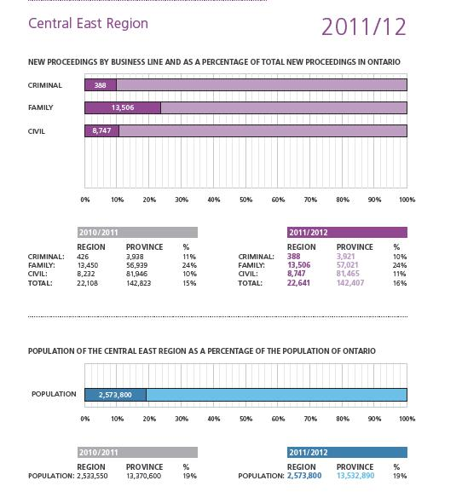

Central South Region
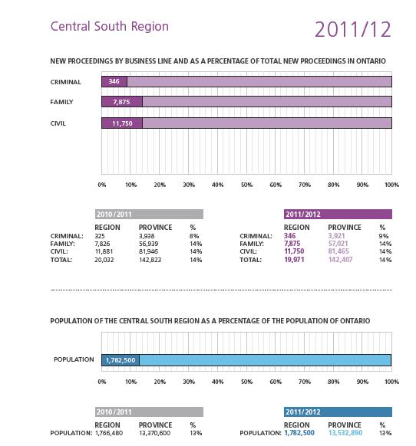

Central West Region
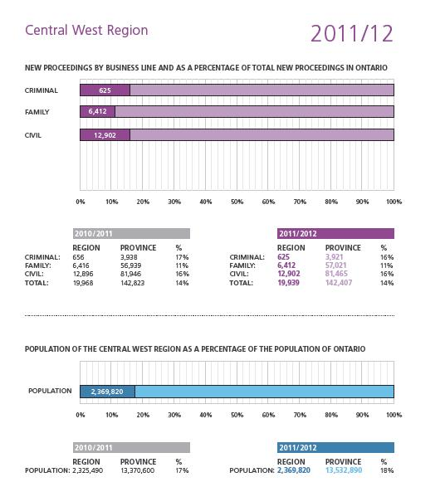

East Region
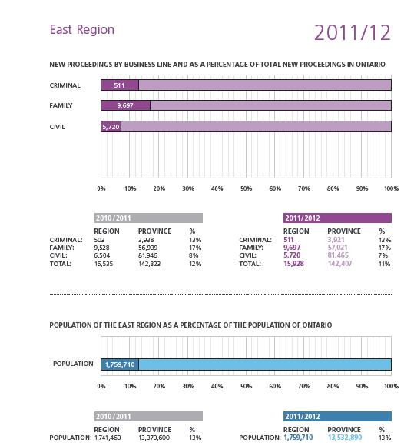

Northeast Region
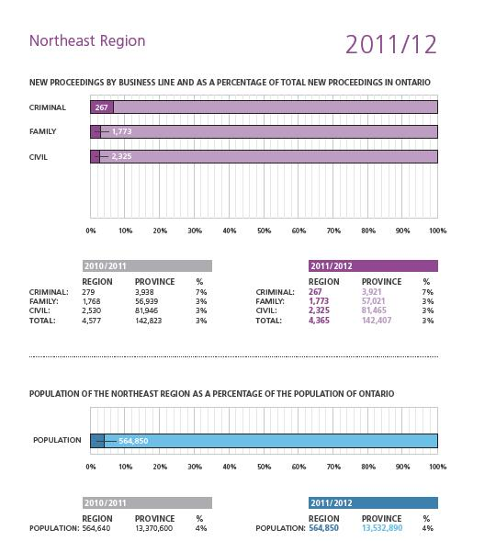

Northwest Region
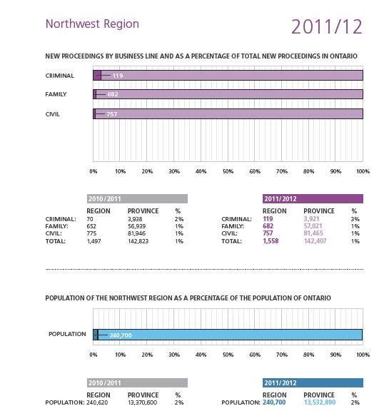

Southwest Region
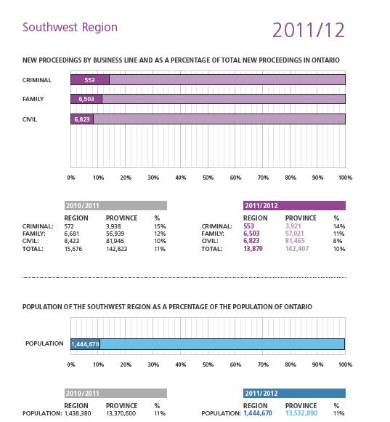

Toronto Region
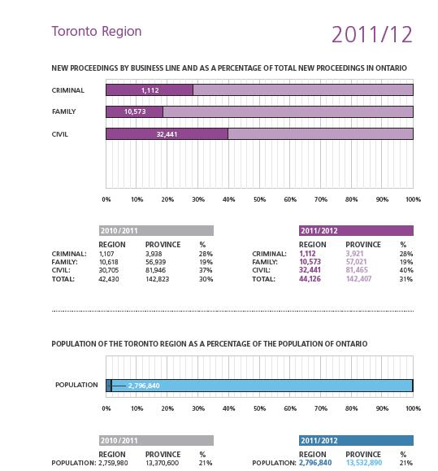

Comparison between New Civil Proceedings:

Superior Court and Small Claims Court Branch
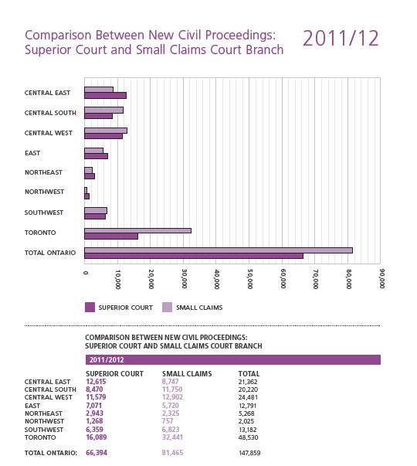

Retired Judges
April 1, 2010 – March 31, 2012

Central South Region

Hamilton
The Hon. Mr. Justice Nicholas Borkovich
1982 – 2010
The Hon. Mr. Justice William J. Festeryga
1996 – 2010
The Hon. Mr. Justice C. Raymond Harris
2001 – 2011

Central West Region

Brampton
The Hon. Mr. Justice Ronald G. Thomas
1985 – 2012

East Region

Ottawa
The Hon. Mr. Justice Bernard J. Manton
1997 – 2010
The Hon. Mr. Justice Robert C. Desmarais
1982 – 2011
The Hon. Mr. Justice Roydon J. Kealey
1996 – 2012
The Hon. Mr. Justice W.J. Lloyd Brennan
1995 – 2012

Northeast Region

Haileybury
The Hon. Mr. Justice Ian M. Gordon
1991 – 2011

Sault Ste. Marie
The Hon. Mr. Justice Frank R. Caputo
1995 – 2011

Southwest Region

London
The Hon. Mr. Justice B. Thomas Granger - 1988 – 2011
The Hon. Mr. Justice Jack Jenkins - 1986 – 2011

Windsor
The Hon. Mr. Justice Anthony E. Cusinato - 1983 – 2011

Toronto Region
The Hon. Mr. Justice Peter A. Grossi - 1993 – 2010
The Hon. Mr. Justice Don R. Cameron - 1995 – 2010
The Hon. Mr. Justice Maurice C. Cullity - 1997 – 2010
The Hon. Madam Justice Denise E. Bellamy - 1997 – 2010
The Hon. Mr. Justice Romain W.M. Pitt - 1994 – 2010
The Hon. Mr. Justice John F. Hamilton - 1991 – 2010
The Hon. Mr. Justice Lee K. Ferrier - 1991 – 2011

In Memoriam
April 1, 2010 – March 31, 2012
The Honourable Mr. Justice Randall S. Echlin
November 29, 1950 – August 12, 2011
Date of Appointment: April 11, 2003
Region / Centre: Toronto
The Honourable Mr. Justice T. David Little
August 15, 1940 – December 15, 2011
Date of Appointment: May 13, 2005
Region / Centre: Southwest / London
The Honourable Mr. Justice Gordon I. Thomson
October 5, 1939 – December 22, 2011
Date of Appointment: July 31, 1992
Region / Centre: Southwest / Windsor

Looking Forward
Thanks to the determined efforts of judges and judicial officers, aided by a very professional Court Services staff, over the past two years, the Superior Court of Justice has navigated through a difficult economic period and has still managed to make great strides in improving an already respected and admired justice system. In the year ahead, the Court will chart a course that ensures continued innovation and modernization to enhance the administration of justice in Ontario.
The Court looks forward to continued collaboration with the Ministry of the Attorney General to incorporate new technology into the justice system, thereby enhancing both public access to the Court and the efficiency of court processes. The Court will also continue to support and encourage judges’ use of new technology, a step that becomes increasingly important as the Ministry develops technological infrastructure for electronic filing. Also, in the coming year, the Court expects to issue a consistent and principled approach to the media’s use of electronic devices and social media in the courtroom.
Within the Court’s own areas of jurisdiction, the Superior Court will continue on its path to improving access to timely and affordable justice. In the area of criminal law, the Court continues to refine the Criminal Proceedings Rules. In civil law, the Court continues to monitor the impact of reforms from the Civil Justice Reform Project. In the area of family law, the coming year promises to be just as busy as the last.
With the expansion of front-end family justice services completed, the Court’s focus in family law now shifts to child protection proceedings. Children at risk are a top priority of the Court. Nowhere is this more important than in child protection proceedings. Moving forward, our first priority is to encourage practices that ensure that the statutory and regulatory timelines are met in child protection cases.
All of the initiatives highlighted in this Report, both completed or in progress, and the tremendous efforts invested in them over the last two years, have shared a common goal: to enhance access to effective, efficient, affordable, and timely justice for the people of Ontario.
In the coming year, the Court remains steadfast in this goal and looks forward to achieving even greater success in meeting the needs of Ontarians.

Endnotes and Photo Descriptors
1 The Civil Justice Reform Project Report was completed by the Honourable Coulter A.A. Osborne, Q.C. and released in November 2007. The report is accessible online: http://www.attorneygeneral.jus.gov.on.ca/english/about/pubs/cjrp/CJRP-Report_EN.pdf.
2 See pages 15-17 of the 2007-2008 Annual Report of the Superior Court of Justice, accessible online: http://www.ontariocourts.ca/scj/en/reports/annualreport/07-08.pdf.
3 Sections 14(7) and 52(2.2) of the Courts of Justice Act.
4 Memorandum of Understanding between the Chief Justice of the Superior Court of Justice of Ontario and the Attorney General of Ontario, May 5, 2008: http://www.ontariocourts.ca/scj/en/about/framework/memorandum_of_understanding.htm.
5 Chief Justice Beverley McLachlin, “The Relationship Between the Courts and the Media” (January 31, 2012) in remarks provided to students at Carleton University, accessible through the Supreme Court website: http://www.scc-csc.gc.ca/court-cour/ju/spe-dis/bm2012-01-31-fra.asp.
6 The Blueprint for Security of Judicial Information is accessible on the Canadian Judicial Council website through the following address: http://www.cjc-ccm.gc.ca.
7 Peter W. Hogg, The Role of a Chief Justice in Canada, 1993, 19 Queen’s L.J. 249.
Printed in Canada 2012 by General Printers.
Graphic Design by Timothy Belanger.
Inside Cover: Pillars of Justice, Sculpture by Edwina Sandys, 2007, McMurtry Gardens of Justice, Toronto. Photography by Shai Gil.
Table of Contents: Equal Before the Law, Sculpture by Eldon Garnet, 2012, McMurtry Gardens of Justice, Toronto. Photography by Shai Gil.
Page 34: Durham Courthouse. Photography by Shai Gil.
Page 42: Pembroke Courthouse. Photography by Steven Evans.
Page 50: Top: Quinte Courthouse. Rendering provided by WZMH Architects.
Page 50: Bottom: Waterloo Courthouse. Rendering provided by NORR Architects.
Page 68: Top: Durham Courthouse. Photography by Shai Gil.
Page 68: Bottom: Sault Ste. Marie Courthouse. Photo provided by Court Services Photo Library.
Page 78: Top: Thunder Bay Courthouse. Rendering provided by Adamson Associates Architects.
Page 78: Bottom: New St. Thomas (Elgin County) Courthouse. Rendering provided by NORR Architects.
Page 83: Top: A. Grenville & William Davis Court House. Photography by Shai Gil.
Page 83: Bottom: Durham Courthouse. Photography by Shai Gil.

