
JUDICIAL APPOINTMENTS ADVISORY COMMITTEE
ANNUAL REPORT
for the Period from
1 January 2009 to 31 December 2009
Toronto, Ontario
January, 2010
ISSN 1198-7111 (Bilingual Print)
ISSN 1923-8959 (English Internet)
ISSN 1923-8967 (French Internet)
JUDICIAL APPOINTMENTS ADVISORY COMMITTEE
ANNUAL REPORT
for the Period from
1 January 2009 to 31 December 2009
Toronto, Ontario
January, 2010

CONTACTING THE JUDICIAL APPOINTMENTS ADVISORY COMMITTEE
Persons wishing to comment on the procedures or selection criteria of the Judicial Appointments Advisory Committee are invited to visit the website at www.ontariocourts.on.ca/jaac/en/ or write to:
The Chair
Judicial Appointments Advisory Committee
3rd Floor
720 Bay Street
Toronto, Ontario
M7A 2S9
Telephone: (416) 326-4060
Fax: (416) 212-7316
PREVIOUS PUBLICATIONS OF THE JUDICIAL APPOINTMENTS ADVISORY COMMITTEE:
- Interim Report (September, 1990);
- Final Report and Recommendations (June, 1992);
- Annual Report for the Period from 1 July 1992 to 31 December 1993 (January, 1994);
- Annual Report for the Period from 1 January 1994 to 28 February 1995 and for the Period from 1 March 1995 to 31 December 1995 (January, 1996);
- Annual Report for the Period from 1 January 1996 to 31 December 1996 (January, 1997);
- Annual Report for the Period from 1 January 1997 to 31 December 1997 (January, 1998);
- Annual Report for the Period from 1 January 1998 to 31 December 1998 (January, 1999);
- Annual Report for the Period from 1 January 1999 to 31 December 1999 (January, 2000);
- Annual Report for the Period from 1 January 2000 to 31 December 2000 (February, 2001);
- Annual Report for the Period from 1 January 2001 to 31 December 2001 (January, 2002);
- Annual Report for the Period from 1 January 2002 to 31 December 2002 (February 2003);
- Annual Report for the Period from 1 January 2003 to 31 December 2003 (February 2004);
- Annual Report for the Period from 1 January 2004 to 31 December 2004 (January 2005);
- Annual Report for the Period from 1 January 2005 to 31 December 2005 (January 2006);
- Annual Report for the Period from 1 January 2006 to 31 December 2006 (January 2007);
- Annual Report for the Period from 1 January 2007 to 31 December 2007 (January 2008);
- Annual Report for the Period from 1 January 2008 to 31 December 2008 (January 2009).

TABLE OF CONTENTS
LETTER OF TRANSMITTAL v
EXECUTIVE SUMMARY vii
INTRODUCTION ix
PART I 1
ANALYSIS OF JUDICIAL APPOINTMENTS MADE 1
1.0 Judges Appointed: 1 January 2009 - 31 December 2009 1
2.0 Overview of Appointments: 1 January 1989 - 31 December 2009 1
PART II 7
LEGISLATION 7
1.0 The Courts of Justice Statute Law Amendment Act 7
PART III 9
CONFIDENTIALITY 9
1.0 Introduction 9
2.0 Information on Process and Procedures 9
3.0 Information on Persons who are applying for Appointment 9
4.0 Seeking Information 10
5.0 What is to be done 10
PART IV 11
CRITERIA FOR APPOINTMENT 11
1.0 Criteria for Evaluating Candidates 11
PART V 13
JUDICIAL APPOINTMENT PROCESS AND POLICIES 13
1.0 Overview of Process 13
2.0 The Judicial Candidate Information Form 15
3.0 References 16
4.0 Law Society and Other Outstanding Complaints and Claims 16
5.0 Criminal Record 17
6.0 Conflict of Interest Guidelines 18
TABLE OF CONTENTS (Continued)
PART V (Continued)
JUDICIAL APPOINTMENT PROCESS AND POLICIES
7.0 Re-Interviewing Candidates 18
8.0 Notice of Vacancies and Transfer after Appointment 18
9.0 Changes in Committee Membership 19
10.0 Support Staff 20
11.0 Communications, Education and Marketing 20
PART VI 23
LOOKING TO THE FUTURE 23
1.0 Recommendations of Candidates 23
2.0 Outreach 23
3.0 A Representative Committee 25
CONCLUSION 27
JUDICIAL APPOINTMENTS ADVISORY COMMITTEE BIOGRAPHIES 29
APPENDICES
Appendix I – Pamphlet – “Where Do Judges Come From?” 37
Appendix II – Judicial Appointments Made – January 2009 to December 2009 39
Appendix III – Judicial Appointments Made – January 1989 to December 2009……………….41
LETTER OF TRANSMITTAL
January 31, 2010
The Honourable Chris Bentley
Attorney General for Ontario
720 Bay Street, 11th Floor
Toronto, Ontario
M5G 2K1
Dear Mr. Attorney:
The Judicial Appointments Advisory Committee has the honour of presenting to you this report on its activities for the period from 1 January 2009 to 31 December 2009, pursuant to section 43 of the Courts of Justice Act. It covers all significant matters related to the recommendation to the Attorney General of suitable candidates for judicial appointment to the Ontario Court of Justice.
Respectfully yours,
Original signed by Hanny A. Hassan
Hanny A. Hassan
Chair

EXECUTIVE SUMMARY
1 January 2009 to 31 December 2009
The Judicial Appointments Advisory Committee was set up as a pilot project by the then Attorney General, the late Honourable Ian Scott, in January 1989. Since then, 297 judges have been appointed based on Committee recommendations. Of these, 19 appointments were made between 1 January 2009 and 31 December 2009.
The highlights of Committee activities are as follows:
Appointments: Each of the 19 appointments has been made from among candidates recommended by the Committee in accordance with the first criterion, being that of professional excellence, and then on the other criteria set out in this Report. In addition to the 19 appointments, the Committee has submitted its recommendation to the Attorney General on one vacancy before the end of 2009.
Legislation: Amendments to the Courts of Justice Act that came into force on 28 February 1995 established the Judicial Appointments Advisory Committee and clothed it with legislative authority. These amendments set out in detail the composition, procedures, criteria for selection, and independent function of the Committee.
Confidentiality: The Committee continues to request the Government to pass legislation exempting its confidential information so that it shall be protected by the exemption of the Freedom of Information and Protection of Privacy Act.
Procedures and Policies: The Committee continually reviews its procedures and policies which are set forth in detail in this Report.
Candidates will generally not be considered for an interview if they have any outstanding complaints registered with a Law Society. The candidate is responsible for ensuring the removal of such complaints; however, if the Committee receives sufficient information as to the complaint being frivolous or lacking in foundation, then such a complaint will not be a bar to the candidate being considered and interviewed, but the candidate will not be recommended until it has been removed.
Candidates will generally not be considered for an interview if they have any outstanding Errors and Omissions claims registered with the Lawyers’ Professional Indemnity Company. The candidate is responsible for ensuring the removal of such claims; however, if the Committee receives sufficient information that the claim is not substantiated, then such a claim will not be a bar to the candidate being considered and interviewed, but the candidate will not be recommended until it has been removed.
The Committee would be prepared to consider the application of a candidate who is involved in any other civil claim or proceeding if, after receiving details of the proceeding, the members are of the opinion that the nature of the claim is such that it should not prevent the candidate from being considered for a judicial appointment.
The Committee must be informed of any outstanding civil judgments, arrears in family support payments, any past or present proposals to creditors or assignments in bankruptcy, and any sanctioning by The Law Society of Upper Canada or any other Law Society.
The Committee will not consider a candidate who has a criminal record.

INTRODUCTION
On 15 December 1988, the then Attorney General, the late Honourable Ian Scott, announced in the Ontario Legislature the establishment of the Judicial Appointments Advisory Committee as a pilot project, and set out its mandate:
First, to develop and recommend comprehensive, sound and useful criteria for selection of appointments to the judiciary, ensuring that the best candidates are considered; and second, to interview applicants selected by it or referred to it by the Attorney General and make recommendations.
On February 28, 1995, the Courts of Justice Act established the Committee by legislation. All appointments to the Ontario Court of Justice must be made by the Attorney General from amongst a list of applicants recommended to him by the Committee, and chosen in accordance with its own process of criteria, policies and procedures. The Committee’s criteria, policies and procedures are described, in detail, on the following pages.
The total number of applicants from the inception of the Committee to December 31, 2009 is 2,957, of whom 941 (32%) are women.
In 2009, the Committee met 22 times to select candidates, conduct interviews and attend to Committee business. 103 applicants were interviewed during the period and 61 have been recommended, from which the Attorney General has selected and appointed 19 judges.

PART I

ANALYSIS OF JUDICIAL APPOINTMENTS MADE

1.0 Judges Appointed: 1 January 2009 - 31 December 2009
During this period, there have been 19 judges appointed as a result of recommendations made by the Committee. Added to the 278 appointments previously made, this number makes a total of 297 judges appointed since the Committee began its work in 1989. However, with various transfers, etc., the current number of judges presiding in the Ontario Court of Justice as a result of the Committee’s recommendations is 268. The complement of the Ontario Court of Justice is 284 judges. Over 94% of all the present judges have been selected through the Committee process.
Of the 19 new appointments this calendar year, two were francophone, one was bilingual; seven were female; two were from the visible minority communities; 11 came from private practice, one from government, one was a federal prosecutor and six were formerly Crown counsel. A list of these judges will be found in Appendix II.
The ages of appointees range from 39 to 61 years, and the average age is 49 years.

2.0 Overview of Appointments: 1 January 1989 - 31 December 2009
The reader will find a list of all judges appointed under the Committee process in Appendix III; the Appendix lists the names in alphabetical order together with location and date of appointment.
The demographics of these appointments are set out in the following tables which show the timing of the various appointments, the legal background of the appointees, and the numbers selected for appointment from under-represented groups.

Timing of the Appointments
Reporting Period | 1 Jan 89 –  31 Oct 90 | 1 Nov 90 –  30 June 92 | 1 July 92 –  31 Dec 93 | 1 Jan 94 –  28 Feb 95 | 1 Mar 95 –  31 Dec 95 | 1 Jan 96 –  31 Dec 96 | 1 Jan 97 –  31 Dec 97
Total  Appointments | 28 | 39 | 23 | 15 | 5 | 7 | 16
Legal Background
 | 1 Jan 89 –  31 Oct 90 | 1 Nov 90 –  30 June 92 | 1 July 92 –  31 Dec 93 | 1 Jan 94 –  28 Feb 95 | 1 Mar 95 –  31 Dec 95 | 1 Jan 96 –  31 Dec 96 | 1 Jan 97 –  31 Dec 97
Private Practice | 16 | 32 | 14 | 9 | 4 | 3 | 13
Provincial Crown | 5 | 3 | 5 | 6 | 0 | 4 | 3
Federal Prosecutor | 3 | 1 | 2 | 0 | 0 | 0 | 0
Government | 4 | 3 | 2 | 0 | 1 | 0 | 0
Appointments from Representative Groups
 | 1 Jan 89 –  31 Oct 90 | 1 Nov 90 –  30 June 92 | 1 July 92 –  31 Dec 93 | 1 Jan 94 –  28 Feb 95 | 1 Mar 95 –  31 Dec 95 | 1 Jan 96 –  31 Dec 96 | 1 Jan 97 –  31 Dec 97
Women | 9 | 18 | 12 | 3 | 1 | 1 | 5
Francophone | 2 | 2 | 1 | 2 | 1 | 0 | 0
First Nations | 0 | 2 | 0 | 1 | 0 | 1 | 0
Visible Minority | 2 | 4 | 4 | 0 | 0 | 0 | 0
Persons with Disabilities | 0 | 0 | 0 | 0 | 0 | 0 | 0

Timing of the Appointments
Reporting  Period | 1 Jan 98 –  31 Dec 98 | 1 Jan 99 –  31 Dec 99 | 1 Jan 00 –  31 Dec 00 | 1 Jan 01 –  31 Dec 01 | 1 Jan 02 –  31 Dec 02 | 1 Jan 03 –  31 Dec 03 | 1 Jan 04 –  31 Dec 04
Total  Appointments | 14 | 18 | 13 | 4 | 13 | 14 | 15
Legal Background
 | 1 Jan 98 –  31 Dec 98 | 1 Jan 99 –  31 Dec 99 | 1 Jan 00 –  31 Dec 00 | 1 Jan 01 –  31 Dec 01 | 1 Jan 02 –  31 Dec 02 | 1 Jan 03 –  31 Dec 03 | 1 Jan 04 –  31 Dec 04
Private Practice | 10 | 11 | 11 | 3 | 12 | 8 | 9
Provincial Crown | 3 | 5 | 2 | 1 | 1 | 3 | 4
Federal Prosecutor | 0 | 0 | 0 | 0 | 0 | 2 | 1
Government | 1 | 2 | 0 | 0 | 0 | 1 | 1
Appointments from Representative Groups
 | 1 Jan 98 –  31 Dec 98 | 1 Jan 99 –  31 Dec 99 | 1 Jan 00 –  31 Dec 00 | 1 Jan 01 –  31 Dec 01 | 1 Jan 02 –  31 Dec 02 | 1 Jan 03 –  31 Dec 03 | 1 Jan 04 –  31 Dec 04
Women | 4 | 5 | 2 | 1 | 4 | 6 | 4
Francophone | 0 | 3 | 2 | 0 | 0 | 2 | 0
First Nations | 0 | 0 | 0 | 0 | 0 | 0 | 0
Visible Minority | 1 | 0 | 2 | 0 | 1 | 0 | 1
Persons with Disabilities | 0 | 0 | 0 | 0 | 0 | 0 | 0

Timing of the Appointments
Reporting  Period | 1 Jan 05 –  31 Dec 05 | 1 Jan 06 -  31 Dec 06 | 1 Jan 07 -  31 Dec 07 | 1 Jan 08 -  31 Dec 08 | 1 Jan 09 -  31 Dec 09 | Overall Total of Appointments
Total  Appointments | 16 | 20 | 6 | 12 | 19 | 297
Legal Background
 | 1 Jan 05–  31 Dec 05 | 1 Jan 06 -  31 Dec 06 | 1 Jan 07 -  31 Dec 07 | 1 Jan 08 -  31 Dec 08 | 1 Jan 09 -  31 Dec 09 | Total  No. | Percent  (N=297)
Private Practice | 10 | 14 | 3 | 10 | 11 | 203 | 68.4%
Provincial Crown | 4 | 2 | 3 | 1 | 6 | 61 | 20.5%
Federal Prosecutor | 0 | 0 | 0 | 1 | 1 | 11 | 3.7%
Government | 2 | 4 | 0 | 0 | 1 | 22 | 7.4%
Appointments from Representative Groups
 | 1 Jan 05 –  31 Dec 05 | 1 Jan 06 -  31 Dec 06 | 1 Jan 07 -  31 Dec 07 | 1 Jan 08 -  31 Dec 08 | 1 Jan 09 -  31 Dec 09 | Total  No. | Percent  (N=297)
Women | 6 | 7 | 5 | 6 | 7 | 106 | 35.7%
Francophone | 1 | 1 | 0 | 0 | 2 | 19 | 6.4%
First Nations | 1 | 0 | 0 | 0 | 0 | 5 | 1.7%
Visible Minority | 1 | 2 | 0 | 1 | 2 | 21 | 7.1%
Persons with Disabilities | 0 | 0 | 0 | 0 | 0 | 0 | 0%
The Committee continues to encourage applications from members of under-represented groups. Each advertisement for a judicial vacancy states that:
The Judiciary of the Ontario Court of Justice should reasonably reflect the diversity of the population it serves. Applications from members of equality-seeking groups are encouraged.
The advertisement appears in the Ontario Reports and The Lawyers Weekly, both publications have a wide circulation amongst lawyers in the Province. It is also posted on the Ontario Courts website at www.ontariocourts.on.ca/jaac/en/ and on the Bar-eX Communications Inc. website at www.bar-ex.com.
In addition, advance notice of a judicial vacancy is provided to approximately 214 legal and non-legal associations, such as: the Ontario Bar Association, the Advocacy Research Centre for Persons with Disabilities (formerly ARCH), the Aboriginal Legal Services of Toronto, the Canadian Association of Black Lawyers and the Metro Toronto Chinese & Southeast Asian Legal Clinic, with a request that the material be brought to the attention of their members. This notice of judicial vacancy is also emailed to The Advocates’ Society, the National Association of Women and the Law, the Ontario Bar Association, the Ontario Crown Attorneys Association, the Ontario Trial Lawyers Association, the Women’s Law Association of Ontario, the Canadian Muslim Lawyers Association, Indigenous Bar Association, L’Association des juristes d’expression française, Criminal Lawyers’ Association as well as the legal clinics and law associations throughout Ontario. Committee members are prepared to and do attend association meetings of groups, legal or non-legal, to discuss the appointment process and answer questions concerning Committee procedures and criteria. Our desire is to make sure that the profession and public are fully informed about the process of judicial appointment.

PART II

LEGISLATION

1.0 The Courts of Justice Statute Law Amendment Act
The amendments to the Courts of Justice Act were given Royal Assent in June 1994 and proclaimed on 28 February 1995. Section 43 deals with the Judicial Appointments Advisory Committee and it is included here in full, for ease of reference:
“Judicial Appointments Advisory Committee
43. (1) A committee known as the Judicial Appointments Advisory Committee in English and as Comité consultatif sur les nominations à la magistrature in French is established.
Composition
(2) The Committee is composed of,
(a) two provincial judges, appointed by the Chief Judge of the Provincial Division;
(b) three lawyers, one appointed by The Law Society of Upper Canada, one by the Canadian Bar Association-Ontario and one by the County and District Law Presidents' Association;
(c) seven persons who are neither judges nor lawyers, appointed by the Attorney General;
(d) a member of the Judicial Council, appointed by it.
Criteria
(3) In the appointment of members under clauses (2) (b) and (c), the importance of reflecting, in the composition of the Committee as a whole, Ontario's linguistic duality and the diversity of its population and ensuring overall gender balance shall be recognized.
Terms of Office
(4) The members hold office for three-year terms and may be reappointed.
Staggered terms
(5) Despite subsection (4), the following applies to the first appointments made under subsection (2):
1. One of the provincial judges holds office for a two-year term.
2. The lawyer appointed by the Canadian Bar Association-Ontario holds office for a two-year term and the lawyer appointed by the County and District Law Presidents' Association holds office for a one-year term.
3. Two of the persons who are neither judges nor lawyers hold office for two-year terms and two hold office for one-year terms.
Chair
(6) The Attorney General shall designate one of the members to chair the Committee for a three-year term.
Term of Office
(7) The same person may serve as chair for two or more terms.
Function
(8) The function of the Committee is to make recommendations to the Attorney General for the appointment of provincial judges.
Manner of Operating
(9) The Committee shall perform its function in the following manner:
1. When a judicial vacancy occurs and the Attorney General asks the Committee to make a recommendation, it shall advertise the vacancy and review all applications.
2. For every judicial vacancy with respect to which a recommendation is requested, the Committee shall give the Attorney General a ranked list of at least two candidates whom it recommends, with brief supporting reasons.
3. The Committee shall conduct the advertising and review process in accordance with criteria established by the Committee, including assessment of the professional excellence, community awareness and personal characteristics of candidates and recognition of the desirability of reflecting the diversity of Ontario society in judicial appointments.
4. The Committee may make recommendations from among candidates interviewed within the preceding year, if there is not enough time for a fresh advertising and review process.
Qualification
(10) A candidate shall not be considered by the Committee unless he or she has been a member of the bar of one of the provinces or territories of Canada for at least ten years or, for an aggregate of at least ten years, has been a member of such a bar or served as a judge anywhere in Canada after being a member of such a bar.
Recommendation by Attorney General
(11) The Attorney General shall recommend to the Lieutenant Governor in Council for appointment to fill a judicial vacancy only a candidate who has been recommended for that vacancy by the Committee under this section.
Rejection of List
(12) The Attorney General may reject the Committee's recommendations and require it to provide a fresh list.
Annual Report
(13) The Committee shall submit to the Attorney General an annual report of its activities.
Tabling
(14) The Attorney General shall submit the annual report to the Lieutenant Governor in Council and shall then table the report in the Assembly.”

PART III

CONFIDENTIALITY

1.0 Introduction
The Judicial Appointments Advisory Committee has developed two fundamental principles on the issue of confidentiality of committee information. These are:
- information about committee process is completely open to any person whomsoever,
- information about particular candidates is completely confidential unless released by candidates themselves.

2.0 Information on Process and Procedures
The Courts of Justice Act, by virtue of the amendments made in 1995, sets out very clearly that the Committee is to have 13 members of which the majority shall be lay persons, i.e., neither judges nor lawyers. The appointing bodies are required to recognize that the Committee should reflect the diversity of Ontario’s population and maintain linguistic duality, minority and gender balances.
The criteria for, and the manner of, selection of candidates are outlined in this Report.
Committee members individually speak to organizations and at legal conferences to publicize the process of appointments and believe that the process should be completely open and transparent.

3.0 Information on Persons who are applying for Appointment
By contrast to the preceding section, the Committee goes to great lengths to protect the privacy of the applicant. These measures include:
- keeping most sensitive information securely stored in the private homes of members, or with the Secretary;
- keeping applicants apart on interview days;
- destroying or shredding applications and notes as soon as possible after appointment of a candidate and after a candidate’s application has lapsed;
- advising references that their names will not be associated with their confidential comments;
- advising lawyers, judges, court officials and community contacts approached for discreet inquiries that their names will not be associated with their confidential comments;
- maintaining strict non-access to our files, including government personnel not associated with the Committee;
- holding all meetings and interviews in non-government locations.

4.0 Seeking Information
The Committee has had one major application from a citizen seeking information about a successful candidate. This application commenced in 1993 and formally concluded in 1997 at which time the Ontario Court of Appeal, overruling the Divisional Court, held that private notes of the Committee members were not available to the public under the Freedom of Information and Protection of Privacy Act (FIPPA). Details of this litigation are to be found in our Annual Reports of 1996 and 1997.

5.0 What is to be done
The Committee has requested and continues to request the Government to amend the Freedom of Information and Protection of Privacy Act. The Committee wants to exempt the confidential candidate information from the operation of that Act. There is a precedent for this to be found in S.O. 1994 c.12 under which all records of the Ontario Judicial Council are only to be disclosed if that Council approves such disclosure.

PART IV

CRITERIA FOR APPOINTMENT
It is important that eligible members of the Bar and the public be aware of the criteria used by the Committee in the selection of candidates for recommendation, and for convenience, those criteria are reiterated again in this Annual Report.
The current Summary Statement of the criteria is as follows:

1.0 Criteria for Evaluating Candidates

Professional Excellence
- A high level of professional achievement in the area(s) of legal work in which the candidate has been engaged. Experience in the field of law relevant to the jurisdiction of the Ontario Court of Justice on which the applicant wishes to serve is highly desirable but not essential.
- Involvement in professional activities that keeps one up to date with changes in the law and in the administration of justice.
- A demonstrated commitment to continuing legal education.
- An interest in or some aptitude for the administrative aspects of a judge's role.
- Good writing and communications skills.

Community Awareness
- A commitment to public service.
- Awareness of and an interest in knowing about the social problems that give rise to cases coming before the courts.
- Sensitivity to changes in social values relating to criminal and family matters.
- Interest in methods of dispute resolution alternatives to formal adjudication and interest in community resources available for participating in the disposition of cases.

Personal Characteristics
- An ability to listen.
- Respect for the essential dignity of all persons regardless of their circumstances.
- Politeness and consideration for others.
- Moral courage and high ethics.
- An ability to make decisions on a timely basis.
- Patience.
- Punctuality and good regular work habits.
- A reputation for integrity and fairness.
- Compassion and empathy.
- An absence of pomposity and authoritarian tendencies.

Demographics
- The Judiciary of the Ontario Court of Justice should be reasonably representative of the population it serves. The Committee is sensitive to the issue of under-representation in the judicial complement of women, visible, cultural, and racial minorities and persons with a disability. This requires overcoming. However, professional excellence is still the paramount criterion in assessing judicial candidates.

PART V

JUDICIAL APPOINTMENT PROCESS AND POLICIES
Set out below is a step-by-step account of how the Committee arrives at its recommendations:

1.0 Overview of Process

1. Advertising the Vacancy
All vacancies are advertised in the Ontario Reports and The Lawyers Weekly. Three weeks are allowed for applications to be received. In addition to advertising, the Committee contacts approximately 214 legal and non-legal associations with advance notice of the vacancy with a request that they bring the copy of the advertisement to the attention of their members. The advertisements are also posted on the Ontario Courts website at www.ontariocourts.on.ca/jaac/en/ as well as on the Bar-eX Communications Inc. website at www.bar-ex.com.

2. Review of Applications by Members
Each member is provided with a list of all candidates who respond to an advertisement plus copies of all new and updated Judicial Candidate Information Forms. Members carefully review and assess the application forms and list candidates whom they feel should proceed to the second stage of reference checks and confidential inquiries. This list is submitted to the committee secretary who compiles a master list of candidates who have been selected by four or more members for the purpose of making reference checks and confidential inquiries. If any member of the Committee ascertains that a possible suitable applicant for a judicial appointment has not been selected for reference checks and confidential inquiries, the member may request that the applicant’s name be added to the list.

3. References and Confidential Inquiries
Each member is provided with a list of candidates who have been selected by four or more Committee members for the purposes of reference checks and confidential inquiries. These inquiries are made of the judiciary, court officials, lawyers, law associations, community and social service organizations, plus the named references provided by the candidate. Once the reference checks and confidential inquiries are completed, the Committee meets to discuss the information obtained and to select candidates to be interviewed.
This selection meeting usually takes place three to four weeks after the members have received the list of candidates to be considered. Interviews normally take place approximately two weeks after the selection meeting.

4. Interviews
The number of candidates to be interviewed for a judicial vacancy will normally be a maximum of 16 over a two-day period. Each interview will last approximately 30 minutes. The entire Committee sits for each interview but for questioning purposes, the Committee members take alternate interview turns. Following each interview, the Committee discusses the merits of the candidate interviewed. After the last interview for that particular vacancy, the Committee discusses the merits of the candidates interviewed, plus the merits of the candidates interviewed on a prior occasion within the year and who have applied to be considered for the current vacancy.

5. Recommendations to the Attorney General
The list of recommended candidates is provided to the Attorney General only after the clearances requested from the Law Society, LawPRO and CPIC checks have been received. These clearances are usually received approximately three weeks after the interviews have taken place.
A short ranked list, together with only the application form submitted by each ranked candidate, is then delivered to the Attorney General.
It is at this point that the Committee’s work is complete. A candidate is not notified whether or not his or her name has been put forward in the short ranked list to the Attorney General as this recommendation is personal and confidential for the Attorney General.

6. Unexpected Vacancies
It should also be noted that the Committee has established a procedure to avoid delays in filling vacancies that occur unexpectedly, such as from sudden resignation, illness or death. In such cases, when so requested by the Attorney General, it may recommend, without advertising the vacancy, candidates who have previously applied for the area of the judicial vacancy and who have been interviewed. This procedure will only apply to areas where there has been an advertised competition within a twelve-month period. However, the policy of advertising is the procedure of preference and will only be departed from in limited circumstances.

7. Interviewing for More Than One Position
Occasionally, after a vacancy has been advertised and the selection process is in progress, a second vacancy occurs in the same location, with the same specialty of law. In these circumstances, in the interest of time, the Committee may forego advertising the second vacancy. The members will evaluate the candidates who have responded to the advertised position and decide which of those candidates will be selected for consideration and interview for both vacancies.

2.0 The Judicial Candidate Information Form
1. All candidates must complete a typed Judicial Candidate Information Form (revised) which has been designed to elicit information that is not usually included in a standard curriculum vitae, such as the nature of the legal work and experience gained in various positions the candidates have held, including pre-law experience. Also, applicants are required to express their reasons for wanting to become a judge and provide an appraisal of their own qualifications for being a judge.
Candidates who send in their standard curriculum vitae and do not complete the Committee’s form are not considered.
2. Candidates are required to provide 14 copies of the Judicial Candidate Information Form together with a copy each of the signed Security Release Form, Release of Information Form and Authorization and Release Form in the first instance, and for subsequent applications, 14 copies of a letter requesting consideration. Should a candidate wish to change any information in his or her application, he or she must send in 14 copies of a fully revised Judicial Candidate Information Form.
3. A candidate must apply by application or letter for each and every advertised vacancy that is of interest. The Committee does not automatically consider applications on file. It is preferred that a candidate submit a new application after one year to reflect any changes in the application.
4. A Judicial Candidate Information Form is kept on file for one year. At the end of one year, a candidate is advised that his or her form is out of date and in order to maintain a current application, 14 copies of a new revised form should be submitted.
5. All responses to an advertisement to be considered for a judicial vacancy are acknowledged. However, the Committee does not advise candidates that they have not been selected for an interview. Instead, the acknowledgement letter states: “If you are selected for an interview, you will be contacted by telephone during the week of .....” .
6. Candidates who have been interviewed within the previous twelve-month period may not necessarily be re-interviewed but will be equally considered, based on the previous interview, by the Committee in determining its list of recommendations, provided that he or she has applied to be considered for the vacancy advertised.
7. Candidates who are interviewed and/or candidates who have been interviewed on a previous occasion and who have requested to be considered for a particular advertised vacancy are not advised as to whether they have been included in the list submitted to the Attorney General. Also, the Committee does not advise applicants when its work has been completed for a particular judicial vacancy and a list of recommended candidates has been submitted to the Attorney General.

3.0 References
1. The Committee requests that a candidate does not send or have submitted letters of support.
2. The Committee requires a candidate to provide the names, complete residential/office and e-mail addresses, including postal codes, home telephone and business telephone numbers of his or her named references. Care should be taken to provide the correct information before submitting the form. Since the members who check the references frequently do so during evenings and weekends, it is essential that home telephone numbers be provided.
3. All named references receive a letter from the Committee advising them that a candidate has provided their names for reference purposes and that they may be contacted by a member of the Committee. They are advised that they do not have to write to the Committee. Attached to the letter is a list of current Committee members.
4. The Committee maintains strict confidentiality with respect to the information provided by named references and obtained by confidential inquiries.

4.0 Law Society and Other Outstanding Complaints and Claims
1. Membership: To qualify for consideration, candidates must have been a member of the Bar of one of the provinces or territories of Canada for at least 10 years, or, for an aggregate of at least 10 years, been a member of such Bar or served as a judge anywhere in Canada, after being a member of such a Bar, and currently be a member in good standing.
2. Complaints as to Practice: Candidates will generally not be considered for an interview if they have any outstanding complaints registered with a Law Society. The candidate is responsible for ensuring the removal of such complaints; however, if the Committee receives sufficient information as to the complaint being frivolous or lacking in foundation, then such a complaint will not be a bar to the candidate being considered and interviewed, but the candidate will not be recommended until it has been removed.
3. If the candidate has been sanctioned by The Law Society of Upper Canada or any other Law Society, the Committee wants to know the circumstances. The Committee will then decide whether the candidate should still be considered for a judicial appointment.
4. Errors and Omissions Claims: Candidates will generally not be considered for an interview if they have any outstanding Errors and Omissions claims registered with the Lawyers’ Professional Indemnity Company. The candidate is responsible for ensuring the removal or resolution of such claims; however, if the Committee receives sufficient information that the claim is not substantiated, then such a claim will not be a bar to the candidate being considered and interviewed, but the candidate will not be recommended until it has been removed.
5. Civil Claims or Judgments: Members of the Committee would be prepared to consider the application of a candidate who is involved in a civil claim or proceeding if, after receiving details of the proceeding, the members are of the opinion that the nature of the claim is such that it should not prevent the candidate from being considered for a judicial appointment.
6. Other Financial Matters: The Committee must be informed of any outstanding civil judgments, arrears in family support payments, any past or present proposals to creditors or assignments in bankruptcy, or serious financial difficulties of each candidate.
7. The Committee must also be informed by the candidate if he or she is the subject of any current court order.

5.0 Criminal Record
The Committee will not consider a candidate who has a criminal record. It is the responsibility of the candidate to obtain a pardon.

6.0 Conflict of Interest Guidelines
1. The Committee will not consider an application for judicial appointment from a member of the Legislative Assembly if he/she is a member of the political party of the current government. Former members of the Legislative Assembly of the same political party as the current government may apply two years after the date of resignation or retirement from office.
2. Members of the Committee cannot apply to be considered for a judicial appointment for a period of two years from the date they cease to serve as a member of the Committee.
3. No current member of the Committee can act as a reference for a candidate seeking a provincial judicial appointment.
4. Members of the Committee who have a conflict or a perceived conflict in the nature of a potential bias or prejudice in regard to a candidate must declare such conflict and refrain from taking part in the entire process for the vacancy for which the candidate has applied.

7.0 Re-Interviewing Candidates
The Committee does not maintain a pool of candidates who have previously been recommended but not appointed, or interviewed but not recommended.
The Committee does not consider it essential to re-interview a candidate who has been interviewed in the previous twelve months. That candidate will be compared objectively and ranked along with all other persons interviewed for that vacancy so long as the candidate has requested in writing to be considered for that advertised vacancy. Nevertheless, the Committee may, in its discretion, re-interview a previously interviewed candidate, and, in fact, does in circumstances where it deems it appropriate.

8.0 Notice of Vacancies and Transfer after Appointment
When a vacancy in the complement of the Ontario Court of Justice occurs, the Chief Justice of the Ontario Court of Justice, after considering the judicial resources required throughout Ontario, determines the location of the vacancy to be filled and advises the Attorney General accordingly. The Attorney General then requests the Committee to commence its process to identify candidates suitable for judicial appointment in order to make recommendations to him.
Because of the many requests for transfer, the Chief Justice has advised the Committee that while the Chief Justice retains the discretion to assign judges according to the needs of the Court at any time, it is the general policy of the Ontario Court of Justice that no personal request for permanent re-assignment will be considered for a period of at least five years following a judge’s appointment. The determination of a judicial vacancy involves a review and assessment of the needs of the Court and a long-term commitment to the community in which the vacancy is declared. It is a commitment that is made both by the Court and by the judge who is appointed to that position. Generally speaking, where a judge is appointed to sit at a base court location and the judge does not live within that community or near to it, the Court will expect the judge to move either to the community or to within a reasonable distance of it shortly after the judge’s appointment. The Court will, as set out in the Judge’s Manual in those circumstances, pay for the cost of transportation for the judge and the judge’s family, and for moving expenses. Once a judge has been on the bench for a period of five years, the judge may request a re-assignment to another base court location. If a vacancy subsequently arises, that request will be considered along with requests received from other judges who wish to move to the same location. Other factors will also be taken into account, including the needs of the locations involved, the views of the regional senior judges and of the judges at the affected locations.

9.0 Changes in Committee Membership
Mr. Douglas Grenkie retired in April 2009, after serving almost seventeen years on the Committee. The Committee is extremely grateful to Mr. Grenkie for his dedication, commitment and contribution to the administration of justice in Ontario.
Mr. Frank Walwyn was appointed by the Ontario Bar Association to succeed Mr. Grenkie.
Mr. F. Clifford Fraser, after serving the Committee for more than eight years, retired on July 30, 2009.
Madam Justice Lucy Glenn’s term of office expired during the year.
During their tenure on the Committee, Mr. Fraser and Justice Glenn showed a deep commitment to the judicial appointment process and worked diligently and contributed enormously to the work of the Committee.
Madam Justice Eileen Martin was appointed by the Ontario Judicial Council to replace Justice Glenn.

10.0 Support Staff
Priscilla Chu has been the Committee Secretary since December 6, 1999. Her work and dedication has proved invaluable in maintaining a high level of proficiency in all areas of the Committee’s work. Ms. Chu anticipates the needs of the Committee and, like the Committee members, works arduously. Her contribution to the Committee cannot be over emphasized. Her knowledge of all aspects of the process and smooth co-ordination allow the Committee members to concentrate on the selection of appointments to the Judiciary.
The Committee also wishes to acknowledge the professionalism and commitment of Ms. Carol Chan. Her organizational skills, coupled with a congenial manner, have provided exemplary secretarial and clerical service to the Committee.
Finally, the Committee would like to extend its appreciation to the Honourable Chris Bentley, Attorney General for Ontario. It also wishes to acknowledge the co-operation that it has received from Mr. Brian Garrah, (A) Senior Manager of Judicial Support Services of the Ministry; Mr. Michael Elliott at The Law Society of Upper Canada; Ms. Carol O’Reilly at the Toronto Police Services; and Ms. Caron Wishart and Ms. Kathi MacDonald at the Lawyers’ Professional Indemnity Company.

11.0 Communications, Education and Marketing

The Committee
- notified approximately 205 organizations, including law schools, that the Committee would be pleased to attend any meetings of any group to explain its mandate, criteria and procedures. This offer extends to both legal and non-legal organizations;
- has appeared and spoken at various legal meetings and to associations, including the Annual Institute of the OBA and council meetings of the Ontario Bar Association;
- has appeared and spoken at schools and universities.

Initiatives
On May 14, 2009, Mr. Hanny Hassan, Chair of the Committee, gave a presentation on the judicial appointments process to the Canadian Muslim Lawyers Association.
On October 26, 2009, the Ontario Bar Association’s Equal Opportunity Committee and the Judicial Appointments Advisory Committee held a reception and information session on the judicial appointments process. The session, entitled “Diversifying the Judiciary – Student Event”, was aimed at law students and articling students to prepare them for considering judicial service as a career choice.
On December 1, 2009, the Committee, with co-sponsorship from The Law Society of Upper Canada, held a joint session on “Panel Discussion – Judicial Selection Process”. This session offered an in-depth presentation on the judicial appointments system in Ontario, as well as a presentation by a panel of judges on individual perspectives and experiences.
Members of the Committee were present at both sessions, giving a presentation and responding to questions from the audience regarding the appointments process.

PART VI

LOOKING TO THE FUTURE

1.0 Recommendations of Candidates
The Committee believes that trial experience is important. However, it also believes that all its criteria must be applied in assessing the merits of each applicant. Accordingly, the Committee from time to time has recommended and will continue to recommend suitable individuals who are not trial lawyers but who have achieved a professional excellence in other areas of law.
The Committee has continued the increased number of interviews for each vacancy. With the inclusion for consideration of all candidates who have been interviewed in the previous twelve months, a larger number of candidates from diverse backgrounds are being considered for recommendation to the Attorney General on a ranked list. Professional excellence remains of paramount importance to the Committee.

2.0 Outreach
The Committee has firmly accepted outreach as one of its roles, and will continue to invite candidates from the various under-represented sections of the legal community to seek appointment. It is looking for ways to communicate with all eligible candidates to encourage them to consider a public service through appointment to the Ontario Court of Justice.
Although there has been a steady increase in the number of students from traditionally under-represented communities entering the legal profession, the Committee recognizes that there are a number of barriers, both physical and societal, to be overcome before there will be a large enough pool to enable Ontario to reach its goal of a truly representative judiciary.
The Committee has found that, frequently, applicants from the various under-represented groups do not re-apply if unsuccessful in their first application for a particular judicial vacancy. The Committee encourages all lawyers with the requisite qualifications to apply and continue to apply if they are desirous of seeking a judicial appointment.
The following table shows the percentage of applications from women on an annual basis:
Year | Total of New Applications Received | Female Applicants | Percent of Female Applicants
1989 | 338 | 42 | 12%
1990 | 318 | 137 | 43%
1991 | 116 | 44 | 37%
1992 | 186 | 58 | 31%
1993 | 113 | 39 | 34%
1994 | 137 | 51 | 37%
1995 | 85 | 22 | 26%
1996 | 235 | 52 | 22%
1997 | 108 | 30 | 28%
1998 | 148 | 38 | 26%
1999 | 142 | 36 | 25%
2000 | 126 | 36 | 29%
2001 | 100 | 33 | 33%
2002 | 29 | 10 | 34%
2003 | 175 | 73 | 42%
2004 | 75 | 28 | 37%
2005 | 149 | 49 | 33%
2006 | 120 | 55 | 46%
2007 | 87 | 35 | 40%
2008 | 122 | 51 | 41%
2009 | 48 | 22 | 46%
TOTAL | 2,957 | 941 | 32%
The Committee is concerned about the number of new applications. It is to be noted that the quality of the applicants is high; nevertheless, the Committee feels that there are many truly qualified applicants out there, but for some unknown reason are not applying.
The Committee believes that the profession, community groups and the public in general have a duty to encourage appropriate lawyers to submit applications.
The Committee acknowledges that it must increase its efforts to encourage qualified members of under-represented groups to apply for judicial positions.

3.0 A Representative Committee
It is important to have representation on the Committee that is as diverse as possible. Subsection 43(3) of the amended Act establishes criteria for Committee members as follows:
In the appointment of members ..., the importance of reflecting, in the composition of the Committee as a whole, Ontario’s linguistic duality and the diversity of its population and ensuring overall gender balance shall be recognized.
In 2009, the Committee consisted of seven male and five female members, from different geographical areas of the Province. Although it may not be possible for the Committee to reflect all groups at all times, a good balance certainly enriches its deliberations. It is important that this continue.
Although the Attorney General makes the majority of appointments to the Committee, it is equally important that the remaining members appointed by The Law Society of Upper Canada, the Chief Justice, the Ontario Bar Association, the County and District Law Presidents’ Association and the Ontario Judicial Council also continue to be reflective of the population of the Province of Ontario.
The Chief Justice designates certain judicial positions, in locations where there are large Francophone populations, to be bilingual. To assess the capabilities of candidates to conduct a trial in French, it is essential that some members of the Committee be bilingual. In 2009, three committee members are fluent in both English and French.

CONCLUSION
The Committee has established criteria and procedures that have resulted in a fair and impartial process for the appointment of judges to the Ontario Court of Justice, one that it hopes has assisted in removing any perception of unwarranted political bias or patronage in appointments to the judiciary. It will continue to re-evaluate its criteria and procedures. The Committee has worked to ensure that the candidates recommended to the Attorney General possess all the required qualities set out in its criteria and are well regarded by their peers and community.
The Committee will continue its pursuit of excellence in recommending candidates for appointment as judges to the Ontario Court of Justice. It will continue to encourage applicants from under-represented groups such that the provincial judiciary shall reasonably reflect the diversity of the population it serves. The quality of the applicants it sees is impressive.
The majority of the Committee members are lay persons who work during the day and give extraordinarily of their time and abilities to the workings of the Committee. Despite a heavy workload, Committee members work tirelessly to maintain a high level of interest in the process and derive a great deal of personal satisfaction in being part of this rewarding work.
Set out below is the estimated time spent by a lay member on the selection and recommendation process for one judicial vacancy:
Stage 1: Review of applications received
- on average, 150 applications are received for each advertised vacancy
- 15 minutes to go over one application
15 min. x 150 = 2250 minutes = 37.5 hours
Stage 2: Reference checks
- 4 named referees for each applicant
- assuming each member has to conduct reference checks on 5 applicants and each reference check takes 15 minutes
15 min. x 5 x 4 = 300 minutes (minimum - to add call back time) = 5 hours
Stage 3: Preparation for selection meeting
- on average, 60 applicants are on the list to be selected for an interview
- time spent going over applications and notes on reference checks/discreet inquiries
- 15 minutes per applicant
15 min. x 60 = 900 minutes = 15 hours
Stage 4: Selection meeting, on average, to select 16 applicants out of 60 to be interviewed
- 3 minutes for each applicant
3 min. x 60 = 180 minutes = 3 hours
Stage 5: Preparation for interviews
- assuming 15 minutes are spent on reviewing each application and notes on reference checks/discreet inquiries on 16 candidates
15 min. x 16 = 240 minutes = 4 hours
Stage 6: Interviews, on average, 16 interviews over 2 days
- 45 minutes per interview
45 min. x 16 = 720 minutes = 12 hours
Stage 7: Evaluation of previously interviewed candidates
- Discussion of candidates’ merits
- Recommendation
1 hour – 2 hours
Estimated total hours spent by each lay member on one judicial vacancy = 78.5 hours
Assuming there are 7 hours in a working day, 78.5 hours = 11.21 days. The above numbers and figures are estimates only.
The above estimate does not allow for travel time associated with attendance at committee meetings.
In addition, each Committee member has additional administrative work relating to the maintenance of all the confidential documents associated with the work of the Committee. Currently, there are some 486 active files. The typical file is 13 to 15 pages in length and is updated usually once a year and during the selection process for the judicial vacancy if that person has applied.
Therefore, I wish to personally commend each of the lay members as well as the judicial and lawyer members for his or her contribution to the justice system in Ontario.
All of which is respectfully submitted,
Original signed by Hanny A. Hassan
Hanny A. Hassan
Chair
MEMBERS:
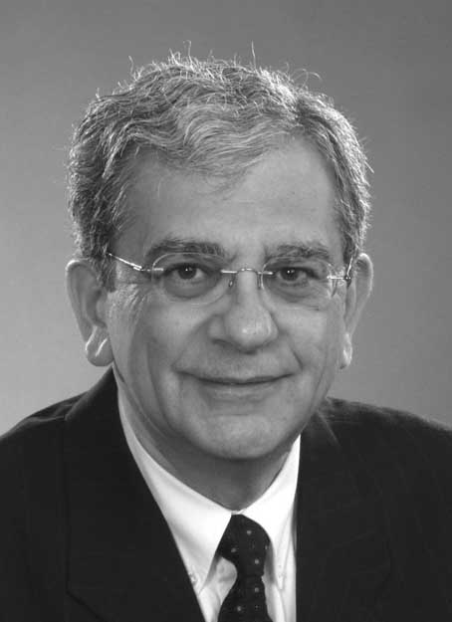
Hanny A. Hassan, London: (Lay Member) (Chair)
After obtaining his Bachelor of Engineering degree from the University of Western Ontario in 1964, Mr. Hanny Hassan received his Master of Engineering degree from Dalhousie University (formerly Technical University of Nova Scotia) in 1971. Mr. Hassan has been an active professional, advancing within a major professional engineering consulting firm, where he served as a Director and a Partner of the firm until his retirement in 2002. He now manages an independent consulting engineering practice, Alef Consulting Inc., in London, Ontario. Hanny presently serves on the Board of Governors and Senate of the University of Western Ontario. He is a member of the National Executive and Vice Chair of the Ontario Panel of the Canadian Broadcast Standards Council. He is the Past Co-Chair of the National Muslim Christian Liaison Committee. He served as the President of the Ontario Advisory Council on Multiculturalism and Citizenship, from 1991 to 1995. He has been, for many years, a member of the advisory committee of OMNI Television.
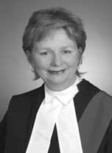
Madam Justice Judith C. Beaman, Regional Senior Justice, Ottawa
Following a brief time as partner in a small law firm in Kingston, Judith Beaman relocated to Toronto where she joined the Office of the Official Guardian. There she designed and presented training programs to lawyers representing children. She then became a founding partner in what eventually grew to become a nine person law firm, practising in the fields of family, civil, real estate and estates law. Upon moving to Ottawa, she became a Senior Legal Policy Analyst for the federal government with Status of Women Canada. From that position, she was appointed in 1998 to the Ontario Court of Justice, in Toronto, hearing family and criminal matters. Justice Beaman now presides in Ottawa, where she has become actively involved in judicial and public legal education, and in the creation of a specialized Drug Treatment Court. Between 2004 and 2007, she was a member of the Ontario Judicial Council. In September 2007, she was appointed the Regional Senior Justice for the East Region of the Ontario Court of Justice. Regional Senior Justice Beaman is appointed to the Committee by the Chief Justice of the Ontario Court of Justice.
Mr. Justice William B. Horkins, Toronto
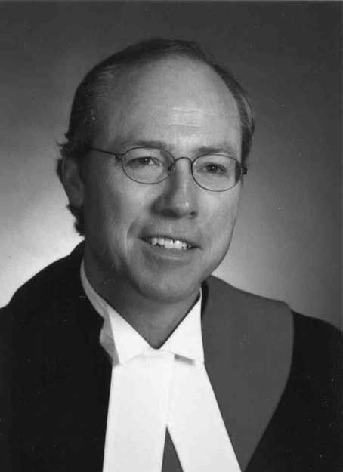
Appointed to the Ontario Court of Justice in 1998, Justice Horkins is presently the Local Administrative Judge at the College Park Courthouse in Toronto, a member of the Ontario Court of Justice Information Technology Committee and a former member of the Court’s Education Secretariat. Justice Horkins was called to the Bar in 1980 and practised primarily in the field of criminal law and professional discipline advocacy as both trial and appellate counsel. He was certified by The Law Society of Upper Canada as a Specialist in Criminal Litigation. In addition to his defence practice, he acted frequently as counsel to victims of crime seeking advice, standing and compensation. For many years, he was a part-time Assistant Crown Attorney and Counsel to the Discipline Committee of The Ontario College of Pharmacists. Justice Horkins has had a long-standing involvement in continuing legal education. He has been a Special Lecturer in Trial Advocacy at the Faculty of Law, University of Toronto, an Instructor at the Bar Admission Course and a frequent presenter and conference planner in education programs of the National Judicial Institute and the Ontario Court of Justice. Justice Horkins is appointed to the Committee by the Chief Justice of the Ontario Court of Justice.
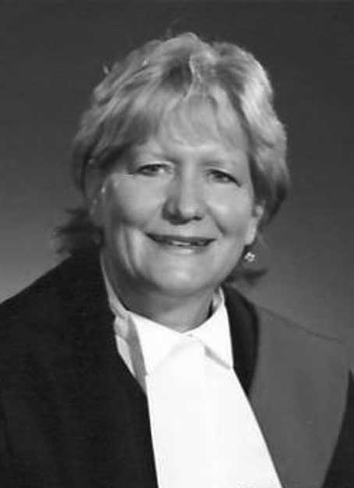
Madam Justice Eileen Martin, Welland
Justice Martin was educated at the University of New Brunswick (Hon. B.A. 1976). She obtained her L.L.B. from Osgoode Hall Law School in 1979. After practicing for five years in Toronto at a specialized family law firm, she spent one year teaching at Osgoode Hall Law School and at the University of Saskatchewan. From 1987 until the date of her appointment she maintained a family law practice at the law firm of Chown, Cairns in St. Catharines, Ontario. She was on the Executive and President of the Lincoln County Law Association and participated as a speaker in various Educational Seminars in the area of Family Law at both the local and provincial level. After being appointed as a Judge of the Ontario Court of Justice in 2006, she has sat in Welland hearing family law cases. In August of 2009 she was appointed by the Chief Justice of the Ontario Court of Justice as a member of the Ontario Judicial Council. Justice Martin is appointed to the Committee by the Ontario Judicial Council.
Alan D. Gold, Toronto: (Lawyer)
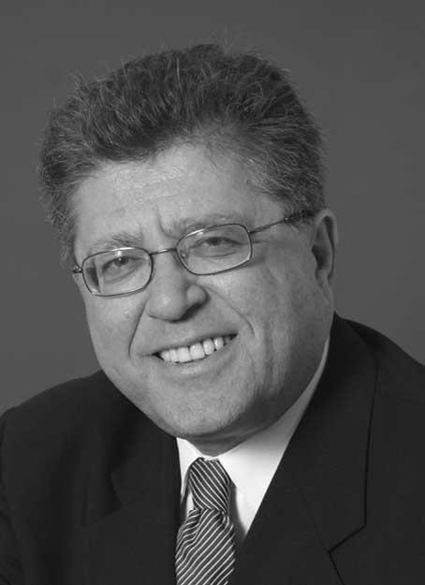
Mr. Alan Gold practises at Alan D. Gold Professional Corporation. He graduated from Queen’s University Faculty of Law in 1970 with the Gold Medal in Law. He was called to the Bar in 1973. His practice is restricted to criminal trial and appellate work. He has appeared as counsel before all levels of courts in Ontario, as well as in other provinces. Mr. Gold has defended accused in many major trial matters. A large number of the many hundred appellate cases Mr. Gold has argued before the Ontario Court of Appeal and Supreme Court of Canada are reported. Mr. Gold is certified by The Law Society of Upper Canada as a Specialist in Criminal Litigation and was the first Chairman of the Criminal Litigation Specialty Committee for five years. He was honoured in 1997 with the annual G. Arthur Martin Award for Contribution to Criminal Justice. Mr. Gold was President of the Criminal Lawyers’ Association for two terms from November 1997 through October 2001. Mr. Gold, elected as a Bencher of The Law Society of Upper Canada in May 2003 for a four-year term, was re-elected in 2007. Mr. Gold is an inductee of the American College of Trial Lawyers and a member of the Ontario Criminal Lawyers’ Association, The Advocates’ Society, and the National Association of Criminal Defence Lawyers (U.S.). Mr. Gold has written many articles and other publications on legal topics and has delivered speeches and presentations on a wide assortment of legal topics to lawyers, judges, law students and other audiences, and is frequently a media commentator. Mr. Gold’s most recent book is Expert Evidence in Criminal Cases: The Scientific Approach, Second Edition (Irwin Law, 2009). Mr. Gold is also author of The Practitioner’s Criminal Code, an annual publication with its inaugural edition published in 2007. Mr. Gold is appointed by The Law Society of Upper Canada to this Committee.
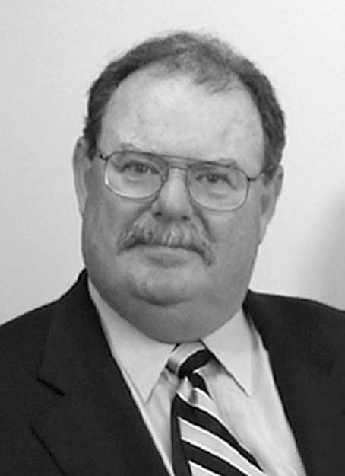
W. Ormond Murphy, Ottawa: (Lawyer)
Ormond received his Bachelor of Laws (1975) from Queen’s University and was called to the Ontario Bar in 1977. He is currently practising in association with Tierney, Stauffer, primarily in the fields of estates and trusts and civil litigation. Ormond has been actively involved in Continuing Legal Education and has been a guest lecturer in programs on Family Law and Estates and Trusts for The Law Society of Upper Canada, Ontario Bar Association, County of Carleton Law Association, University of Ottawa Law School and Carleton University. Ormond is author of Inter Vivos Gifts and Evidentiary Presumptions, Special Lectures of The Law Society of Upper Canada, 1996. Ormond was President of the County of Carleton Law Association in 1995, and was a member of the Board of Directors of the County and District Law Presidents' Association from 1996 to 2008, serving as Chair from 2004 to 2006. Mr. Murphy is appointed to the Committee by the County and District Law Presidents’ Association.
Frank E. Walwyn, Toronto: (Lawyer)
Frank is a litigation partner at WeirFoulds LLP. He is a member of the Bars of Ontario (1995) and St. Kitts and Nevis (2000). He is frequently consulted and appears as counsel on litigation matters in the Caribbean. Frank participates on many legal and community boards and initiatives. His contributions include: President of the Canadian Association of Black Lawyers (CABL); membership in the Ontario Bar Association (OBA) where he sits on OBA Council as President of CABL; Director of The Advocates' Society; member of the board of Community Legal Education Ontario (CLEO), a specialty clinic that produces and delivers public legal education to communities in Ontario that are low-income or who otherwise face barriers to full participation in the justice system; membership on the Steering Committee of DiverseCity: The Toronto Leadership Project, which is aimed at diversifying Toronto's leadership landscape; and, member of the Equity Advisory Group, which assists the Equity and Aboriginal Issues Committee of The Law Society of Upper Canada in the development of policy options for the promotion of equity and diversity in the legal profession. Frank is a contributing editor to Credit and Banking Litigation Journal. He speaks regularly to various audiences on diversity issues, and is a frequent presenter at continuing legal education seminars on many areas dealing with the litigation process, including seminars put on by the OBA, The Advocates' Society, The Law Society of Upper Canada, CABL, the Organisation of Eastern Caribbean States Bar Association and the Judicial Education Institute of the Eastern Caribbean Supreme Court. Frank is appointed by the Ontario Bar Association to the Committee.
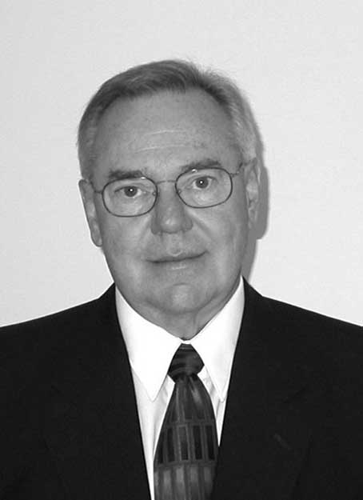
Roger R. Davidson, Cornwall: (Lay Member)
Mr. Davidson is a native of Sturgeon Falls. He has taught in elementary and secondary schools, in French-language and in English-language school boards. He has taught in regular and in special education programs, and has served as a vice-principal, a school principal, and a curriculum consultant. His academic qualifications include a B.A and a M.Ed. in Educational Administration from the University of Ottawa. He has worked with the Ministry of Education as an Educational Officer at the Central Ontario Regional Office. He has also served as a Superintendent of Education with the Stormont, Dundas and Glengarry County Board of Education and with the Sudbury District Roman Catholic Separate School Board where he was responsible for such portfolios as Personnel, Special Education, Curriculum, Operations, and French Immersion. He also served as Director of Education for the Timmins District Roman Catholic Separate School Board as well as for the Stormont, Dundas and Glengarry Roman Catholic Separate School Board. After thirty-five years in education, Mr. Davidson retired in 1999.
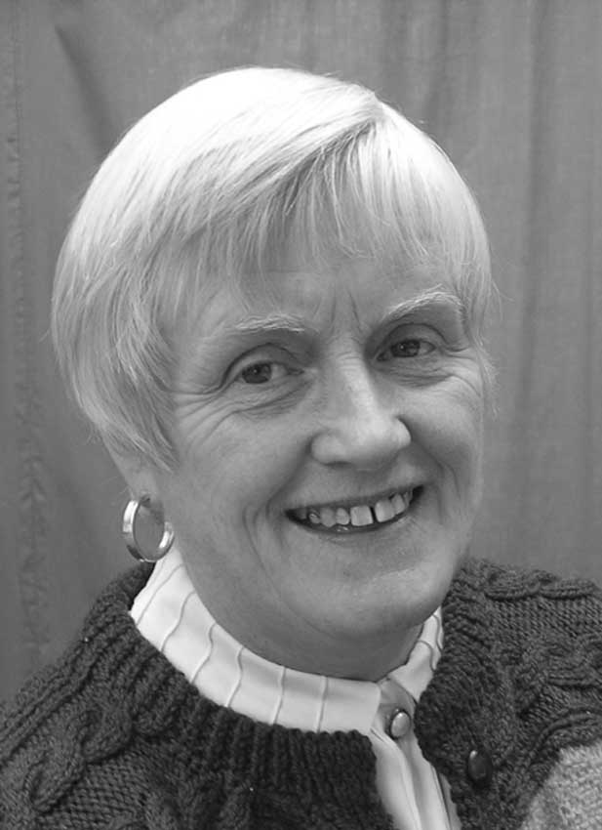
Ann Murphy, Brampton: (Lay Member)
Formerly a high school teacher-librarian with overseas teaching experience, Ann Murphy has also worked in commercial and corporate banking and investment sectors in Europe. She has traveled extensively in North America, Africa and Europe and initiated such community building projects as cross-border cultural exchanges for women in Northern and Southern Ireland. Currently, Ms. Murphy is involved in the Peel community through CARABRAM, Brampton’s annual multicultural festival and is a member of Brampton South Rotary. She also sits on the Executive and Board of Directors of United Way Peel Region. She holds a Bachelor of Arts and Masters of Education and is Governor of the Ontario Teachers’ Federation for Ontario English Catholic Teachers’ Association. She also sits as a member of the Board of Directors of the Institute of Catholic Education.
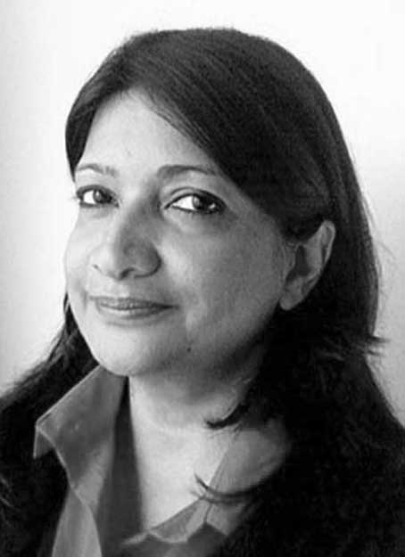
Shamira Qureshi, Mississauga: (Lay Member)
Shamira Qureshi is currently employed as an IT Coordinator at the CPPIB (Canadian Pension Plan Investment Board) since 2009. For more than twenty years in the Information Technology industry, she has led major organizations and private firms in business development and human resources initiatives. Born in Zanzibar, Shamira has lived within many different cultures around the world. This has developed not only her extensive linguistic skills but more importantly it complements her understanding in interrelationship nuances. She volunteers considerably in the community with poverty related initiatives with the Ansaar Foundation and previously with settlement services QLIP (Quality of Life Improvement Program). Shamira is a Public Speaker and a past Toastmaster, she has facilitated numerous groups to reach consensus. She currently resides in Mississauga, Ontario with her husband and two children who attend university.
Gail Stiffler, Kingsville: (Lay Member)
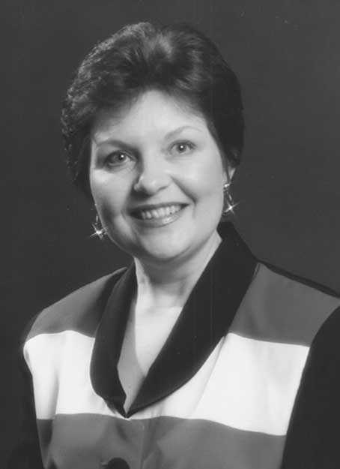
Mrs. Gail Stiffler is the President and General Manager of Toni-Gail Enterprises Ltd. since 1976. Mrs. Stiffler operated the Copper Kettle Restaurant in Harrow for twenty-three years. In 1999 she sold the business, after developing it into a highly successful enterprise and a landmark in Essex County. While living in Harrow, she served her community as Municipal Town Councillor. She is Past President of the Harrow and Colchester South Chamber of Commerce and took the lead role in developing their award-winning Strategic Plan for Economic Development. As Chair of the Committee to Amalgamate the Harrow and Colchester South Police Services, she worked with the Solicitor General’s Office and the Ontario Civilian Commission on Police Services to negotiate an acceptable contract for all parties. She co-chaired the committee to “Save Harrow High School” which developed a workable plan with the School Board to save the school from closure. She served on the Board of Directors of the South Essex Economic Development Corporation and later took the position of Acting Manager and Economic Development Officer. As Founder of the County Focus on Business Association, she worked closely with all Business Improvement Associations (BIAs) and Chambers of Commerce in Essex County to stimulate and attract business to the area. In 1995 she founded the South Essex Tourism Association (SETA) which brought together tourist-related businesses and organizations to develop a united marketing plan for Essex County. Over the years she has served her community on several volunteer boards and non-profit organizations including the Harrow and Colchester South Youth Association, Canadian Artist’s Workshop, Kingsville Community Policing and the Kingsville Economic Development Committee.
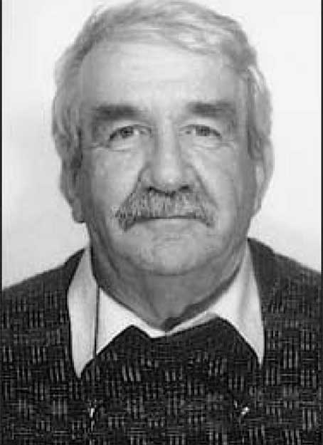
Gabriel Tremblay, Blind River: (Lay Member)
Mr. Tremblay retired in 1999 after 29 years in the teaching profession at the Elementary Level. He graduated from Laurentian University with a Major in Sociology and Political Science. He possesses a broad range of experience: Councillor, Town of Blind River for 24 years, Director of AFMO (Association Francaise des Municipalites de l’Ontario), Member of Blind River Police Board, President for the North Shore Region of AEFO (Association des Enseignants francais de l’Ontario), President of the Holy Family Parish Church Council, President of Royal Canadian Legion Branch 189 and presently a Life Member (served in the late 50’s in the Royal Canadian Air Force). He continues to be involved and presently is the President of Blind River Non-Profit Housing Corporation, a Board Member of Algoma District Services Administration Board representing the territory without municipal organization, and Director of the Blind River Development Corporation.
Madam Justice Lucy C. Glenn, Chatham (Retired on August 9, 2009)
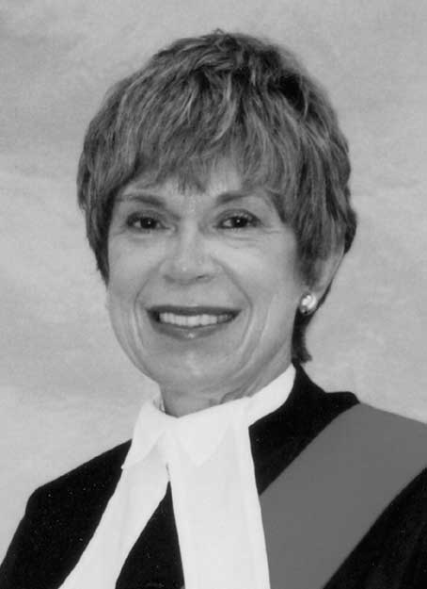
Justice Glenn is a graduate of the University of Guelph (B.H.Sc. 1969) and the University of Toronto (B.Ed. 1970) and had a career as a secondary school teacher from 1970 to 1974. She received her LLB from the University of Western Ontario in 1977 and after being called to the Bar (Ontario) in 1979, she practiced as a sole practitioner for 17 years in the small town of Blenheim, Ontario. In addition to having a general practice, she also worked as a part-time Assistant Crown Attorney for the County of Kent between 1979 and 1984. She was a founding member of the Chatham Kent Women’s Center, which is a shelter for women and children, and has worked on a number of other Boards in addition. After being appointed as a Judge of the Ontario Court of Justice in 1996, she has sat in Chatham hearing mainly family law related cases. In September of 2005, she was appointed by the Chief Justice of the Ontario Court of Justice as a member of the Ontario Judicial Council. Justice Glenn was appointed to the Committee by the Ontario Judicial Council.
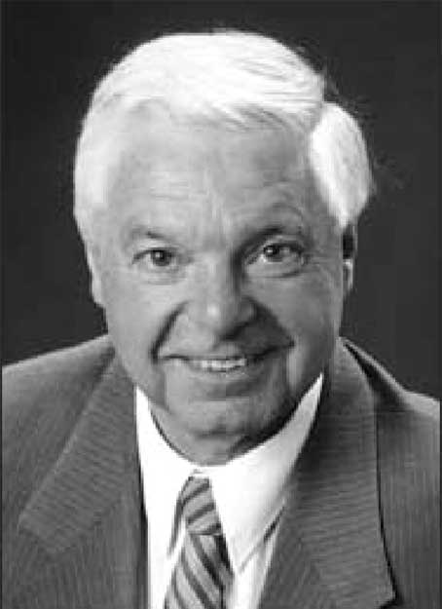
J. Douglas Grenkie, Q.C., Morrisburg: (Lawyer) (Retired on April 17, 2009)
Called to the Ontario Bar in 1970, Mr. Grenkie is a general practitioner in Morrisburg and a partner in the firm of Gorrell, Grenkie, Leroy & Remillard with offices in Morrisburg, Cardinal and Ingleside. He is also a partner in the firm of Cass, Grenkie in Chesterville. Mr. Grenkie is an active member of the Morrisburg & District Lions Club and the S. D. & G. Cornwall Shrine Club (Karnak Temple Montreal). He is a former President of the East District of the Cancer Society, Ontario Division, the founding President of the Upper Canada Playhouse and Past President of the Ontario Bar Association (OBA) and has served on the National Executive of the Canadian Bar Association. Also, Mr. Grenkie is the Conference Director of the OBA Foreign Conference Committee, and was appointed by the OBA to the Committee.
F. Clifford Fraser, Whitby: (Lay Member) (Resigned on July 30, 2009)
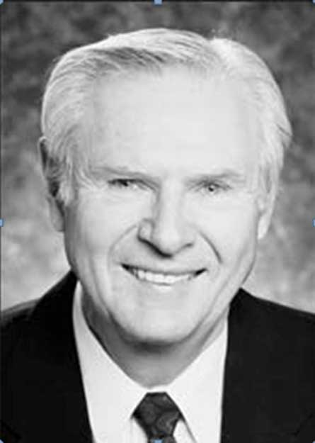
Mr. Fraser retired in 1994 as Vice President, Operations - Canada after 43 years of service with State Farm Insurance Companies. In 1999, he retired as President and Chief Executive Officer of Property and Casualty Insurance Compensation Corporation. He was appointed in 1970 by the Insurance Bureau of Canada as Chairman of a special committee to develop Automobile Insurance Tort Reform, now known as No-Fault Automobile Insurance. Variations of this study are now operating in several Canadian Provinces. Mr. Fraser is a Past Director on the Boards of: Property and Casualty Insurance Compensation Corporation, Insurance Bureau of Canada, Vehicle Information Centre of Canada, Insurance Crime Prevention Bureau, Ontario Chamber of Commerce, Scarborough General Hospital, Valley National Bank, Wayne, New Jersey, USA and the Past Chair of the Toronto Board of Trade - Insurance Committee and the Property and Casualty Insurance Compensation Corporation; and Chairman of the Judicial Appointments Advisory Committee, June 2001 to June 2004. Mr. Fraser is a recipient of The Queen’s Golden Jubilee Medal awarded for his significant contribution to Canada. In June 2006, he was inducted as an Honorary Member of the Toronto Board of Trade.
APPENDIX I


WHERE

DO JUDGES

COME FROM?
THE PROCESS OF
APPOINTMENT OF
ONTARIO PROVINCIAL JUDGES
“Judges ought to be more learned than witty; more reverend than plausible, and more advised than confident. Above all things, integrity is their portion and proper virtue.”
Lord Chancellor Bacon
Essays: Of Judicature (1597)

COMMITEE MEMBERS
Mr. Hanny Hassan (Chair)
London, Ontario
The Honourable Justice Judith C. Beaman
Regional Senior Justice – East Region
Appointment of the Chief Justice
Ottawa, Ontario
The Honourable Mr. Justice William B. Horkins
Appointment of the Chief Justice
Toronto, Ontario
The Honourable Madam Justice Eileen Martin
Appointment of Ontario Judicial Council
Welland, Ontario
Mr. Alan Gold
Appointment of The Law Society of Upper
Canada
Toronto, Ontario
Mr. W. Ormond Murphy
Appointment of County & District Law
Presidents' Association
Ottawa, Ontario
Mr. Frank E. Walwyn
Appointment of Ontario Bar Association
Toronto, Ontario
Mr. Roger Davidson
Long Sault, Ontario
Ms. Ann Murphy
Brampton, Ontario
Ms. Shamira Qureshi
Mississauga, Ontario
Ms. Gail Stiffler
Kingsville, Ontario
Mr. Gabriel Tremblay
Blind River, Ontario
OUTREACH
Committee members are available to speak to your organization about the Committee and the selection process. Requests for presentations should be forwarded to:
The Secretary
Judicial Appointments Advisory Committee
3rd Floor, 720 Bay Street
Toronto, Ontario M5G 2K1
Telephone: (416) 326-4060
Fax: (416) 212-7316
Email: Priscilla.Chu@ontario.ca
This leaflet is also available in the French language.
This leaflet, the current Judicial Candidate Information Form and policies and process are also available on the Ontario Courts website @ http://www.ontariocourts.on.ca/jaac/en/.
PROCESS
Vacancies on the Bench are advertised in the Ontario Reports and The Lawyers Weekly as the need arises. Candidates must submit 14 copies of a prescribed application form. These applications are reviewed by the Committee and a short list is prepared. The Judicial Appointments Advisory Committee meets to select candidates for interviews from the short list.
After reference checks, confidential inquiries and interviews, the Committee sends a ranked list of its recommendations to the Attorney General who is required to make the appointment from that list.
COMPOSITION OF THE COMMITTEE
The Legislation requires the composition of the Committee to reflect the diversity of Ontario’s population, including gender, geography, racial and cultural minorities. In addition to seven (7) lay members who are appointed by the Attorney General, six (6) from the legal community are appointed by the Chief Justice of the Ontario Court of Justice, The Law Society of Upper Canada, Canadian Bar Association - Ontario and the County and District Law Presidents’ Association respectively. All members serve for a term of three (3) years.
CONFIDENTIALITY
The selection process including the application form is treated with total confidentiality.
INDEPENDENCE
The Committee is independent of the Ministry of the Attorney General and the Government.
WHO SHOULD APPLY?
To qualify for consideration, applicants must have at least 10 years membership at the Bar in one of the provinces or territories of Canada. Applicants must have a sound knowledge of the law, an understanding of the social issues of the day and an appreciation for the cultural diversity of Ontario.
While courtroom experience is a distinct asset, the Committee also considers suitable candidates whose experience includes work with administrative tribunals, academia and in the social policy field.
Applications are encouraged from women, aboriginal peoples, francophones, persons with disabilities, and visible and ethnocultural minorities.
Applicants with Errors and Omissions claims or complaints on file with the Law Society of Upper Canada or any other Society will generally not be considered until such claims have been cleared. The candidate is responsible for ensuring the removal of such claims or complaints; however, if the Committee receives sufficient information as to the claim or complaint being frivolous or lacking in foundation, then such a claim or complaint will not be a bar to the candidate being considered.
Applicants who are involved in civil claims or proceedings would be considered if the Committee is of the opinion that the nature of such a claim does not prevent the candidate from being considered.
The Committee must be informed of any outstanding civil judgments, arrears in family support payments and any past or present proposals to creditors or assignments in bankruptcy.
The Committee will not consider a candidate who has a criminal record.
The Judicial Appointments Advisory
Committee of Ontario
A Brief History
In 1988, Attorney General Ian Scott announced a three-year pilot project to try a different model of appointment for Provincial Court Judges. The Judicial Appointments Advisory Committee (JAAC) began its work under the chairmanship of Professor Peter Russell with a mandate: “First, to develop and recommend comprehensive, sound and useful criteria for selection of appointments to the judiciary, ensuring that the best candidates are considered; and, second, to interview applicants selected by it or referred to it by the Attorney General and make recommendations.”
Between 1990 and 1995, the size of the pilot committee grew from 9 to 13 persons and the committee worked at developing criteria and procedures which were reviewed, refined and eventually publicized. In 1992, under the chairmanship initially of Professor Emily Carasco and then Associate Chief Judge Robert Walmsley, the Committee issued a Final Report and prepared recommendations for draft legislation to ensure that judges in future will be appointed by a process independent of political considerations.
JAAC was formally established on February 28, 1995 by proclamation of the Courts of Justice Act amendment passed in 1994.
The Committee began a programme of public information to tell interested people how the appointment system works.
The Judicial Appointments Advisory Committee is required to provide the Legislature with an Annual Report.

APPENDIX II
JUDICIAL APPOINTMENTS RECOMMENDED BY
THE JUDICIAL APPOINTMENTS ADVISORY COMMITTEE
JANUARY 2009 - DECEMBER 2009
NAME | LOCATION | EFFECTIVE DATE
Beninger, Robert William | Oshawa/Tri-County | 28 January 2009
Block, Michael Simon | Oshawa | 28 January 2009
Boucher, Patrick James | Cochrane  | 14 October 2009
Chapin, Leslie Alison Perry | Toronto | 2 December 2009
Coroza, Steve Anthony | St. Catharines | 2 December 2009
Elder, Joyce Susan | Thunder Bay | 2 December 2009
Greene, Mara Beth | Toronto | 17 June 2009
Hoffman, Mitchell | Windsor | 30 September 2009
Kozloff, Neil Leslie | Toronto | 2 December 2009
Legault, Jean Guy | L’Orignal  | 14 October 2009
ODonnell, Fergus Colm | Toronto | 17 June 2009
Oleskiw, Diane Iris | Toronto | 2 December 2009
Pawagi, Manjusha Bhaskar | Brampton | 28 January 2009
Perkins-McVey, Heather Elizabeth | Ottawa | 17 June 2009
Rabley, Wayne Gould | London | 17 June 2009
Schwarzl, Richard Hans Karl | Brampton | 17 June 2009
Skowronski, John Stanley | London | 4 March 2009
Speyer, Maria | Hamilton | 17 June 2009
Tobin, Barry Martin | Windsor | 30 September 2009
 Denotes designated bilingual position

APPENDIX III
JUDICIAL APPOINTMENTS RECOMMENDED BY THE
JUDICIAL APPOINTMENTS ADVISORY COMMITTEE
JANUARY 1989 - DECEMBER 2009
NAME | LOCATION | EFFECTIVE DATE
Adams, Peter R. | Cornwall | 7 April 2004
Agro, P.H. Marjoh | Brantford | 16 September 1994
Alder, Ann | Ottawa | 3 December 2003
Allen, J. Elliott | Brampton | 15 November 1991
Anderson, Charles D. | Brockville | 15 August 1990
Andre, Irving W. | Brampton | 13 November 2002
Armstrong, Simon C. | Newmarket | 3 December 2003
Atwood, Hugh K. | Brampton | 4 January 1993
Austin, Deborah J. | Sarnia | 1 December 1992
Baig, Dianne P. | Fort Frances | 2 April 1990
Baldock, Juliet | Kitchener | 20 October 1997
Baldwin, Lesley Margaret | St. Catharines | 6 May 1997
Barnes, Kofi N. | Oshawa | 18 February 2004
Bassel, William P. | Toronto | 15 May 1995
Beaman, Judith | Toronto | 12 January 1998
Beasley, Geoffrey Alan  | Pembroke | 5 May 2004
Beatty, William George | Bracebridge | 23 November 1998
Bellefontaine, Paul | Oshawa | 5 January 1998
Beninger, Robert William | Oshawa/Tri-County | 28 January 2009
Bentley, Paul | Toronto | 1 June 1992
Bhabha, Feroza | Toronto | 24 August 2006
Bigelow, Robert G. | Toronto | 9 August 1993
Bignell, Ellen Kristine | Sault Ste. Marie | 3 December 2003
Bishop, Peter T. | Dryden | 6 September 1994
Blacklock, W. James | Brampton | 25 January 1993
Blishen, Jennifer A.  | Ottawa | 15 January 1993
Block, Michael Simon | Oshawa | 28 January 2009
Bloomenfeld, Miriam | Toronto | 14 December 2005
Blouin, Richard | Newmarket | 4 August 2004
Bode, Marc | Thunder Bay | 30 January 2008
Boivin, Ronald D.J. | Cochrane North  | 25 June 2003
Bondy, Sharman S. | Sarnia | 19 October 1998
Bonkalo, Annemarie E. | Brampton | 2 April 1990
Borenstein, Howard Joseph Arnold | Toronto | 24 August 2006
Botham, Louise Alice | Brampton | 6 September 2007
Boucher, Patrick James | Cochrane  | 14 October 2009
Bourque, Peter Nicholas | Newmarket | 15 February 2006
Bovard, Joseph W. | Toronto | 31 December 1989
Brewer, Carol Anne Ruth | Toronto | 24 August 2006
Brophy, George J. | Sarnia | 12 May 1997
Brown, Beverly Anne | Toronto | 3 December 2003
Brown, Stephen Douglas | Burlington | 21 June 2006
Brownstone, Harvey P. | Toronto | 13 March 1995
Budzinski, Lloyd M. | Brampton | 1 April 1992
Buttazzoni, Andrew L. | Sault Ste. Marie | 26 April 2006
Caldwell, Kathy | Toronto | 5 May 2004
Campbell, Gregory Alfred | Windsor | 18 October 2006
Campbell, Hugh J. | Oshawa | 7 November 1994
Campling, Frederic Miller | Toronto | 3 December 2003
Carr, David George | Kitchener | 28 April 1999
Carr, Ralph E.W. | Sudbury | 1 July 1991
Casey, Jeff  | Toronto | 21 December 1992
Caspers, Jane E. de Meysey | Guelph | 7 February 2001
Cavion, Bruno | Brampton | 15 November 1991
Chapin, Leslie Alison Perry | Toronto | 2 December 2009
Chester, Lorne Edward | Lindsay | 12 July 1999
Chisvin, Howard I. | Newmarket | 18 February 2004
Clark, Steven R. | Brampton | 13 February 2002
Cleary, Thomas P. | Barrie | 6 June 1994
Clements, Sydney Ford | Brampton | 18 February 2004
Cohen, Marion L. | Toronto | 9 August 1993
Cole, David P. | Scarborough | 1 March 1991
Colvin, J.A. Tory | Welland | 26 May 2005
Cooper, Alan Douglas | Halton | 22 December 2004
Coroza, Steve Anthony | St. Catharines | 2 December 2009
Cowan, Ian | Toronto | 20 January 1997
Crawford, James C. | Oshawa | 1 June 1990
Culver, Timothy A. | Kitchener | 16 May 1994
Currie, Paul Reed | Brampton | 18 February 2004
Curtis, Carole | Toronto | 30 January 2008
Dawson, Nancy Anne | Barrie | 3 December 2003
De Filippis, Joseph Anthony | Brampton | 3 January 2000
Dean, Lloyd Clayton | Windsor/Chatham | 5 October 2005
DeFreitas, Peter Joseph | Oshawa | 23 July 2008
Deluzio, Elaine Isabel | Belleville | 6 December 2006
Devlin, Mary Teresa E. | Oshawa | 13 November 2002
Di Zio, Antonio | Toronto | 3 May 1999
DiGiuseppe, Dino | Thunder Bay | 15 November 2000
Dobney, Susan Gail | Toronto | 28 April 1999
Dorval, Célynne S. | Ottawa  | 15 March 1999
Douglas, Jon-Jo Adam | Barrie | 13 October 1998
Douglas, Norman S. | Brampton | 16 May 1994
Dunbar, Mary F.  | Brampton | 1 February 1991
Duncan, Bruce | Brampton | 1 May 1997
Edward, Gethin | Brantford | 1 December 1996
Elder, Joyce Susan | Thunder Bay | 2 December 2009
Epstein, Michael Jonathan | Kitchener | 26 May 2005
Evans, Kerry Patrick  | Barrie | 2 October 1997
Fairgrieve, David A. | Brampton | 21 December 1990
Favret, Lucia Piera | Newmarket | 5 May 2004
Feldman, Lawrence | Toronto | 5 January 1998
Fernandes, Ivan J. A.  | Toronto | 21 February 2000
Finnestad, Faith M. | Toronto | 1 May 1995
Flaherty, Roderick J. | Dryden | 2 April 1990
Forsyth, Frederick L. | Milton | 3 May 1999
Foster, Stephen E. | Newmarket | 7 November 1994
Fraser, Hugh L. | Toronto | 3 May 1993
Frazer, Bruce | Kitchener | 13 January 1997
French, Paul Joseph | Toronto | 24 August 2006
Fuerth, Stephen Joseph | Chatham | 18 October 2006
Gage, George Stephen | Toronto | 3 December 2003
Gauthier, Louise L.  | Northeast Region | 15 August 1992
Getliffe, John Lawrence | Stratford | 6 December 2000
Glaude, G. Normand N. | Elliot Lake  | 17 April 1990
Glenn, Lucy C. | Chatham | 16 December 1996
Gorewich, William A. | Barrie | 14 October 1997
Graydon, Robert Lawson | Cobourg | 12 July 2006
Green, Melvyn | Toronto | 14 December 2005
Greene, Mara Beth | Toronto | 17 June 2009
Gregson, Nathalie | Sault Ste. Marie | 3 December 2008
Griffin, Geoffrey J. | Napanee | 8 September 2004
Griffiths, Peter | Brockville | 11 May 1998
Grossman, Jack Morris | Toronto | 28 April 1999
Hackett, Donna G. | Scarborough | 21 December 1990
Hansen, Inger  | Kitchener | 1 February 1991
Hardman, Paddy A. | Kitchener | 1 March 1991
Harpur, Charles Michael | Barrie | 18 May 2005
Harris, C. Roland | Barrie | 8 August 1994
Harris, David Allan | St. Catharines | 21 June 2006
Harris, Peter A.J. | Brampton | 13 February 1995
Hatton, Mary Jane  | Toronto | 2 April 1990
Hawke, Kathryn L. | Brampton | 6 February 1995
Hearn, Gary F. | Kitchener | 26 October 1998
Hoffman, Mitchell | Windsor | 30 September 2009
Horkins, William | Toronto | 5 January 1998
Hornblower, Geoffrey Mark | Sarnia | 6 October 1999
Hoshizaki, Jennifer Ruth | Kenora | 30 January 2008
Hryn, Peter | Toronto | 1 June 1991
Humphrey, Richard | Sudbury | 12 July 1999
Hunter, Stephen J. | Ottawa | 1 June 1991
Isaacs, Peter R.W. | Stratford | 13 February 1995
Jennis, Richard | St. Catharines | 20 May 1997
Johnston, Karen E. | Oshawa | 1 July 1991
Jones, Penny J. | Toronto | 15 July 1991
Kastner, Nancy Susan | Brampton | 15 February 1999
Katarynych, Heather L. | Central South Region | 1 July 1993
Keaney, James J. | Oshawa | 2 July 2003
Keast, John D. | Sault Ste. Marie | 11 July 2001
Kehoe, Catherine Ann | Ottawa | 6 September 2007
Kelly, Robert Francis | Brampton | 6 September 2007
Kenkel, Joseph F. | Newmarket | 19 June 2000
Kerrigan-Brownridge, Jane | Brampton | 15 January 1993
Khawly, Ramez | Sarnia | 1 December 1991
Khoorshed, Minoo F. | Toronto | 1 June 1992
Klein, Lawrence Joseph | Parry Sound | 26 April 2006
Knazan, Brent | Toronto | 15 August 1990
Kowalyshyn, Paul John Stephen | Chatham/Windsor | 3 December 2008
Kozloff, Neil Leslie | Toronto | 2 December 2009
Krelove, Glenn D. | Barrie | 26 October 1998
Kukurin, John | Sault Ste. Marie | 29 May 1995
Lacavera, Alphonse T. | Welland | 2 March 1998
Lafrance-Cardinal, Johanne  | Cornwall  | 6 September 1994
Lalande, Randall William | Sudbury  | 3 January 2000
Lambert, Martin | Sault Ste. Marie | 15 February 1999
Lane, Marion E.  | Brampton | 1 February 1991
LeDressay, Richard | Guelph | 1 December 1996
Legault, Jean Guy | L’Orignal  | 14 October 2009
Lenz, Kenneth G. | Simcoe/Norfolk | 4 July 1989
Lester, Ronald B.  | Thunder Bay | 1 March 1991
Libman, Rick | Barrie | 15 November 1996
Linden, Sidney B. | Toronto | 25 April 1990
Lindsay, Eric S.  | Toronto | 1 September 1990
Linhares de Sousa, Maria T.  | Ottawa | 4 July 1989
Lipson, Timothy R. | Toronto | 20 March 2002
Livingstone, Deborah K. | London | 31 December 1989
Lynch, John T. | Kitchener | 18 April 2001
MacLean, Susan | Oshawa | 18 February 2004
MacPhee, Bruce E. | Brampton | 2 April 1990
Main, Robert P. | Barrie | 2 April 1990
Maisonneuve, Lise | Ottawa | 3 December 2003
Malcolm, Wendy Barbara | Belleville | 29 November 2006
March, Stephen | Pembroke | 19 April 2000
Maresca, June | Brampton | 4 August 2004
Marin, Sally E. | Toronto | 9 August 1993
Marshman, Mary E.  | Windsor | 15 July 1991
Martin, Eileen Susan | Welland | 21 June 2006
Masse, Rommel G. | Ottawa  | 4 July 1989
Maund, Douglas B. | Orangeville | 4 October 2000
McCreary, Robert F. | Orillia | 18 May 2005
McFadyen, Anne-Elisabeth E. | Sarnia | 26 October 1998
McGowan, Kathleen E. | St. Catharines | 1 June 1990
McGrath, Edward | St. Thomas | 4 January 1999
McKay, Alan Thomas | Fort Frances | 9 November 2005
McKerlie, Kathryn L. | Stratford | 3 May 1999
McLeod, Katherine Louise | Brampton | 15 February 1999
McLeod, Malcolm Gordon | Sudbury | 27 December 2006
McSorley, Margaret A. | Kitchener/Guelph | 24 December 2003
Merenda, Sal | Toronto | 21 February 1996
Minard, Ronald A. | Newmarket | 5 April 1993
Mocha, Cathy | Toronto | 14 April 1997
Moore, John | Toronto | 12 January 1998
Morgan, J. Rhys | Toronto | 15 August 1990
Morneau, Julia Ann | Owen Sound | 30 May 1997
Morten, Marvin G. | Toronto | 5 July 1993
Mulligan, Katrina Lea | Oshawa | 31 January 2007
Murray, Ellen Bushnell | Toronto | 9 November 2005
Nadel, Joseph Samuel | St. Catharines | 21 June 2006
Nakatsuru, Shaun Shungi | Toronto | 24 August 2006
Nelson, Carol Ann | Brampton | 23 July 2008
Newton, Petra E. | Toronto | 31 December 1989
Nicholas, Dianne M. | Ottawa | 1 June 1991
Nicklas, Sharon Margaret | Kitchener/Guelph | 6 September 2007
O’Dea, Michael P. | St. Thomas | 15 March 2000
O’Hara, Terrence G.  | Newmarket | 6 February 1995
ODonnell, Fergus Colm | Toronto | 17 June 2009
Oleskiw, Diane Iris | Toronto | 2 December 2009
Omatsu, Maryka J. | Toronto | 1 February 1993
Ormston, Edward E. | Toronto | 31 December 1989
Otter, Russell J. | Toronto | 5 July 1993
Paulseth, Debra Ann White | Toronto | 9 November 2005
Pawagi, Manjusha Bhaskar | Brampton | 28 January 2009
Payne, John Andrew | Oshawa | 4 January 1999
Pelletier, Joyce Lynn | Thunder Bay | 28 December 2005
Perkins-McVey, Heather Elizabeth | Ottawa | 17 June 2009
Phillips, Douglas W. | Windsor | 1 March 1991
Pockele, Gregory A. | Stratford | 2 November 1992
Pringle, Leslie Catherine | Toronto | 20 March 2002
Pugsley, Bruce Edmund | Brampton | 13 February 2002
Rabley, Wayne Gould | London | 17 June 2009
Radley-Walters, Sydney Grant | Pembroke | 20 February 2002
Ratushny, Lynn D.  | Ottawa | 1 March 1991
Rawlins, Micheline A. | Windsor | 15 October 1992
Ray, Sheila | Toronto | 15 April 1992
Ready, Elinore A. | Brampton | 21 December 1990
Regis, Gregory | Oshawa | 4 January 1999
Reinhardt, Paul H. | Toronto | 2 April 1990
Renaud, J.R. Giles | Cornwall  | 23 January 1995
Renaud, Yvon | Sudbury | 15 November 2000
Richards, Ronald J. | Toronto | 21 December 1992
Ritchie, John Malcolm | Toronto | 28 April 1999
Roberts, Marietta L.D. | Brampton | 1 March 1991
Robertson, Paul | Toronto | 3 December 2003
Robson, M. Wendy  | Peterborough | 4 July 1989
Rocheleau, Michelle Joanne | Haileybury  | 27 December 2006
Rodgers, Gregory Paul | North Bay | 15 November 2000
Rogers, Lynda J. | Kitchener/Guelph | 19 October 2005
Rogers, Sherrill M.  | Newmarket | 15 July 1991
Rogerson, Robert Wallace | Kitchener/Guelph | 24 December 2003
Rosemay, Vibert T. | Brampton | 1 December 1991
Rutherford, Rebecca Jane | Toronto | 24 December 2008
Salem, Harvey M.  | Scarborough | 1 March 1991
Schnall, Eleanor M. | London | 1 March 1991
Schneider, Richard D. | Toronto | 20 December 2000
Schwarzl, Richard Hans Karl | Brampton | 17 June 2009
Scott, Margaret A.C.  | Oshawa | 17 January 1994
Scully, Brian Muir | Toronto | 3 December 2003
Selkirk, Robert George | Pembroke | 29 December 2004
Serré, Louise | Blind River/Elliot Lake  | 15 November 2000
Shamai, Rebecca S. | Brampton | 2 April 1990
Shaw, Anne-Marie | Newmarket | 16 September 2002
Sheppard, Patrick A.  | Newmarket | 1 June 1991
Sherr, Stanley Bennet | Toronto | 9 November 2005
Shilton, Bruce | Newmarket | 6 July 1998
Simmons, Janet M.  | Brampton | 21 December 1990
Skowronski, John Stanley | London | 4 March 2009
Sparrow, Geraldine | Toronto | 15 January 1993
Spence, Robert Julien | Toronto | 20 March 2002
Speyer, Maria | Hamilton | 17 June 2009
Stead, W. Brian | Simcoe | 1 July 1991
Stone, David M. | Oshawa | 1 June 1990
Sutherland, John Andrew | Toronto | 5 May 2004
Taillon, Raymond P.  | Oshawa | 1 July 1991
Taylor, Paul Michael | Toronto | 20 March 2002
Tetley, Peter | Newmarket | 16 September 2002
Thibideau, Lawrence P. | Brantford | 3 May 2000
Thomas, Bruce G.  | Chatham | 4 May 1999
Timms, David Roger  | Oshawa | 1 March 1991
Tobin, Barry Martin | Windsor | 30 September 2009
Trotter, Gary Thomas  | Toronto | 14 December 2005
Tuck-Jackson, Andrea Edna Ethel | Toronto | 24 August 2006
Vaillancourt, Charles H. | Downsview | 21 December 1990
Valente, Francesco | Thunder Bay | 14 May 2008
Villeneuve, Robert Paul | Elliot Lake/Blind River  | 9 November 2005
Vyse, Diane Terry | Cambridge | 1 March 1991
Wake, John David | Brampton | 8 August 1994
Wakefield, Graham Richard | Oshawa | 23 July 2008
Waldman, Geraldine | Brampton | 15 November 1991
Watson, Ann Jane | St. Catharines | 4 August 2005
Waugh, John D. G. | Pembroke | 30 May 2001
Weagant, Brian | Toronto | 8 May 1995
Weinper, Fern | Newmarket | 6 July 1998
West, Peter Caldwell | Newmarket | 30 January 2008
Westman, Colin R. | Kitchener | 1 June 1990
Whetung, Timothy C. | Peterborough | 1 December 1991
Wilkie, Peter Heward | Brampton | 15 February 1999
Wilson, Joseph Bruce | Parry Sound | 26 May 1997
Wilson, Natalie Jane | Pembroke | 2 November 1998
Wolder, Theo | Brampton | 1 June 1990
Wolski, William | Barrie | 20 January 1997
Wong, Mavin | Newmarket | 19 June 2000
Woolcott, Margaret F. | Brampton | 4 January 1993
Wright, Kelly Pamela | Toronto | 24 December 2008
Wright, Peter J. | East Region | 5 July 1993
Wright, Peter Jeffrey | Newmarket | 16 September 2002
Zabel, Bernd E. | Hamilton | 2 April 1990
Zisman, Roselyn | Milton | 11 April 2007
Zivolak, Martha B. | St. Catharines | 1 July 2002
 Denotes designated bilingual position
❖ Subsequently appointed to the Family Court of the Superior Court of Justice
 Subsequently appointed to the Superior Court of Justice
 Subsequently appointed to the Ontario Court of Appeal
 Deceased
 Resigned
 Retired as full-time judge

