Justices of the Peace Review Council
IN THE MATTER OF A HEARING UNDER SECTION 11.1 OF THE JUSTICES OF THE PEACE ACT,
R.S.O. 1990, c. J.4, as amended
Concerning Two Complaints about the Conduct of
Justice of the Peace Alfred Johnston
Before: The Honourable Justice P. H. Marjoh Agro, Chair
His Worship Maurice Hudson, Justice of the Peace
Dr. Emir Crowne, Community Member
Hearing Panel of the Justices of the Peace Review Council
REASONS FOR DECISION
Counsel:
Ms. Marie Henein Mr. Peter Brauti
Henein Hutchison LLP Brauti Thorning Zibarras LLP
Presenting Counsel Counsel for His Worship Alfred Johnston

Introduction
Two unrelated complaints were received by the Justices of the Peace Review Council (the “Review Council) concerning the conduct of Justice of the Peace Alfred Johnston. The Review Council established a complaints committee pursuant to sub-section 11(1) of the Justices of the Peace Act, R.S.O. 1990, C.J. 4, as amended (the “Act”). The complaints committee investigated each matter and ordered that a formal hearing into each complaint be held, pursuant to sub-section 11(15) of the Act.
The Chief Justice of the Ontario Court of Justice, the Chair of the Review Council, established a Hearing Panel pursuant to sub-section 11(1) of the Act and, as a result, a hearing into both complaints commenced, the particulars of which are set out below. For convenience, the first complaint is entitled the “Leaf Matter”, and the second complaint is entitled the “Docket Dismissal”.
Leaf Matter
The complaint alleges that on November 22nd, 2012 His Worship breached his duty to assist a self-represented defendant and/or failed to ensure a fair trial.
A self-represented defendant, Mr. Alexander Leaf, was charged with “Drive Hand-Held Communication Device” contrary to sub-section 78.1(1) of the Highway Traffic Act, R.S.O. 1990, c. H.8, as amended (the “HTA”). It is alleged that His Worship ridiculed the defendant’s pronunciation of R v Askov, [1990] 2 S.C.R. 1199 (“Askov”) and even feigned ignorance of the case at times. These actions allegedly persuaded the defendant to abandon his motion relating to sub-section 11(b) of the Canadian Charter of Rights and Freedoms, Part I of the Constitution Act, 1982, being Schedule B to the Canada Act 1982 (UK), 1982, c 11 (the “11(b) motion”).
It is also alleged that His Worship refused to give Mr. Leaf an opportunity to retrieve from his car a copy of the relevant legislation that was essential to his defence, in breach of his right to make full answer and defence.
Upon review of the audio recording and written transcript of November 22nd, 2012, the Panel finds that the record supports the following findings, namely:
- His Worship Johnston failed in his role as a judicial officer to provide a self-represented defendant with the requisite minimum assistance in applying, and even pronouncing, Askov.
- In feigning ignorance of Askov, His Worship used a mocking tone that led the defendant to abandon the 11(b) motion.
- His Worship Johnston failed to ensure that any applicable exemption(s) from sub-section 78.1(1) of the HTA was researched and considered, before concluding (as he did) that no such exemption existed.
The Panel, however, finds no support for the allegation that His Worship denied Mr. Leaf an appropriate opportunity to obtain a copy of the legislation from his car. Mr. Leaf made the request during the delivery of His Worship’s reasons for judgment when it became abundantly clear His Worship was about to find Mr. Leaf guilty. In dealing with the interruption, His Worship was both courteous and patient with Mr. Leaf. Furthermore, before rendering his decision, His Worship asked Mr. Leaf if he wished to call any further evidence or make any additional submissions, to which Mr. Leaf replied in the negative.
It is our view that characterizing the facts set out in paragraph 7(c) of the Agreed Statement of Facts as misconduct, whether as a single act or part of a continuum of events in the course of the trial, would set an unacceptable precedent for the trial process and appropriate courtroom decorum.
Docket Dismissal
On December 4th, 2012, His Worship presided in Courtroom “F” of Provincial Offences Court at 60 Queen Street West, in Toronto. His Worship’s decision to dismiss the 1:30 p.m. tier at approximately 1:33:37 p.m. for want of prosecution forms the basis of the second complaint.
Transcripts of those proceedings confirm that His Worship entered the courtroom at 1:32:46 p.m. No prosecutor was present. At 1:33:57 p.m., and after attempting to page the prosecution once, His Worship dismissed the entire docket purportedly pursuant to sub-section 53(1) of the Provincial Offences Act, R.S.O. 1990, c. P.33 (the “POA”), which states that:
“Where the defendant appears for a hearing and the prosecutor, having had due notice, does not appear, the court may dismiss the charge or may adjourn the hearing to another time upon such terms as it considers proper.”
In our view, the conduct of His Worship in dismissing the entire docket fell short of the behaviour expected of a judicial officer. His Worship’s actions were hasty, intemperate and lacked proportionality. It struck at the very core of the public’s confidence in the administration of justice.
Dispositions & the Judicial Disciplinary Process
Sub-section 11.1(10) of the Justices of the Peace Act sets out the dispositions available to this Panel, namely:
“After completing the hearing, the panel may dismiss the complaint, with or
without a finding that it is unfounded or, if it upholds the complaint, it may,
(a) warn the justice of the peace;
(b) reprimand the justice of the peace;
(c) order the justice of the peace to apologize to the complainant or to any other person;
(d) order that the justice of the peace take specified measures, such as receiving education or treatment, as a condition of continuing to sit as a justice of the peace;
(e) suspend the justice of the peace with pay, for any period;
(f) suspend the justice of the peace without pay, but with benefits, for a period up to 30 days; or
(g) recommend to the Attorney General that the justice of the peace be removed from office in accordance with section 11.2.”
The dispositions are therefore arranged from the least serious (i.e., a warning) to the most serious (i.e., a recommendation to the Attorney General to remove the Justice of the Peace from office). Pursuant to sub-section 11.1(11), most dispositions may also be combined (“The panel may adopt any combination of the dispositions set out in clauses (10) (a) to (f)”).
The philosophy behind the judicial disciplinary process is the restoration of public confidence in the judiciary and in the administration of justice. The entire range of dispositions, from dismissal through to a recommendation of removal from office, all serve that overriding objective. Disciplinary panels are neither pre-disposed to punish, or protect, judicial officers.
In this regard, the remarks of the Supreme Court of Canada in Re: Therrien, 2001 SCC 35 are particularly relevant, namely:
110. ... the personal qualities, conduct and image that a judge projects affect those of the judicial system as a whole and, therefore, the confidence that the public places in it. Maintaining confidence on the part of the public in its justice system ensures its effectiveness and proper functioning. But beyond that, public confidence promotes the general welfare and social peace by maintaining the rule of law. In a paper written for its members, the Canadian Judicial Council explains:
Public confidence in and respect for the judiciary are essential to an effective judicial system and, ultimately, to democracy founded on the rule of law. Many factors, including unfair or uninformed criticism, or simple misunderstanding of the judicial role, can adversely influence public confidence in and respect for the judiciary. Another factor which is capable of undermining public respect and confidence is any conduct of judges, in and out of court, demonstrating a lack of integrity. Judges should, therefore, strive to conduct themselves in a way that will sustain and contribute to public respect and confidence in their integrity, impartiality, and good judgment.
(Canadian Judicial Council, Ethical Principles for Judges (1998), p. 14)
111. The public will therefore demand virtually irreproachable conduct from anyone performing a judicial function. It will at least demand that they give the appearance of that kind of conduct. They must be and must give the appearance of being an example of impartiality, independence and integrity. What is demanded of them is something far above what is demanded of their fellow citizens.
The misconduct in this instance was serious. It struck at the heart of the administration of justice, and in the public confidence attached to it. Warnings, reprimands, education or treatment are simply insufficient or inapplicable to remedy the misconduct.
Suspensions (with or without pay), or a recommendation of removal from office, are left. We deal with removal first. A recommendation that a judicial officer be removed from office is a severe sanction. In our view, it should only be ordered where no other combination of sanctions could reasonably achieve the overriding objective.
To that end, a suspension without pay, but with benefits, for a period of seven (7) consecutive calendar days is warranted in this instance, as is a letter of apology. In arriving at this sanction, we were mindful of the need to restore public confidence in the judiciary and in the administration of justice while ensuring His Worship’s sanction is in accordance with growing jurisprudence in this area and the particularized facts of this case, in particular:
- The lack of remorse or self-reflection prior to the public hearing. Indeed, there is no evidence that His Worship expressed regret or apologized for any of his actions in his responses to the complaints or prior to June 9th, 2014 (when Mr. Brauti filed with the Review Council’s office his submissions containing an apology letter, dated June 6th, 2014); and
- The non-isolated nature of the misconduct. There were two (2) separate events in question, both of which had a damaging and public impact on the administration of justice; and
- The public resources expended by the City of Toronto in appealing four (4) of the dismissals.
These, and other, aggravating factors are also addressed in our analysis with respect to costs. In light of the factors set out in Re: Foulds, 2013 (JPRC) with respect to costs, the overlap is inevitable.
Indeed, we may have opted for a lengthier suspension, had the following mitigating factors not come to bear:
- His Worship has had no previous findings of misconduct;
- Five (5) letters of support tendered from various stakeholders involved in the administration of justice;
- His Worship has since admitted to the allegations by way of a letter of apology and the Agreed Statement of Facts;
- His Worship’s verbal acknowledgment before this Panel that his comments, actions and demeanour were inappropriate and amounted to judicial misconduct;
- There is some evidence before us that at the relevant time His Worship was suffering episodes of hypoglycemia, related to a diabetic condition, as well as stress and depression due to matrimonial issues; and,
- His Worship has undergone counselling.
Costs
The Panel in Re: Foulds, 2013 (JPRC) set out some guidelines with respect to the awarding of costs (ibid., para 62) (the “Foulds factors”). We adopt those guidelines, with the caveat that each case is to be measured against its own facts and surrounding circumstances, namely:
“Some factors that might be weighed are these:
        - the severity of the misconduct;
        - the complexity of the hearing;
        - the conduct of the justice of the peace in the course of the hearing, including whether the justice of the peace prolonged or expedited the process;
        - the nature of the disposition(s);
        - whether public funds were lost as a result of the misconduct;
        - whether there had been previous findings of misconduct made against the justice of the peace; and
        - whether the conduct in question relates to a judicial function or impacts judicial independence.”
The case before this Panel falls within the extremes of the spectrum of cases that come before the Review Council. In other words, the allegations against His Worship were not such that they failed to meet the threshold of judicial misconduct and ought to be dismissed, nor was they so egregious and damaging to the public’s confidence in him, the judiciary in general and the administration of justice, that dismissal from office is recommended by this Panel.
Turning now to the Foulds factors:
a) the severity of the misconduct:
i) The Leaf Matter
During the course of the trial on November 22nd, 2012 His Worship demonstrated an arrogant and sarcastic attitude that falls short of the conduct expected of a judicial officer in dealing with a self-represented defendant and offends the Principles of Judicial Office for Justices of the Peace.
The disrespect shown to Mr. Leaf not only compromised that defendant’s right to make full answer and defence but also compromised the dignity of the court and the trial process.
ii) The Docket Dismissal
The dismissal of an entire list of charges under the POA (68 charges against 62 defendants) three (3) minutes and fifty six (56) seconds after court was set to commence and a mere one (1) minute and ten (10) seconds after he himself entered the courtroom was an abuse of the authority granted a justice of the peace under sub-section 53(1) of the POA. It required a review of those charges that were dismissed and an appeal of a selected number, all at public expense.
We consider these to be serious instances of misconduct that undermine the public’s confidence in this justice of the peace, his colleagues, the process by which they are appointed, and in the administration of justice as a whole.
b) the complexity of the hearing:
The hearing itself has not been particularly complex or prolonged.
The evidence relied upon by Presenting Counsel consisted of the court records of November 22nd, 2012 and December 4th, 2012. Those records speak for themselves. Even in the absence of an Agreed Statement of Facts, it is unlikely that other witnesses would have been required.
c) the conduct of the justice of the peace in the course of the hearing, including whether the justice of the peace prolonged or expedited the process:
There are factors that bear on the conduct of the hearing that we do take into account. The first appearance before the Panel was on March 25th, 2014. On that occasion the Notice of Hearing setting out the nature of the complaint was filed.
The Chair offered a pre-hearing before another judicial officer to assist in narrowing the issues or moving toward resolution. That offer was left open to counsel should they wish to avail themselves.
The Chair also explored the feasibility of an Agreed Statement of Facts given the nature of the allegation.
Neither counsel made a definitive commitment respecting these inquiries, although Mr. Niman, who appeared on behalf of Mr. Brauti for His Worship, expressed confidence the matter would resolve before the next return date: Re Johnston, transcript, March 25th, 2014, p.8, l.15-16.
On the return date of May 20th, 2014, it became clear to the Panel that little or no discussion of the issues had taken place and that a multi-day hearing could not be arranged until March 2015 (given other responsibilities of both counsel, the lack of communication between them in the intervening months, and the collective availability of Panel members).
In the view of this Panel, it is incumbent on both counsel to communicate in a timely and cost effective manner once a hearing is required.
At a minimum, counsel should explore without undue delay which facts might be admitted and which might require formal proof; whether witnesses might be required to further that proof or whether the record in any proceeding that is the subject matter of an allegation of judicial misconduct is sufficient to establish that proof; and which might be the range of dispositions sought by Presenting Counsel.
By exploring the issues in this fashion the necessity of a lengthy hearing may be obviated. The Panel is aware of the demands on counsels’ time and the importance of other matters where the liberty of their clients may be in jeopardy. However, it must not be forgotten that an allegation of judicial misconduct not only has an impact on the justice of the peace before the Hearing Panel but also on the public’s confidence in the bench and the administration of justice at large. It is incumbent on counsel to expedite, and not prolong, matters whenever and however possible.
d) the nature of the dispositions:
The Panel’s decision on disposition will, no doubt, have a deterrent effect on His Worship’s conduct going forward. It comes with some financial consequence to him as well.
e) whether public funds were lost as a result of the misconduct:
The wholesale dismissal of an entire list of charges had far reaching consequences to the public purse.
An entire afternoon of court time was squandered. Defendants and witnesses, both law enforcement and civilian, were inconvenienced. A review of those matters was required and appeals of a selected number were successful. The financial cost, while not quantified, is obvious.
f) whether there had been previous findings of misconduct made against the justice of the peace:
There have not been any prior findings of misconduct against His Worship that form part of our considerations on the cost issue.
g) whether the conduct in question relates to a judicial function or impacts judicial independence:
The misconduct in the course of both the Leaf Matter and the Docket Dismissal relates to the performance of a judicial function.
However, it is not the judicial function per se that is the focus of this hearing, as was the case in Reilly v Alberta (which made the case for a recommendation for costs).
Errors in law made by judicial officers are reversible on appeal. Any legal error made by His Worship might have been remedied with that process, as was done in the case of the docket dismissal. It is therefore, His Worship’s manner of performance of his judicial functions that is the subject of this review.
Costs Summary
Given the gravity of the misconduct, and in particular that the misconduct occurred while in the performance of judicial duties with significant effect on the administration of justice, members of the public and the public purse, we are of the view that this is not an appropriate case for a recommendation for costs.
In deciding not to award costs we emphasize that our decision is not intended to be punitive. It is merely a reflection of the unique features of the matters before us, and the discretionary nature of any recommendation.
Conclusion
The Panel orders that His Worship:
- apologize in writing to Mr. Leaf. The letter of apology tendered to the Panel on July 22nd, 2014, labelled as Exhibit 10 and attached hereto as Appendix C shall be deemed to satisfy this disposition; and
- be suspended without pay, but with benefits, for seven (7) consecutive calendar days commencing the 8th day of September 2014.

DATED at the City of Toronto in the Province of Ontario this 19th day of August, 2014.

HEARING PANEL:
The Honourable Justice P. H. Marjoh Agro, Chair
His Worship Maurice Hudson, Justice of the Peace
Dr. Emir Crowne, Community Member
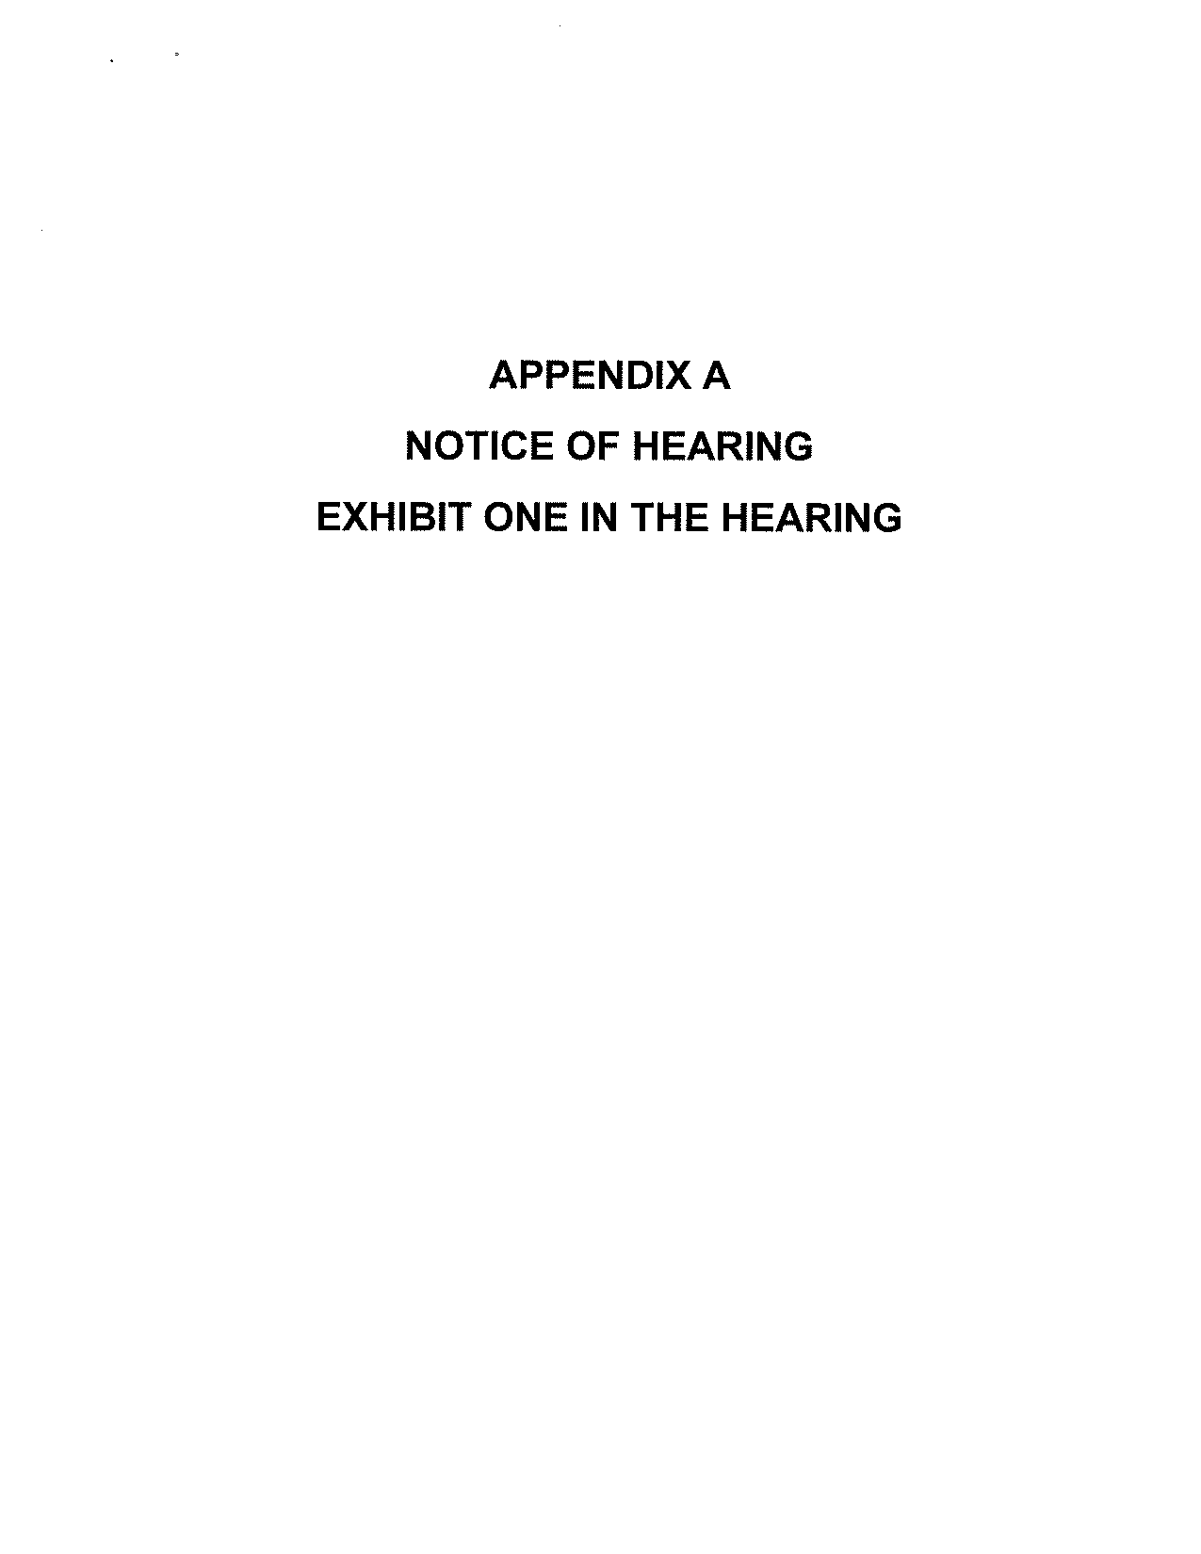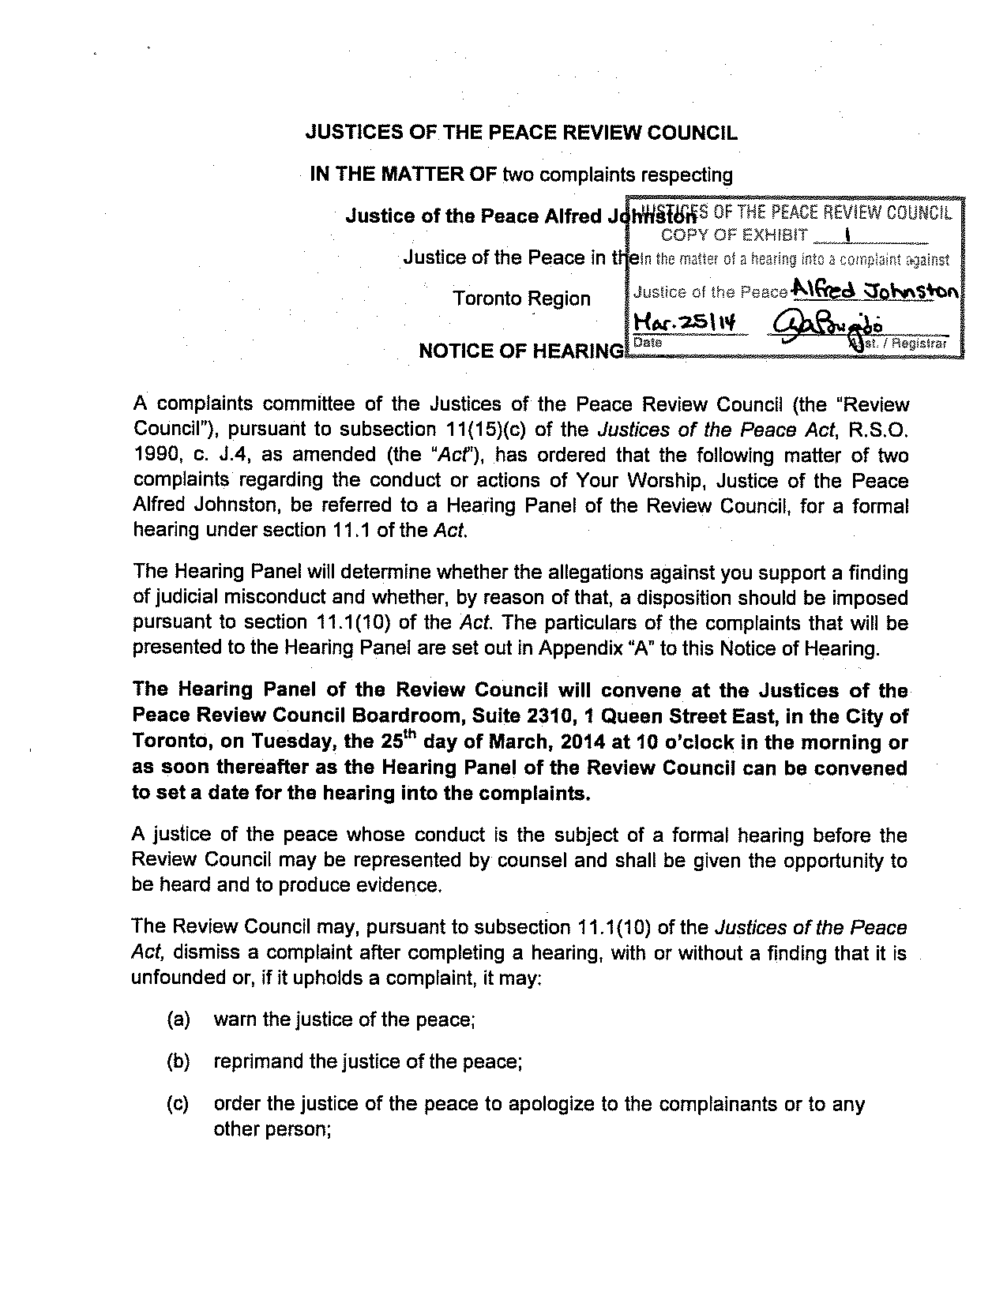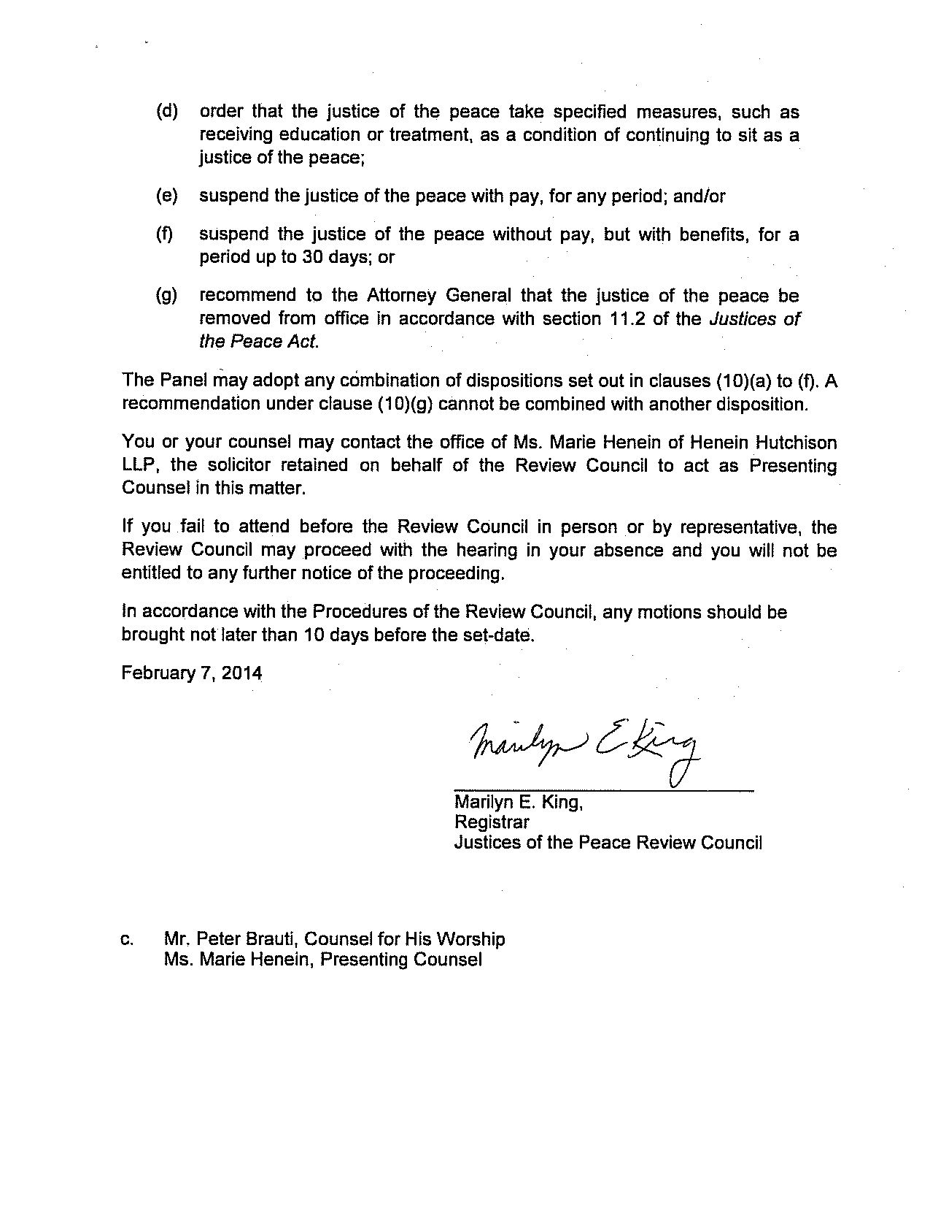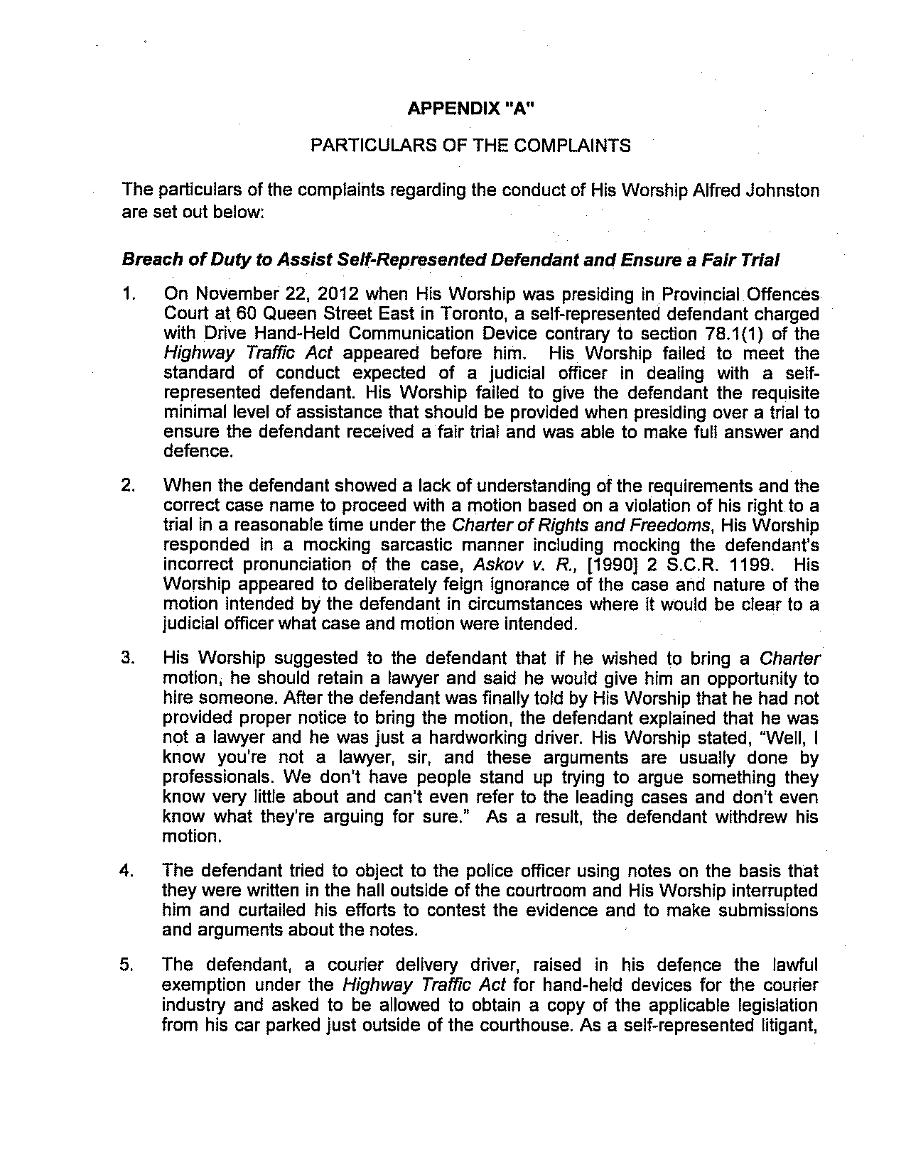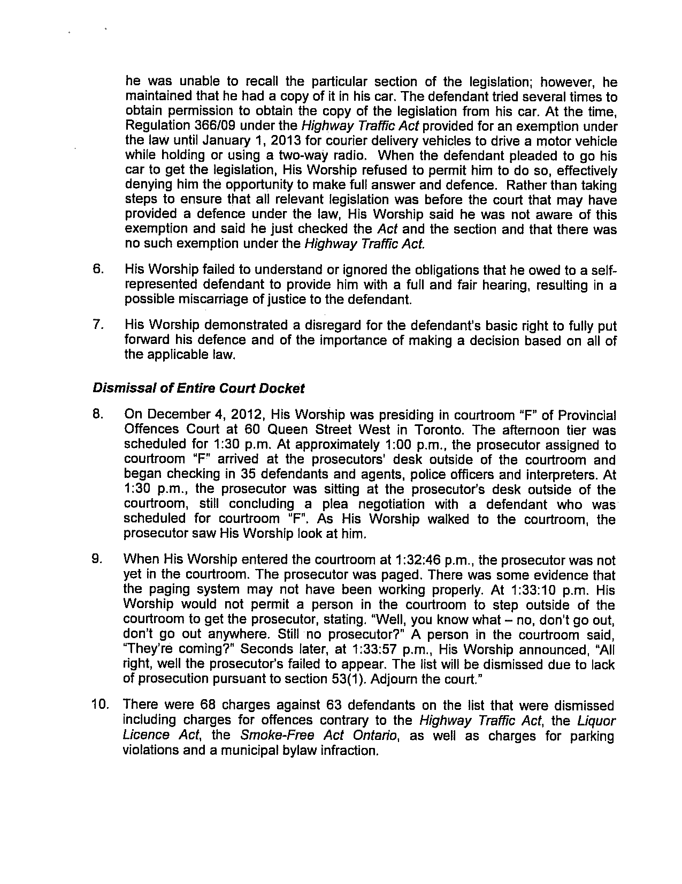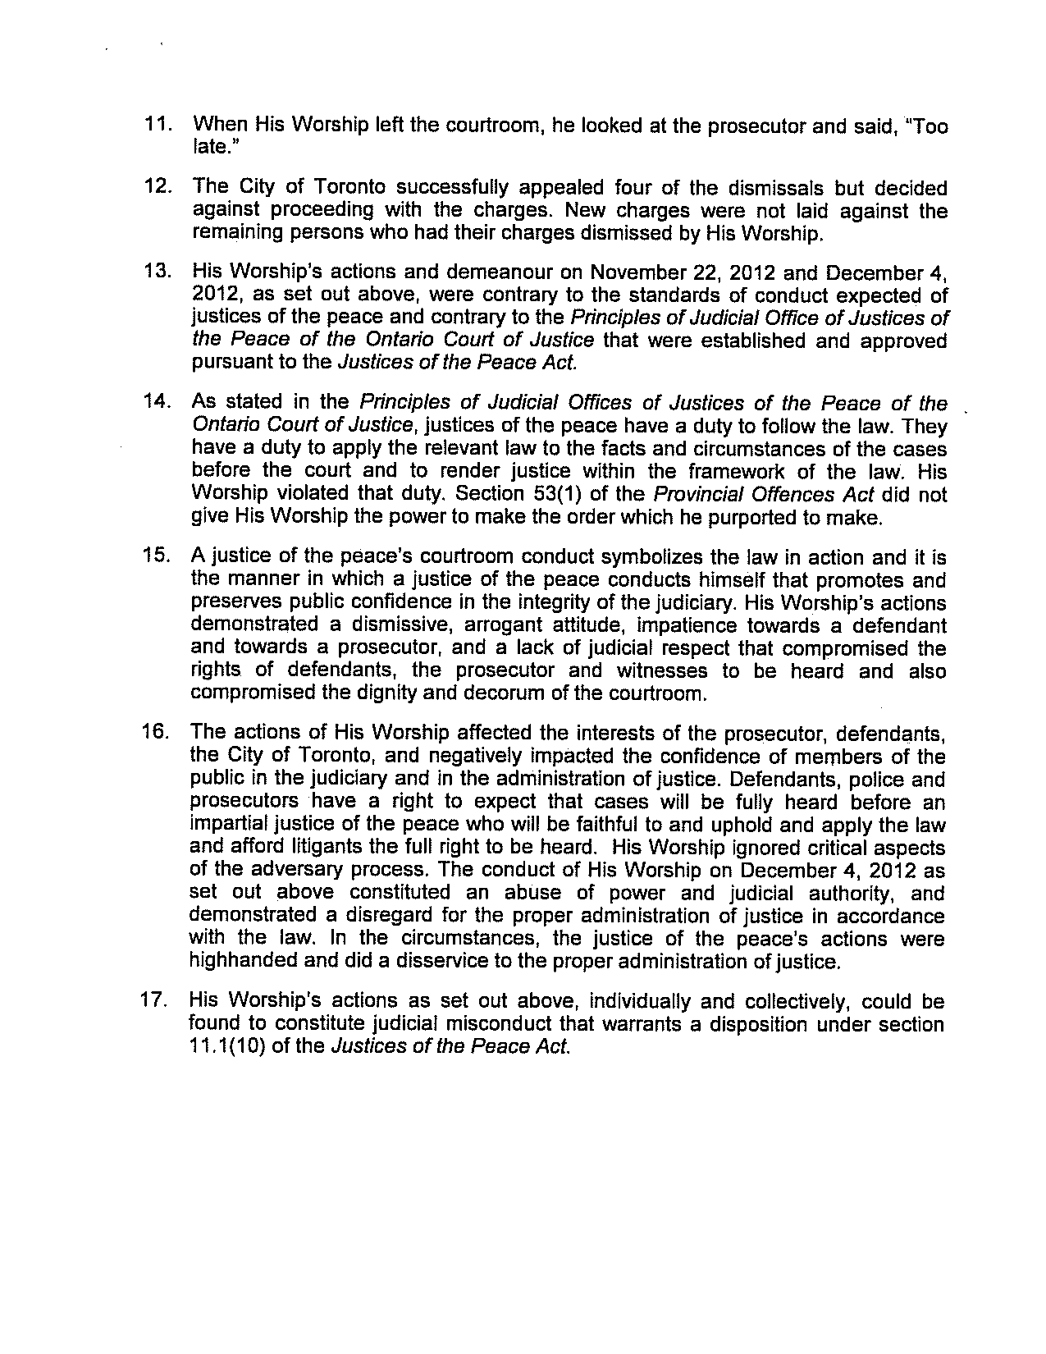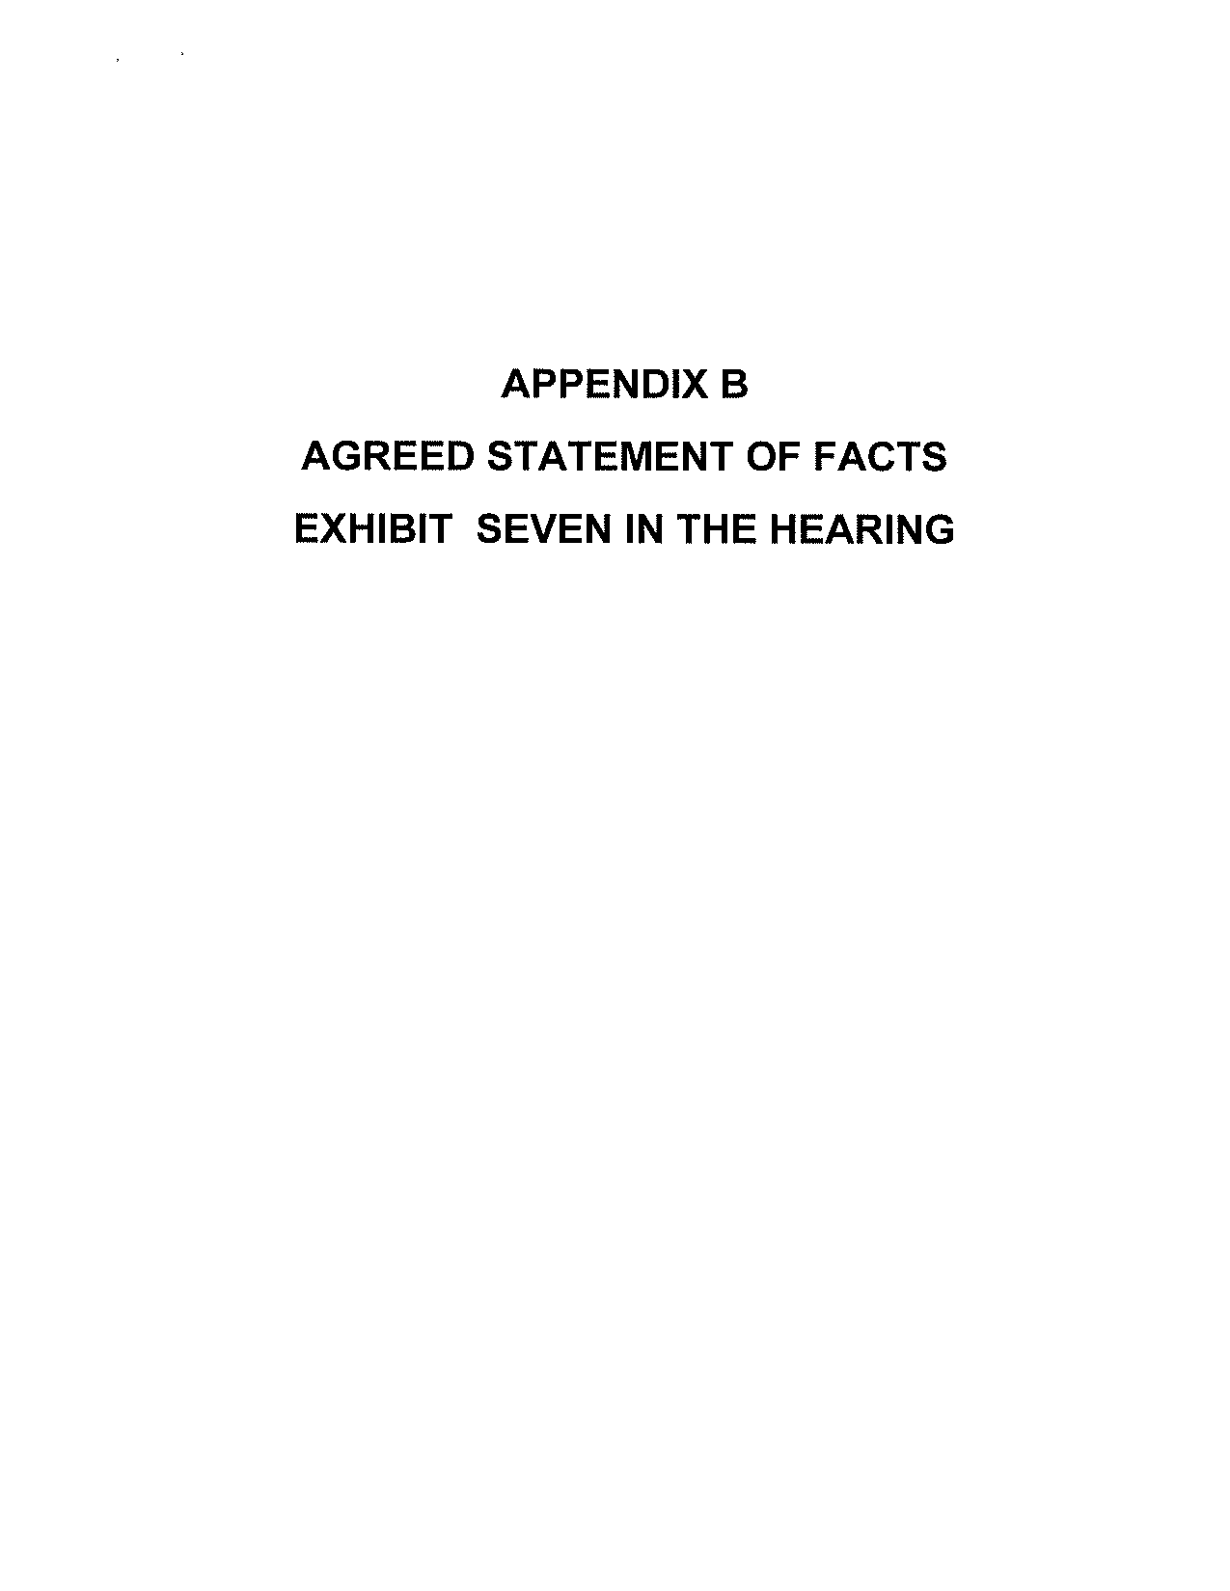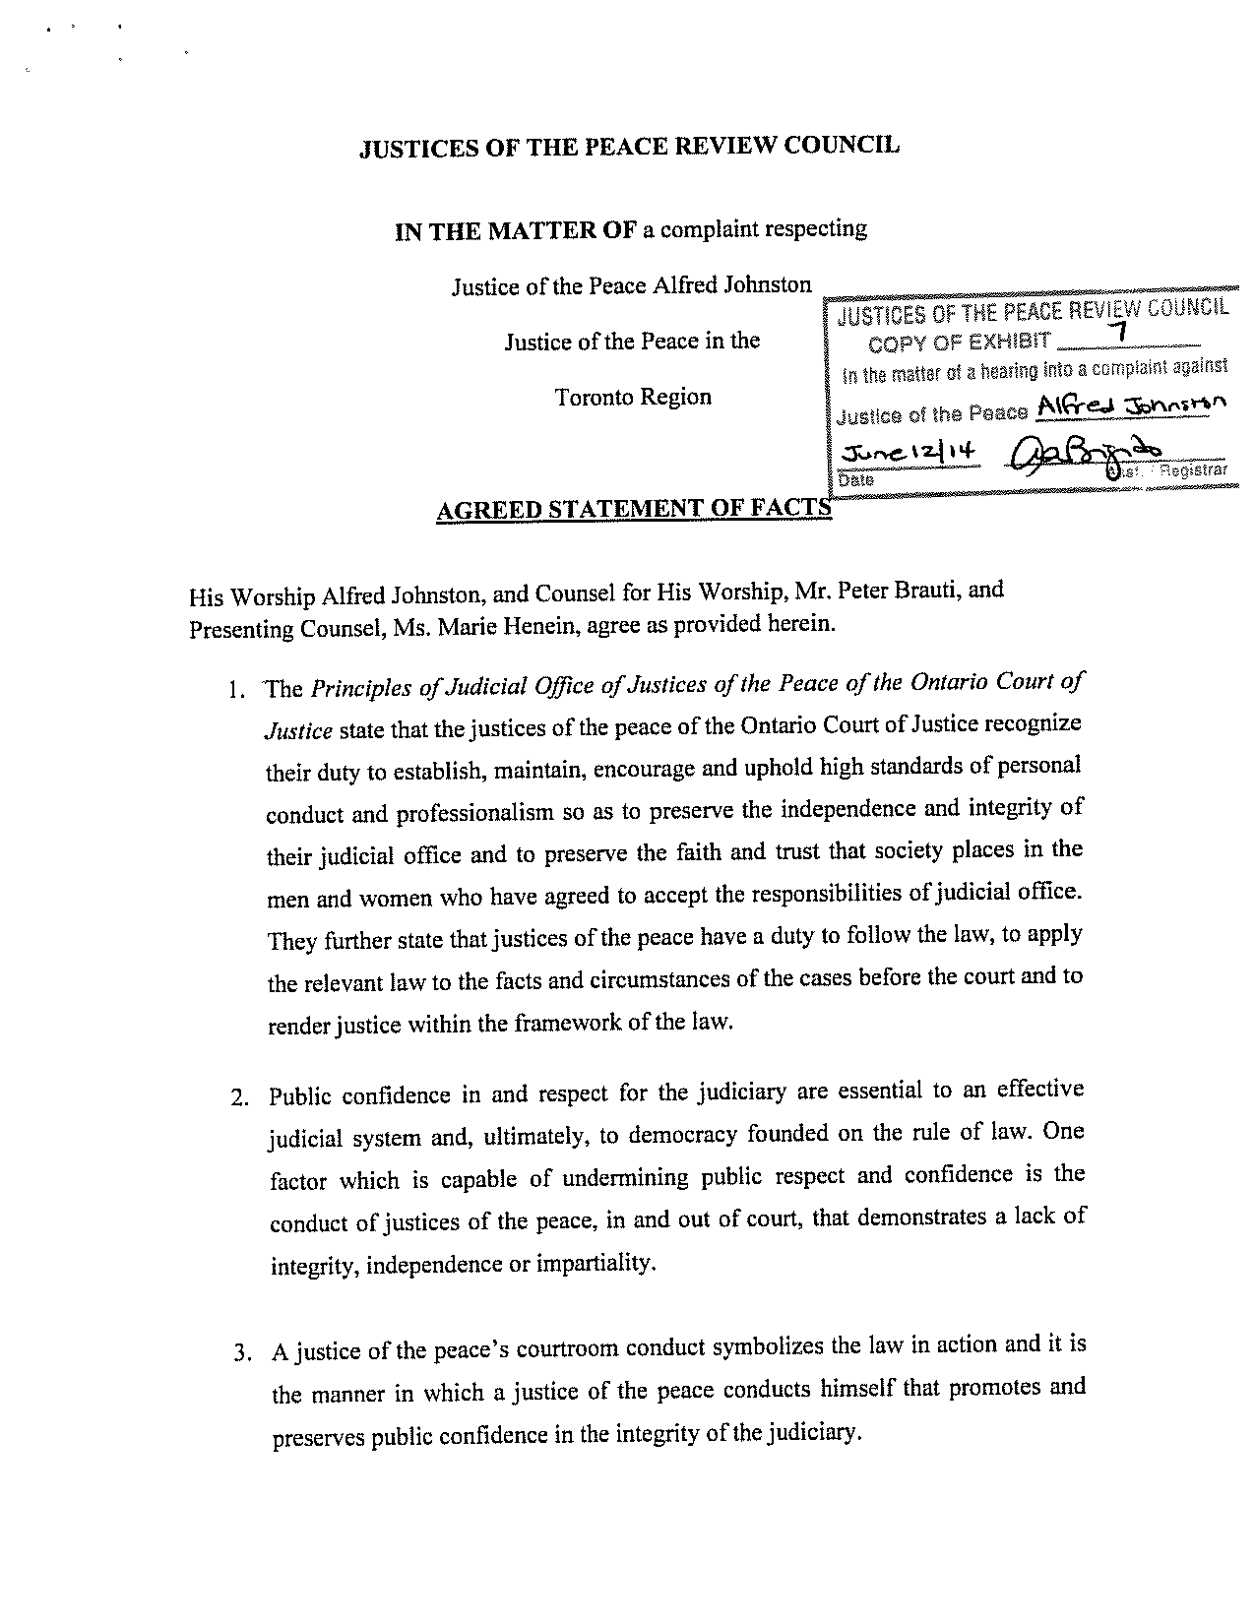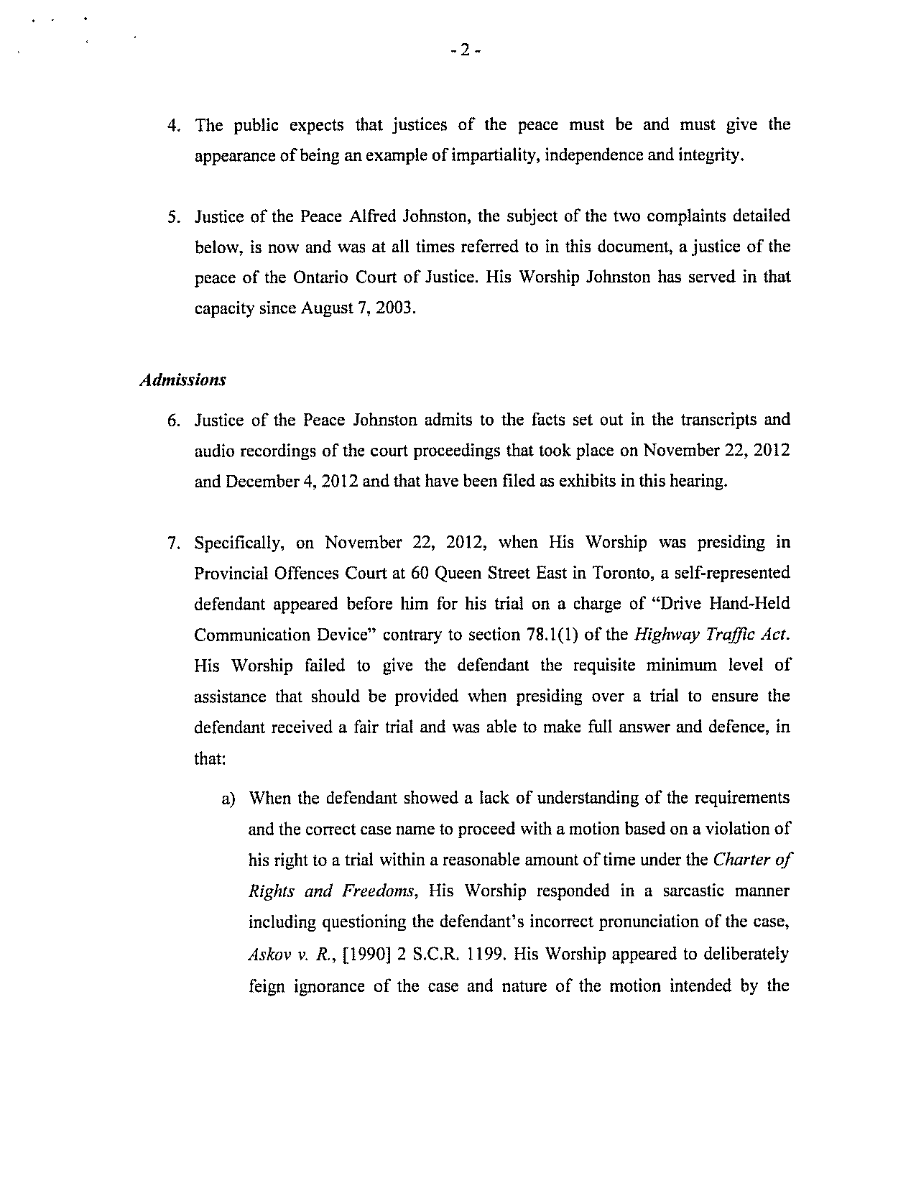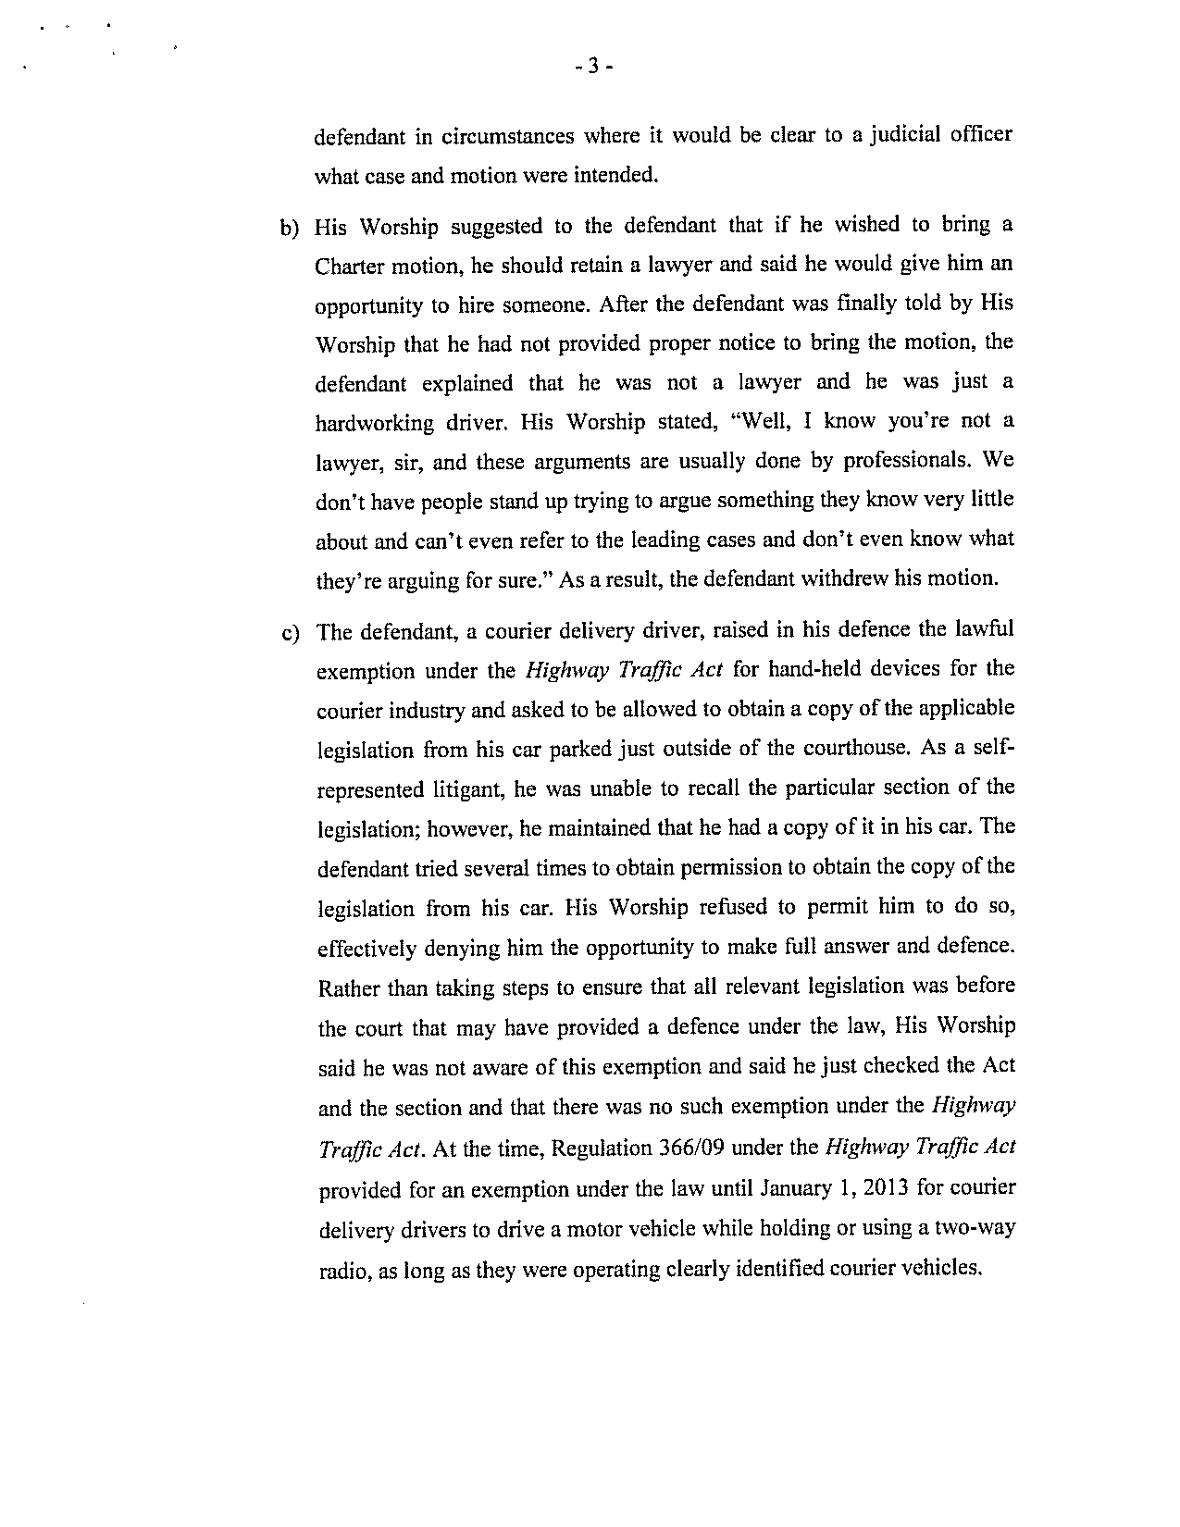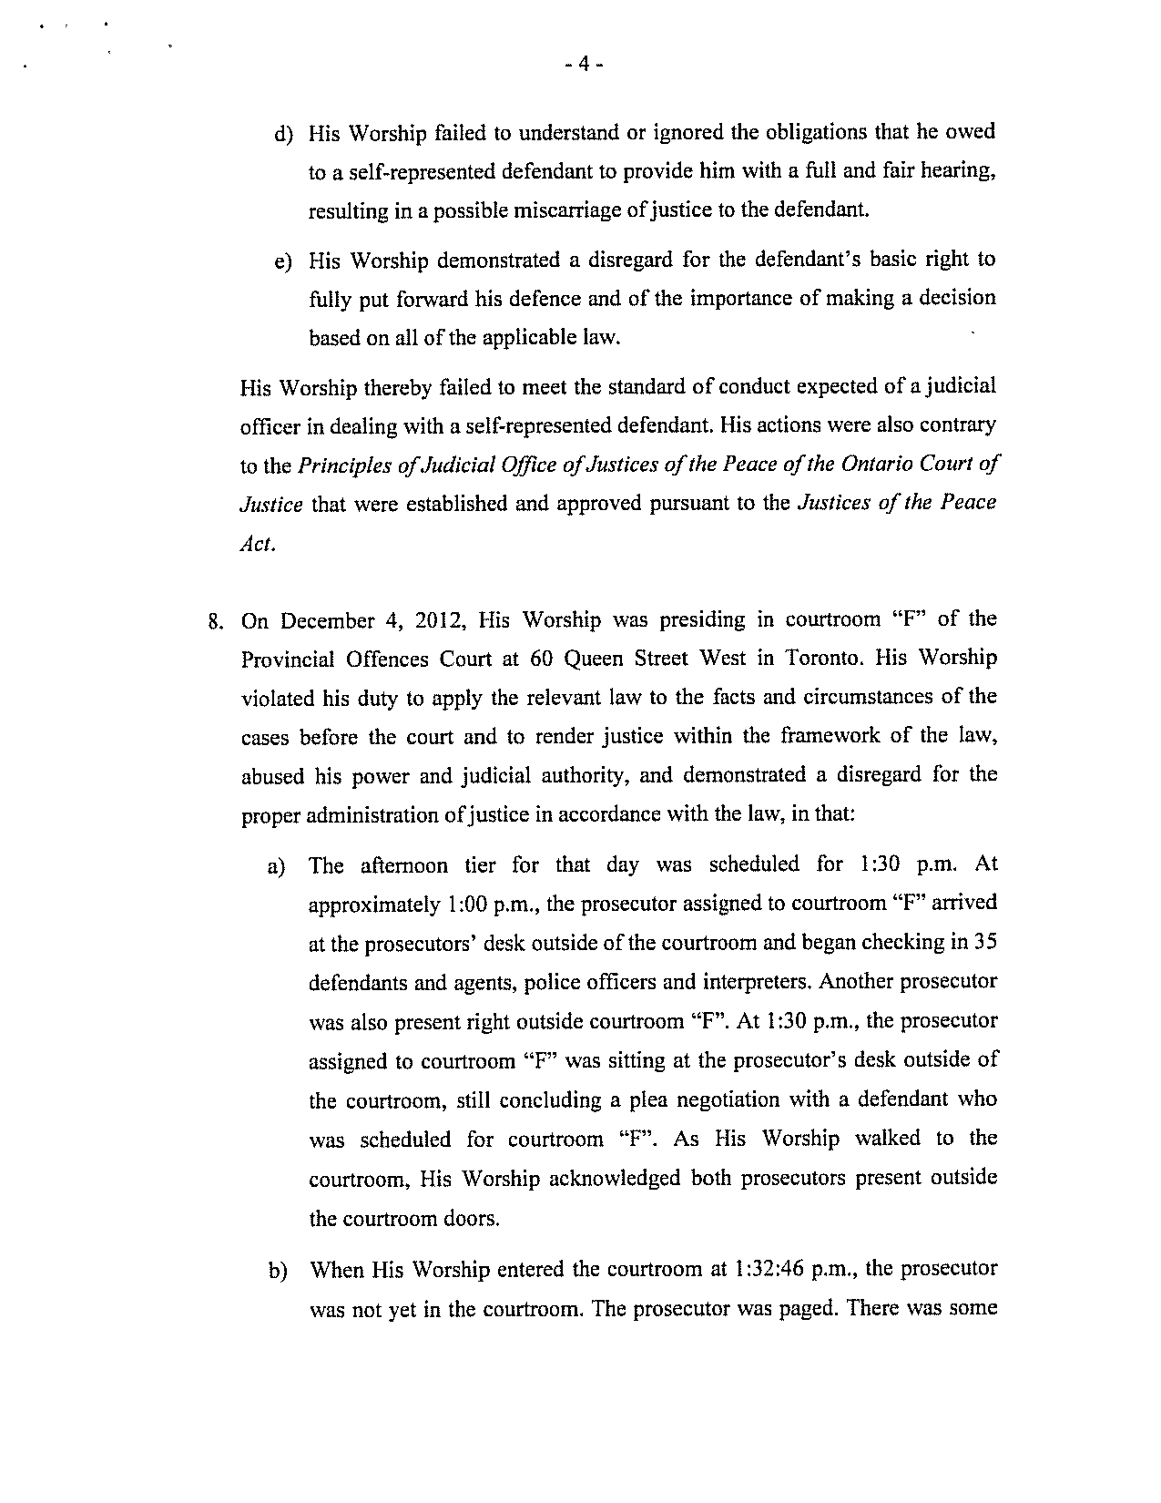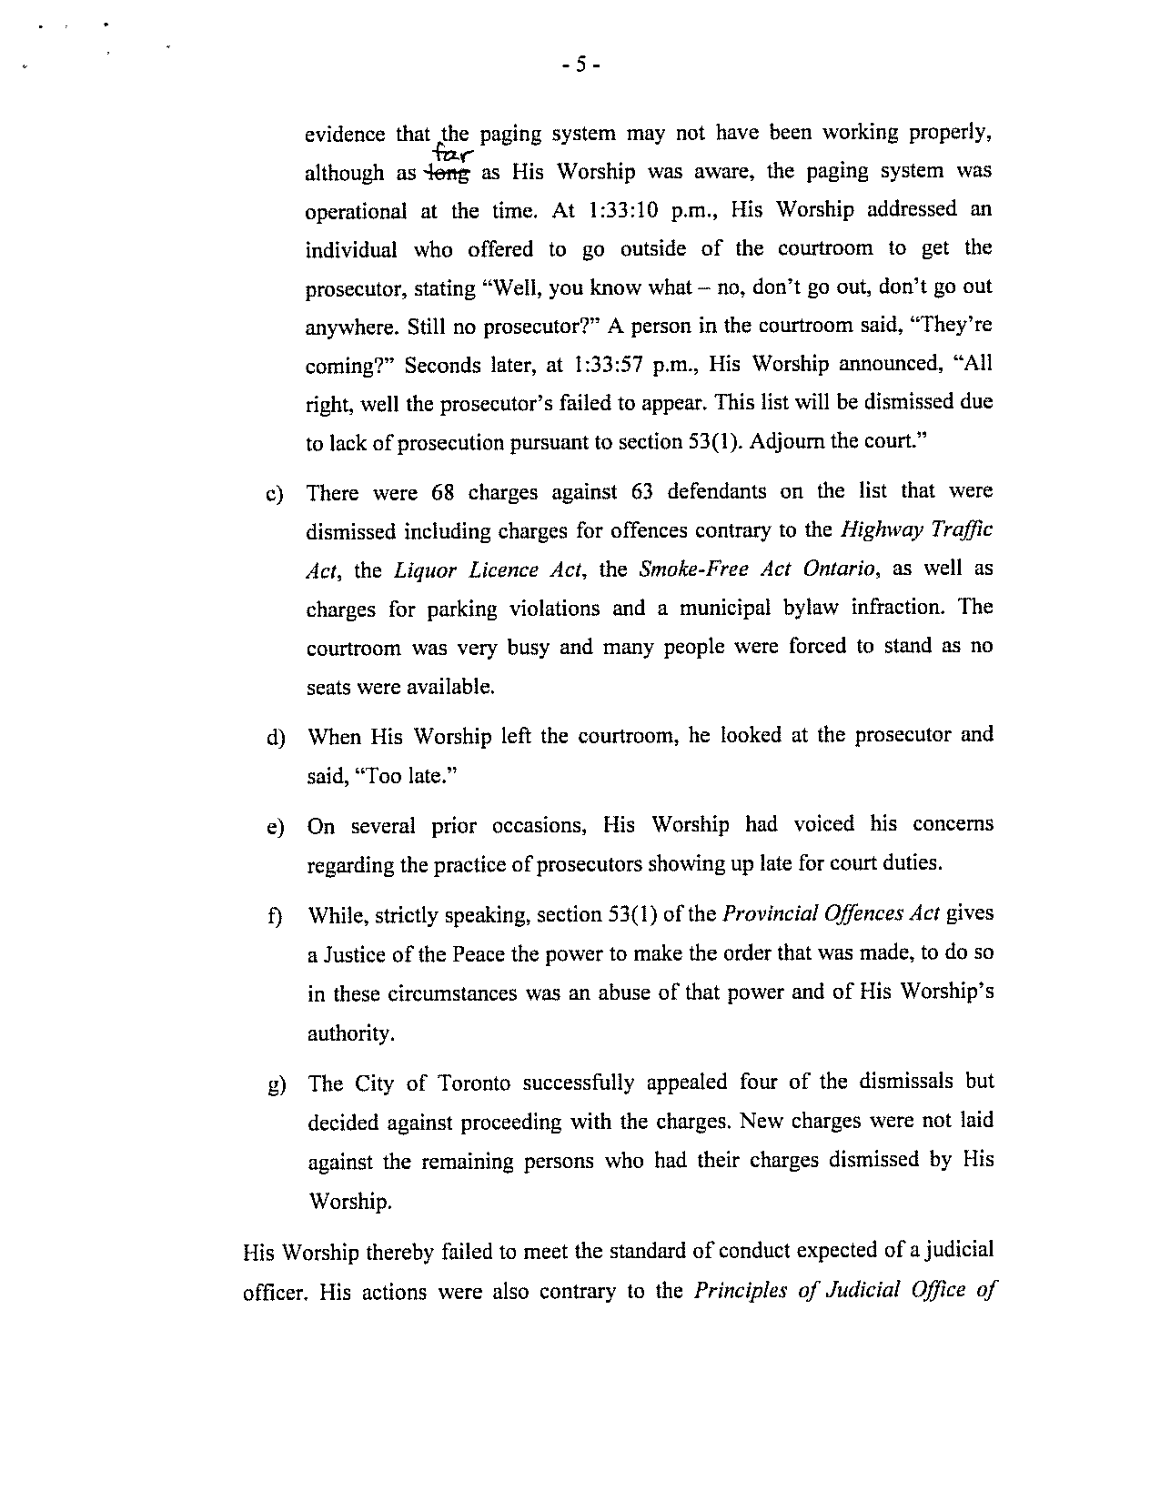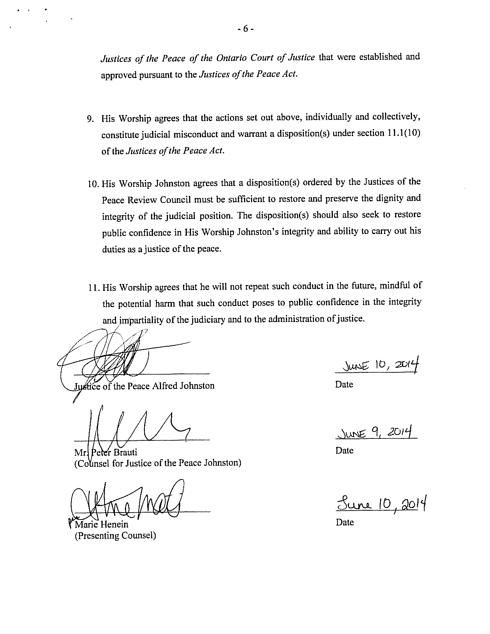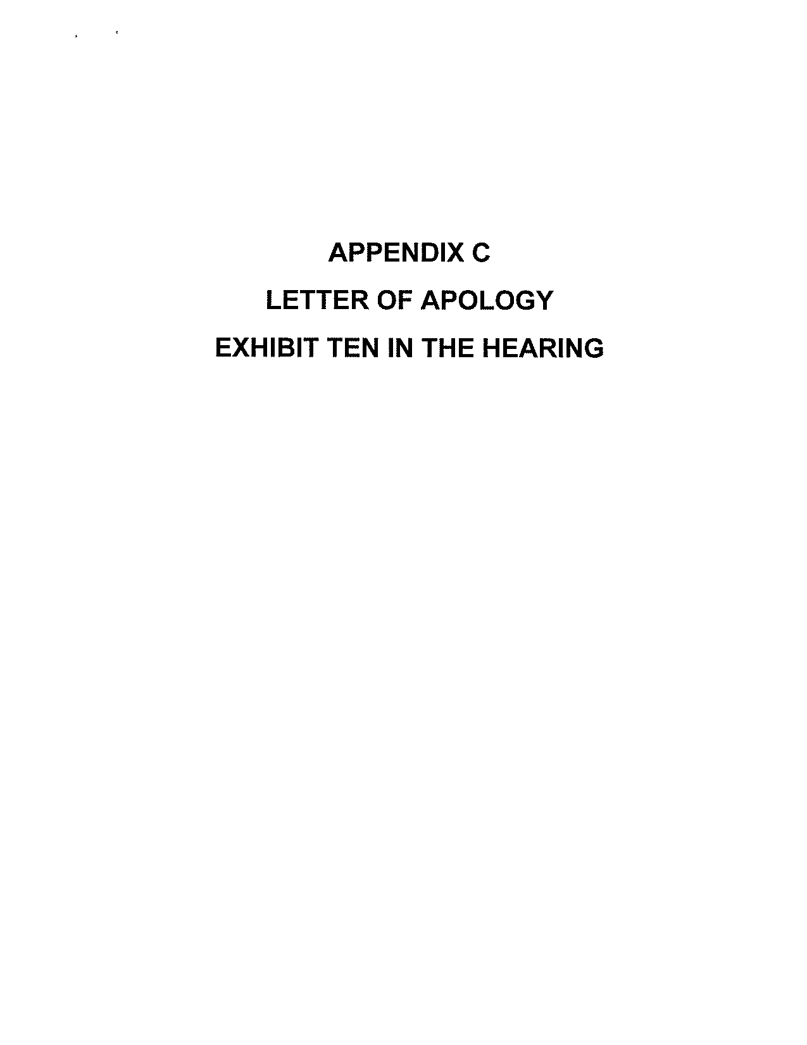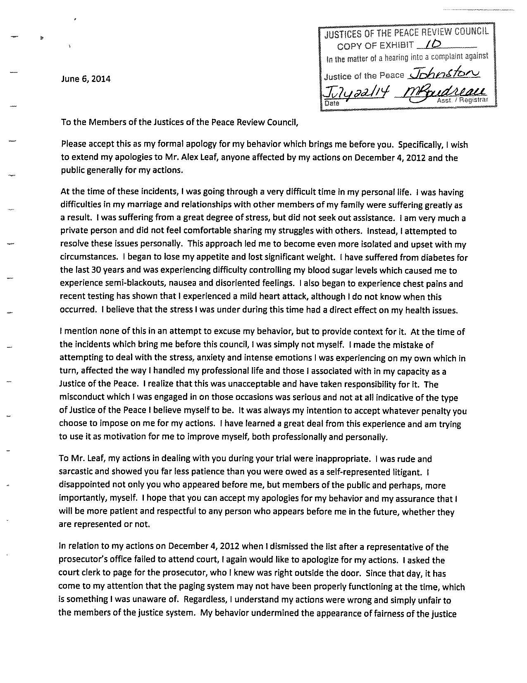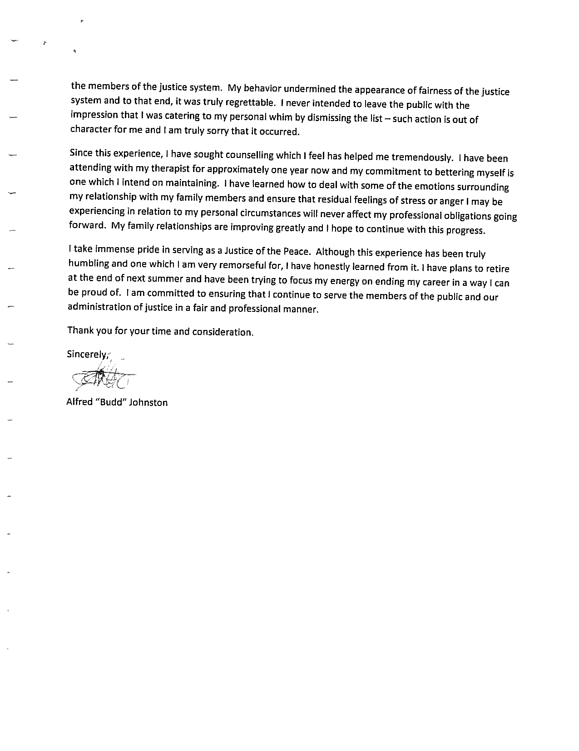

The Notice of Hearing was tendered was Exhibit 1, and is attached to these reasons as Appendix A.
The duty to provide assistance to unrepresented defendants was reinforced in R v Rijal, 2010 ONCJ 329 at para. 66: “To repeat the words of Laskin J.A. in Winlow, at para. 71, a case involving the trial of a party who conducted his own defence under Part I of the Provincial Offences Act, “Special care must be taken to ensure that POA proceedings are fair to defendants.” (citations omitted).
Here the Panel is wary of its jurisdiction. We are not holding His Worship culpable for any legal error, rather, his tone and comportment in relation to such.
The Agreed Statement of Facts was tendered as Exhibit 7, and is attached to these reasons as Appendix B.
Ibid. (As with the law surrounding the Leaf matter, the Panel is mindful of its jurisdiction. We are not dealing with the legality per se of His Worship’s actions, rather the manner in which they were performed and the impact on the public’s confidence in the administration of justice).
Quite unlike the situation in Re: Chisvin, 2012 (OJC), where Justice Chisvin also dismissed an entire docket for want of prosecution, yet recognized his error that very day and reported the mistake to his Regional Senior Justice (ibid., para. 43).
Due to policy restrictions in His Worship’s Employee Assistance Plan, the reasons for and the nature of the counseling was not disclosed by the service provider. Only the dates of counseling sessions were provided.
1999 ABQB 252, aff’d by 2000 ABCA 241.
The date was chosen to provide sufficient opportunity for the Court’s administration to cover His Worship’s dockets for the period of suspension.

